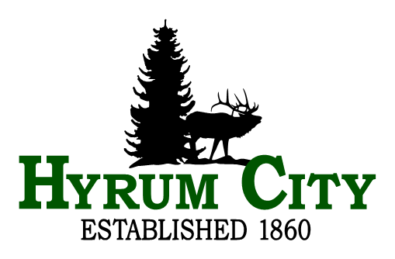
Library Board Meeting
Wednesday, September 10, 2025 at 6:00 PM
Library Board Room, 50 West Main, Hyrum, Utah
Agenda
Public notice is hereby given of a Hyrum Library Board Meeting to be held in the Library Board Room, 50 West Main, Hyrum, Utah at 6:00 PM, September 10, 2025. The proposed agenda is as follows:
1. ROLL CALL
2. CALL TO ORDER
3. WELCOME
4. REVIEW MINUTES
5. PUBLIC COMMENTS
6. BUSINESS
A. Directors Report - Emily Coltrin
B. City Council Report - Jared Clawson
C. Chair nomination and vote
D. Summer Reading wrap-up
E. Master Policy review
Sections 1 - 3
F. Board Bi-laws review and vote
7. ADJOURNMENT
__________________________________
Emily Coltrin
Library Director
In compliance with the Americans with Disabilities Act, individuals needing special accommodations (including auxiliary communicative aids and services) during this meeting should notify Hyrum City Library at 435-245-6411 at least three working days before the meeting.
CERTIFICATE OF POSTING - The undersigned, was posted on the Utah Public Notice Website, Hyrum City’s Website, provided to each member of the governing body, and posted at the Library 50 West Main, Hyrum, Utah, this 2nd day of September, 2025. Emily Coltrin, Library Director.

