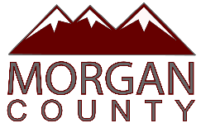

PUBLIC NOTICE is hereby given that the Morgan County Commission will hold 2026 Budget Work Sessions in the Commission Meeting Room 48 West Young Street, Morgan, Utah on:
September 3, 2025 at 3:00pm
September 4, 2025 at 3:00pm
September 5, 2025 at 3:00pm

Date posted: September 2, 2025
Time posted: 9:30am
Leslie A. Hyde, Clerk/Auditor

In compliance with the Americans with Disabilities Act, persons needing auxiliary services for these meetings should call the Morgan County Clerk/Auditor’s Office at 801-845-4010 at least 24 prior to this meeting.

