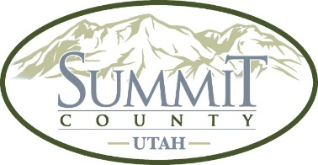

AGENDA

Snyderville Basin Cemetery District Board of Trustees
Wednesday, September 3, 2025 @9:00 AM- CANCELLED.

NOTICE OF MEETING CANCELLATION – September 3, 2025

NOTICE is hereby given that the Snyderville Basin Cemetery District meeting scheduled for Wednesday, September 3, 2025, has been cancelled. The next scheduled special meeting is Thursday, September 4, 2025, at 9:00 AM at the Summit County Sheldon Richins Building, 1885 W Ute Blvd, Park City, UT 84098, RM 133.

