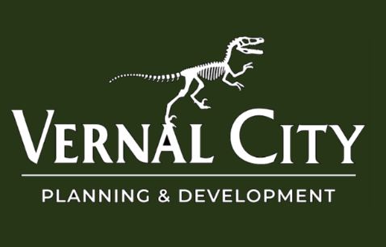

Public Notice
August 29, 2025

VERNAL CITY PUBLIC HEARING

A public hearing of the Vernal City Planning Commission has been scheduled for Tuesday, September 9, 2025 at 5:30 pm in the Vernal City Council Chambers, 374 East Main, Vernal, Utah, to consider amending the Vernal City Municipal Planning and Zoning Code to consider changes to Section 16.16.030 – Area Regulations – Ordinance 2025-025.
Property owners and other interested persons are urged to attend.
In compliance with the Americans with Disabilities Act, individuals needing special accommodation during this meeting should notify Braeden Christofferson at (435) 789-2255 at least five days before the hearing.

Posted on the Utah Public Notice Website;
Posted on the Vernal City Website; and
Posted in conspicuous places within Vernal City
Posting date: August 29, 2025
Notice must remain in place through September 9, 2025

