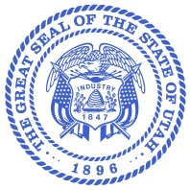
Department of Agriculture and Food

KELLY PEHRSON
Commissioner

TROY FORREST
Deputy Commissioner

LEANN HUNTING
Director, Animal Industry Division

State of Utah

SPENCER J. COX
Governor

DEIDRE M. HENDERSON
Lieutenant Governor

Livestock Brand Board Meeting

Date: Wednesday, September 3, 2025
Time: 8:00 AM
Location: 4315 S 2700 W Ste 2200, TSOB South Bldg. Floor 2, Taylorsville, UT 84129
Google Meet Link: meet.google.com/tdk-rqwe-rjt
Join by phone: (US) +1 662-674-1226 PIN: 925648951

Agenda
1. Welcome & introduction of new board member – Jim Withers, Chairman
2. Review and approve minutes – Action
3. Program Report - Leann Hunting
4. Renewal Update - Suzanne Butler, Brand Recorder
5. New World Screwworm Information- Dr. Sabo, Assistant State Vet
6. Brand Bureau Chief Introduction & Confirmation; Matt Bailey - Leann Hunting and Jim Withers (Action)
7. Public Comment
8. Adjourn

