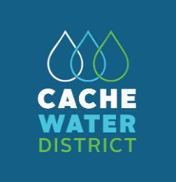
Our Water. Our Future. Our Choice.
The District’s purposes include planning for and facilitating the long-term conservation, development, protection, distribution, management, and stabilization of water rights and water supplies for domestic, irrigation, power, manufacturing, municipal, recreational, and other beneficial uses, including the natural stream environment, in a cost-effective way to meet the needs of the residents and growing population of Cache County.
www.cachewaterdistrict.com
_________________________________________________________________________________________________________

CACHE WATER DISTRICT BOARD OF TRUSTEES
MEETING MINUTES
July 7, 2025
The Cache Water District Board of Trustees convened for a meeting on July 7, 2025, at 5:30 p.m. in the Cache County Historic Courthouse Council Chambers, 199 North Main Street, Logan, Utah.

MEMBERS OF THE BOARD IN ATTENDANCE:

Jared Clawson – At-Large Position
Jonathan Hardman – South Council District
Kirt Lindley – At-Large Position
Beth Neilson – Southeast Council District
Jeff Ostermiller - Logan #1 Council District
Max Pierce – Northeast Council District
Bret Randall – Northeast Council District
Brett Roper – At Large Position

MEMBERS OF THE BOARD EXCUSED:

Mark Anderson – Logan #3 Council
Jeannie Simmonds – Logan #2 Council District
Regan Wheeler – Agricultural Representative

OTHERS IN ATTENDANCE:

Nate Daugs, Chad Brown, Chris Slater, Wayne Wurtsbaugh, Jacob Ames, Eric Franson, Autumn Zierenberg

CALL TO ORDER

Vice-Chairman Ostermiller called the meeting to order at 5:30 p.m.

ACTION: Mr. Hardman moved to approve tonight’s agenda and the June 2, 2025 minutes. Mr. Pierce seconded the motion. The motion was approved (6-0).

Yea: Hardman, Lindley, Ostermiller, Pierce, Randall, Roper
Absent: Anderson, Clawson, Neilson, Simmonds, Wheeler

PUBLIC INPUT

None comments.
FINANCIAL REVIEW
Ms. Simmonds was absent at tonight’s meeting and they will be reviewed next month.

5:35 p.m. Chairman Clawson arrived

CALENDAR

- July 9 - Great Salt Lake Advisory @ 10:00 a.m.
- July 9 – Utah Water Task Force @ 1:00 p.m. - Cancelled
- July 10 – Utah Watersheds Council @ 1:00 p.m.
- July 21 – APO Mtg. @ 5:30 p.m.
- July 29-31 – NWRA Western Water Seminar – Park City
- Aug 4 – CWD Regular Board Mtg. @ 5:30 p.m.

5:45 p.m. Ms. Neilson arrived.

PL-566 Project Update

Logan River Watershed
A meeting was held this morning with staff from USU Facilities and two engineering firms to discuss the potential continuation of the watershed project and a new pipeline connection to First Dam.
- A field visit was conducted with the Army Corps of Engineers to evaluate prospective wetland sites.
- Public comment is tentatively scheduled for later this fall.

Wellsville / Mendon Project
- The project has been formally submitted to NRCS for review.

NRCS recently issued an email noting that the projects' status change from Environmental Assessment (EA) to Environmental Impact Statement (EIS)—due to funding constraints— this has been determined to be improper. As a result, the projects will likely revert back to EA status. Ms. Neilson inquired about the implications of this shift, given the near-completion of the current process. Mr. Daugs confirmed that there will still be a public comment period under the EA process. NRCS seems to be optimistic that funding for this program will continue, there is support from a number of state representatives and senators. Mr. Roper noted that despite strong legislative support, there is no specific funding in the proposed 2026 National Budget. Mr. Hardman asked about the funding request ramifications. Mr. Daugs said the funding limitation can still be raised. Mr. Franson noted that requiring congressional approval of watershed project plans has been argued to be unconstitutional. Mr. Daugs will share the NRCS email with the board members.

Water Supply Studies

Sunrise Engineering is gathering the water data from the northern cities. There have been some discussions with Rep. Snyder about possible funding for some of the possible outcomes.
Next month, Franson will present information on the Blacksmith Fork Canyon dam site project (possible sites).

Hyrum Dam Enlargement Study is reviewing the data.

The study costs were initially overestimated. Currently of the $740,000, $390,000 has been allocated leaving approximately $350,000 left to use on potential conservation outreach programs (have until June 2027 to spend). Revisions to the initial contract can be made.

2025 Tax Resolution Adoption

There are two resolutions that must be adopted annually to establish the certified tax rate. The public hearings held last fall set the rate at 0.000035. This resolution involves the completion of Form PT-800, which formally adopts that rate and is projected to generate approximately $622,000 in revenue. The second required document is the Tax Rate Summary Form (Form 693), which must be completed and submitted as part of the annual tax rate process.

ACTION: Mr. Ostermiller moved to approve submission of form PT-800 and form 693 (Tax Rate Summary) as discussed. Mr. Randall seconded the motion. The motion was approved (7-0).

Yea: Clawson, Hardman, Lindley, Neilson, Ostermiller, Pierce, Randall
Absent: Anderson, Simmonds, Wheeler
Abstain: Roper

Funding Request for the Wellsville/Mendon PL-566 project – Chad Brown

The funding gap for completion of the Wellsville/Mendon project was discussed last month. Mr. Brown from Franson Engineers reviewed the timing and additional requests from NRCS. In July 2024, there was training from NRCS for consultants working on PL-566 projects. In the training, the National Water Management Center was giving different direction than what they were receiving from NRCS Utah. A meeting with NRCS Utah was held in August with instructions to move forward with making changes that were in line with what had been received at the training. Franson Engineers reported that the additional project requirements identified were outside the scope of the original agreement.

In April 2025, the NRCS informed the firm that, due to changes in the national administration, no additional federal funding would be available to cover the added scope. As a result, the required adjustments have increased the project cost by approximately $150,000. Franson Engineers outlined several specific modifications that were necessary to meet the new requirements. Although Franson Engineers is requesting an additional $50,000, the firm acknowledged that this amount will not fully cover the total cost overrun but will assist in offsetting a portion of the additional expenses. The other project co-sponsors, based on their original funding contributions, expressed support for the request.

Mr. Daugs stated that the request from Franson is for each participating entity to double their original funding amount. As Cache Water District (CWD) initially contributed $5,000, an additional $5,000 is now being requested. Other entities involved in the project have also agreed to double their contributions accordingly.

Mr. Clawson commented that the situation has become unfortunate. Mr. Daugs noted that if the environmental document can be approved, the project would have the necessary clearances to proceed as funding allows.

Mr. Roper remarked that Mr. Brown’s presentation was honest and the funding request appears fair. He expressed concern that the federal government is shifting responsibilities and funding burdens to state and local levels, a trend that is occurring nationally.

In response, Mr. Daugs added that the State of Utah is aware of these funding challenges and is exploring options for assessing a new fee or tax on water-providing entities to begin addressing the gap in water infrastructure funding.

Mr. Randall inquired whether there is a budgeted line item for the requested funds. Mr. Daugs confirmed that funding is available within the Water Projects Account to meet the request. Mr. Roper further noted that during the previous meeting, it was discussed that funds would be available for this purpose.

ACTION: Mr. Roper moved to approve an additional $5,000 be allocated as per the request by Franson Engineers as long as the other entities pay their portion(s). Ms. Neilson seconded the motion. The motion was approved (8-0).

Yea: Clawson, Hardman, Lindley, Neilson, Ostermiller, Pierce, Randall, Roper
Absent: Anderson, Simmonds, Wheeler

CONSERVATION OUTREACH UPDATE

Ms. Zierenberg presented a brief overview of the 6-month proposal items.

Over the next six months, we will contact city and county councils to inform and involve board members in ongoing water conservation efforts in Cache County. By engaging with councils, we aim to improve community access to state rebates and other water wise incentives.

To expand the program within Cache County, 15 of 20 municipalities need to adopt a water conservation clause. This will be promoted orally in each city council meeting during this period. Once cities adopt the clause, we will begin supporting residents who want to convert to more water-efficient lawns through state rebate programs. To encourage participation, we propose a rebate match program (pending agreement on the match amount). Lawn conversions to Localscapes or drought-tolerant grass seed will be eligible. Extra funding from county water projects can support this effort. As the state manages the main rebate program, there will be no additional staffing or monitoring costs to us outside of the match funding.

To support alternative seeding practices, we plan to collaborate with local businesses to provide grass seed and promote lawn conversion methods through updated digital resources. Existing digital tools will be evaluated for user-friendliness and consistency (e.g., how our site compares to Slow the Flow). Based on this review, we will expand and improve materials to reach a broader audience. Additionally, attractive lawns within our county will be photographed to be showcased on our website to add a visual incentive to “flip your strip” (with homeowner permission).

Community education will include school presentations, volunteer programs, and participation in local events to teach water conservation practices. Coordination with our school district superintendent will be key to launching these efforts. As Utah curricula are updated within the next few months, we will also promote new resources to teachers within the district.

New and ongoing, partnerships with USU Extension, Utah State University, Slow the Flow, and other stakeholders will support the development of outreach materials and events. We also aim to increase the board’s visibility by encouraging participation in city and county meetings and distributing educational materials such as pamphlets and postcards.

City & County Council Outreach

City Council Engagement
Cities (that haven’t adopted the conservation clause)
- Request five minutes at city council meetings to:
  - Introduce the rebate program and conservation clause
  - Share benefits and progress updates
  - Discuss partnership options
- Offer materials and follow-up opportunities for cities interested in participating.

Cities (adopted the conservation clause)
- Request five minutes at city council meetings to:
  - Introduce the rebate program because of the adopted conservation clause
  - Share benefits and progress updates
  - Discuss partnership options
  - Ask about what their process to adopt the updates to their development code (i.e., the good, bad, and ugly).
- Offer materials and follow-up opportunities for cities interested in participating.
  - Localscapes classes
  - Other events

County Council Involvement
- Replicate the city strategy at the county level:
  - Present to county council meetings
  - Promote county-wide support and funding
  - Align goals across municipalities for stronger program reach

K–12 & Local Program Engagement Ideas
Note: These ideas are flexible starting points and can be tailored based on school interest and community capacity.

Elementary Schools
- Target Charter Schools First: They often have more curriculum flexibility and openness to pilot programs.
- Monthly Outreach: Autumn will attend monthly meetings with teachers and superintendents to build support for water conservation programs.
- Assemblies: Interactive presentations on water conservation, including games, demonstrations, and giveaways (e.g., stickers, seed packets).
- Classroom Activities: Simple water cycle experiments, story time with conservation themes, and drawing contests.
- School Gardens: Introduce small-scale water wise planting beds to teach basic principles of drought-tolerant landscaping. (Would depend on school structure and interest.

Middle / Junior High Schools
- Monthly Outreach: Continued presence in teacher and superintendent meetings to maintain program support and adapt curriculum.
- Assemblies: More in-depth topics like the water cycle, local water challenges, or Utah’s watershed system.
- Volunteer Opportunities: Light-duty events such as planting, creating educational signs, or helping at booths during community water fairs.
- Clubs or After-School Programs: Start a “Water Wise Club” focused on awareness, school projects, and conservation challenges.
- Classroom Projects: Science fair tie-ins, poster campaigns, or water use audits of their homes.

High Schools
- Monthly Outreach: Continued presence in teacher and superintendent meetings to maintain program support and adapt curriculum.
- Volunteer Program: Offer service hours through the water board to assist with outreach, planting days, and conservation events—helpful for resumes and college applications.
- Native Plant Growing Program: Partner with FFA or science departments to cultivate native and drought-tolerant plants for community giveaways or sales.
- Peer Education: Train interested students to teach mini lessons to younger students or at community events.
- Contests: Lawn transformation design competitions or PSA video contests promoting water conservation.

USU Extension
- Master Gardeners Program: Partner to help with plant giveaways, community education, and demo garden installation.
- 4-H Programs: Incorporate conservation into 4-H classes and events (e.g., gardening, science, and environment).
- Community Classes: Offer public water conservation workshops through Extension.

Bridgerland Technical College (BATC)
- Plant Propagation Collaboration: Start a partnership where BATC horticulture students grow native and drought-tolerant plants for local distribution.
- Review the new water wise landscaping on site and explore a possible partnership to convert the remaining turf to Localscapes or other turf options.

Utah State University (USU)
- Class Partnership – Landscape Architecture: Propose a “Flip Your Strip” project where students redesign existing parking strip lawns to be water wise. Could be used as a real-world assignment.
- Environmental Science or Sustainability Classes: Integrate outreach or native landscaping projects into coursework.
- Internships or Capstone Projects: Partner with USU to offer internships with the water board or have students work on outreach materials, mapping tools, or event planning.

Rebate Program for Lawn Conversions
We aim to support residents in converting traditional lawns to water wise landscaping (e.g., xeriscaping or drought-tolerant grass) by matching state rebate checks. This match could be offered in one of two formats:
- Flat Rate Match: A set amount per square foot or square meter converted.
- Proportional Match: A percentage of the rebate amount awarded by the state.
Important Notes:
- All lawn conversions must be inspected and approved by state personnel.
- Once approved, our program will match the amount provided by the state, subject to a defined cap or rate.
- Funding for this match program will possibly come from water conservation funds, high-tier tax revenues, and other local sources.
Possible Catchy Slogans:
- Lawn Switch, Rebate Rich!
- Flip That Strip, Get Rebate Grip
- Smart Lawn, Rebate On
- Cache Valley Cares, Save What’s Rare
- Cache the Drop, Don’t Let It Stop
- Save in Cache, Make a Splash

Collaboration with Local Builders and Developers
To promote long-term change, we will:
- Encourage or incentivize “localscaped” model homes in new subdivisions — starting with at least the first two homes in each development.
- Partner with local developers and builders to seed low-water-use grass or Localscape options in new developments.
- Advocate for inclusion of water wise landscaping in city planning and development codes.

Policy & City-Level Engagement
To ensure participation and maximize funding impact:
- The other 15 cities must adopt a water conservation update to their development code to be eligible for state rebate match funding and other program benefits.
- Regular meetings will be scheduled with city councils and planning departments to encourage adoption and identify available funding.
- Additional support may be offered to cities that adopt conservation language, including:
  - Access to extra conservation funds
  - Increased eligibility for matching programs
  - Potential tax-related incentives or grants for sustainable landscaping

Program Expansion & Policy Support

1. Tiered Tax Structure for Water Use
- Propose a tiered water rate structure where higher water users pay increased rates.
- Revenue from top-tier rates can fund conservation efforts like the rebate match program and educational outreach.

2. Ordinance Development
- Collaborate with city and county councils to pass ordinances that:
  - Require or encourage adoption of a conservation clause
  - Incentivize water wise landscaping in new developments and existing properties
  - Support enforcement or pricing measures to discourage excessive outdoor water use

Broader Engagement & Education

4. Coordination with Other Water Entities
- Look into joining Utah Water Conservation Forum*
- Connect with Utah state agencies and programs in other states to benchmark successful strategies and adapt best practices.
- Explore partnerships for shared outreach materials, training, and potential funding opportunities.
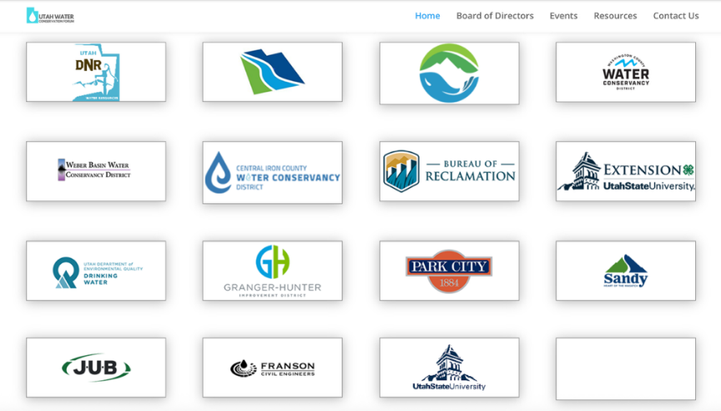
*Pictured Above: These widgets direct visitors directly to individual organizations logos.
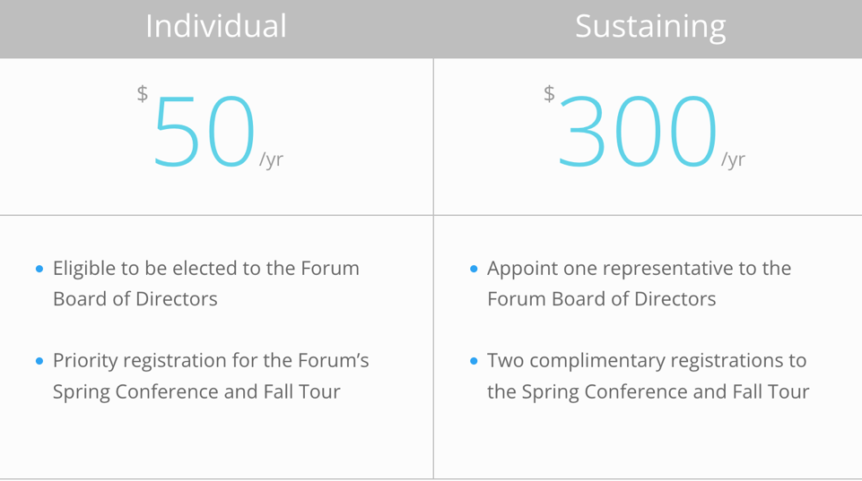

5. Classes
- Host classes to provide practical guidance on converting lawns to water wise landscaping.
- Partner with USU Extension, Slow the Flow, or other experts to deliver these courses online and in person.
- Advertise classes through city newsletters, school networks, and social media.

Policy Advocacy & Legislative Engagement

Utah State Legislation and Capitol Hill
- Engage with state legislators, senators, and representatives to advocate for increased funding and support for local water conservation programs.
- Coordinate with other water districts and conservation groups to present a unified voice during the legislative session.
- Schedule meetings and participate in events at Capitol Hill to:
  - Share local program successes
  - Advocate for legislation that strengthens rebate programs, conservation ordinances, and sustainable development practices
  - Explore new state-level incentives or pilot programs for lawn conversions and education efforts

Mr. Hardman noted that City Council cannot meet in private meetings except for three (3) purposes. Mr. Daugs said the initial meeting could be with the Mayor and the councilmember assigned to water.

Mr. Randall said Hyde Park and North Logan do not have in-house engineers, they contract with Sunrise Engineering and Cache Landmark. He suggested contacting the firms that contract with other cities within the Valley.

Mr. Clawson said there may be some misinformation so working with cities to explain the clarifications.

Mr. Daugs asked members for input on how they would like to potentially allocate funding for rebate and conservation programs. Once a direction is determined, the contract can be modified accordingly.

Mr. Ostermiller noted that the challenge will be determining the actual need for such programs.

Ms. Neilson inquired about the possibility of re-seeding existing lawns without full removal. She recently planted low-water-use grass, which she found difficult to establish.
Mr. Daugs explained that there are a couple of common methods: one involves over seeding directly onto the existing lawn; another approach is to kill the lawn and reseed in the fall or spring. Both options are currently being implemented.

Mr. Daugs added that the website will soon include a dedicated conservation page featuring ideas and suggestions.

There was additional discussion on how to obtain water usage data and whether it would be cost-effective at this early stage of conservation planning.
Mr. Pierce emphasized the importance of focusing on conservation first and assessing usage later.
Mr. Roper agreed but noted that having some data is necessary to demonstrate that conservation efforts are effective.
Mr. Randall said a cultural shift in the valley would be required for long-term success.
Mr. Daugs acknowledged the process will take time, but funding is available to begin initial steps.
Mr. Ostermiller noted that there will need to be flexibility in determining which approaches are most effective.

Mr. Daugs said the APO committee will meet and come up with more specifics and discuss this more at future meetings.

ADJOURN

The meeting adjourned at 7:05 p.m.

