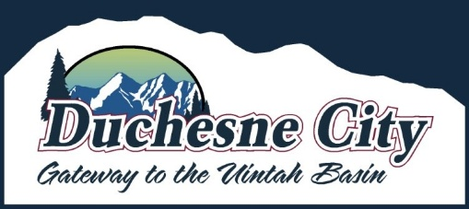

City of Duchesne
Official Certified Duchesne City 2025 Municipal Primary Election Results
Pursuant to Utah Code §20A-4-301(2)(b), the Duchesne City Council and Mayor acting as the Board of Municipal Canvassers, officially canvassed and certified the results of the Duchesne City 2025 Municipal Primary Election held on August 12, 2025, during a public meeting on August 26, 2025.

Certified Results:
Mayor (4-Year Term)
- Jason Andrew Baker 180 votes
- Corby Patrick 12 votes (Not advancing)
- Deborah V Herron 228 votes
City Council (Two seats, 4-Year Term)
- Dawnette Browning 155 votes
- Mark Eugene Nielsen 189 votes
- Jenny Adams 190 votes
- Janice Lynn Shipman 34 votes (Not advancing)
- Marty Anthony Herrera 263 votes

These individuals Jason Andrew Baker, Deborah V. Herron, Dawnette Browning. Mark Eugene Nielsen, Jenny Adams, and Marty Anthony Herrera are hereby certified to advance to the Duchesne City 2025 Municipal General Election on November 4, 2025, where final officeholders will be selected.

This notice serves as the official record of the canvassed primary results. The certified results have been posted publicly and will remain available at the City Office, on the City website, and on the official public noticeboard.
Issued by: Myra Young, Duchesne City Recorder / Election Officer
Date: August 26, 2025

