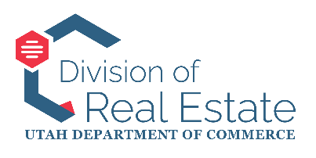
STATE OF UTAH
APPRAISER LICENSING AND CERTIFICATION BOARD
MEETING AGENDA
August 27, 2025 9:00 AM
Anchor Location:
Heber M. Wells Building – Second Floor, Admin Conference Room
160 E 300 S, Salt Lake City, Utah
This agenda is subject to change up to 24 hours prior to the meeting. Timings and order listed are approximate and may be adjusted, accelerated, or delayed.
ELECTRONIC PARTICIPATION:
Google Meet joining info
Video call link: https://meet.google.com/qgz-yyki-qwc
Or dial: (US) +1 401-321-2854‬ PIN: 754 816 965‬#‬‬‬‬
MEETING AGENDA:
- Commencement
  - Welcome and call to order
  - Consideration and approval of the meeting minutes from the July 30, 2025 meeting
  - Public comment
- Division Section Reports
  - Director’s Report – Leigh Veillette, Division Director
  - Licensing and Education – Laurel North, Licensing and Education Manager
  - Commission and Industry Issues – Justin Barney, Hearing Officer and Records Manager
  - Enforcement – Kadee Wright, Chief of Enforcement
    - Stipulations and Orders for the Board’s Consideration and Action
      - In the Matter of Luther Marshal Palmer, Docket No. RE-2025-041
- Executive (Closed) Session
  - Executive session (closed to the public)
  - Results of executive session (open to the public)
- Adjournment

In compliance with the Americans with Disabilities Act, individuals needing special accommodations (including auxiliary communicative aids and services) during this meeting should notify Dallas Thomas, Administrative Assistant, Division of Real Estate, PO Box 146711, 160 E 300 S, Salt Lake City, Utah 84114-6711, Phone 801-530-6750, at least one working day prior to the meeting.

