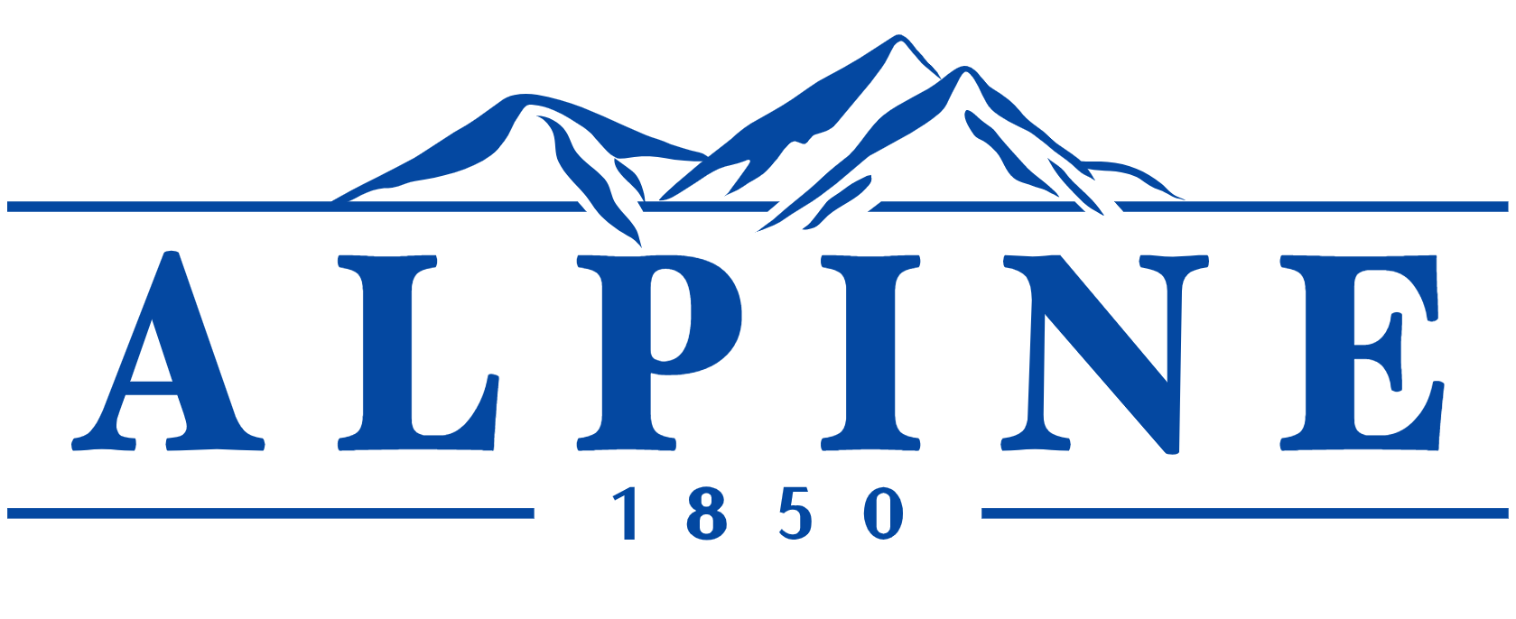

ALPINE CITY APPEAL AUTHORITY MEETING

NOTICE is hereby given that the APPEAL AUTHORITY of Alpine City, Utah will hold a Public Meeting
on Thursday, August 3rd, 2023, at 11:00 am at City Hall, 20 North Main Street, Alpine, Utah. The public may attend the meeting in

- Appeal Request for a Conditional Use Permit for a shooting gallery located at 670 Lupine Drive that was approved by the Alpine City Council on July 11th, 2023.

ADJOURN

Appeal Authority
Angela Adams
August 2nd, 2023.

THE PUBLIC IS INVITED TO ATTEND ALL PLANNING COMMISSION MEETINGS. If you need a special accommodation to participate in the meeting, please call the City Recorder's Office at 801-756-6347 ext. 5.

CERTIFICATION OF POSTING. The undersigned duly appointed recorder does hereby certify that the above agenda notice was posted at Alpine City Hall, 20 North Main, Alpine, UT. This agenda is also available on the City’s web site at www.alpinecity.org and on the Utah Public Meeting Notices website at www.utah.gov/pmn/index.html.

