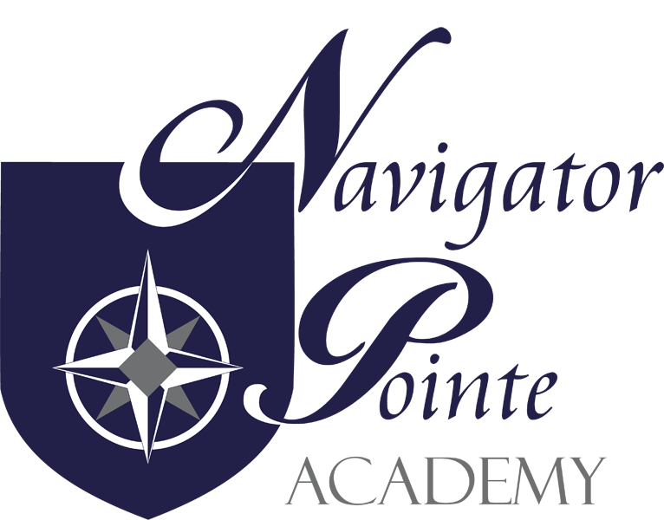
Governing Board Meeting
6844 South Navigator Drive West Jordan, Utah
Thursday June 19, 2025 6:00 p.m.
I. Call to Order/Welcome at 6:13 p.m.
II. Public Comment N/A
III. Governance
A. Board Governance Training – Jake will do August training.
B. Monthly Board Meeting Minutes Approval (Board action may be required)
a. Jake made a motion to approve the May 15, 2025 board meeting minutes. Kristi seconded the motion. Roll Call: Jake – yes; Kristi – yes. Motion passes.
C. Utah State Auditor Fraud Risk Assessment Certifications (Board action may be required)
a. Score is the same as it has been for many years – we scored 365 out of 395 total points.
D. Utah Grants Assurances (Board action may be required)
a. Discussed but don’t need to approve. Sent to Judy Farris and Ally Pierce to finish by June 30.
E. Salary Supplement for Highly Needed Educators Program Policy (SHINE) (Board action may be required)
a. School will determine which teachers are more difficult to find and hire. About $15,000 in funds will be given to us. Jake made a motion to approve the Salary Supplement for Highly Needed Educator Program Policy. Krisi seconded the motion. Roll Call: Jake – yes. Krisi – yes. Motion passes.
F. Paid Parental and Postpartum Recovery Leave Policy (Board action may be required)
a. Jake made a motion to approve the Paid Parental and Postpartum Recovery Leave Policy. Kristi seconded the motion. Roll call – Jake – yes; Kristi – yes. Motion passes.
G. NPA Early Learning Plan (Board action may be required)
a. Pathway to exceed grade level reading. 70% K-3 will be on predicted pathway. 72% 3rd grade. 65% 2nd grade. 80% 1st grade. Math K – 64% . 1st grade – 80%. 2nd grade -62%. 3rd grade – 71%.
b. Jake made a motion to approve the NPA Early Learning Plan. Kristi seconded the motion. Roll Call: Jake – yes; Kristi – yes. Motion passes. We will reach out to get numbers for the 2024-2025 school year.
H. Financial Report
a. Jake made a motion to accept the April 2025 financial report. Kristi seconded the motion. Roll Call: Jake – yes; Kristi – yes. Motion passes.
b. In May there was a $5,700 loss because of roof down payment. But operationally 104 K surplus. Each teacher got $500 to spend on classroom supplies. Jake made a motion to accept the May financial report. Kristi seconded the motion. Roll Call – Jake – yes; Kristi yes. Motion passes.
I. FY25 Final Budget (Board action may be required)
a. Deficit showing of $92K after paying for roof. We need to fall within 5% and not go one penny over. Needs to be certified in a few weeks. Jake made a motion to approve the FY 2025 final budget. Kristi seconded the motion. Roll Call: Jake – yes; Kristi – yes; Motion passes.
J. FY26 Initial Budget Adoption (Board action may be required)
a. Professional Staff has been changed to Flexible allocation. Surplus of $158K- each year it will grow because we don’t have bond payments. Budget based on 374 students. Jake made a motion to approve the FY 26 – Initial Budget. Kristi seconded the motion. Roll Call: Jake – yes. Kristi – yes. Motion passes.
K. “Closed Session, as necessary, to discuss allowed items” (Board action may be required) None
IV. Director’s Report
- Volunteer hours: total 1735 hours recorded. We have big events at the end of the year. Kids stayed engaged the final week. End of year park party was fantastic.
- Enrollment at 398 as of today. K – 50; 1st – 43; 2nd – 38; 3rd – 54; 4th – 53; 5th – 57; 6th – 53; 7th – 26; 8th – 24. We will have one AMK and no PMK and 2 full day Kindergartens.
- Several teachers and paras are returning. Need to hire another special ed teacher and the rest of the teachers are fully staffed. We are short three paraprofessionals – hope to fill those positions this summer. Looking at ways to help teachers with the CKLA reading program for next year.
- Safety conference – more talk about abuse this year in the training at the safety conference. Facility safety was also discussed for most of one day at the two day training.
V. Finance Report – Discussed above
VI. Next Meeting Schedule – August 21
Adjourn at 8:00 p.m.

