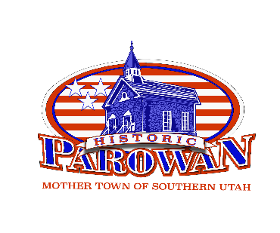
HISTORIC PRESERVATION COMMITTEE MEETING
WEDNESDAY, AUGUST 20, 2025 – 9:00 A.M.
CONFERENCE ROOM, PAROWAN CITY OFFICES
35 E 100 N, PAROWAN, UT 84761

Present: Merry Dean, Kristen Robinson, Steve Decker, Debra Slotboom, Councilmember David Burton,
Admin and Staff Present: Keith Naylor, Callie Bassett
Public Present: None

Call to Order
Merry Dean called the meeting to order at 9:00 a.m.

Declaration of Conflicts with any Agenda Item
Members confirmed they had reviewed the agenda. David Burton stated he had no conflicts. Debra Slotboom and other members also indicated they had no conflicts with any agenda items.

Approval of Minutes from July 8, 2025
Kristen Robinson moved to approve the minutes from the July 9, 2025 meeting, seconded by Debra Slotboom. Motion carried unanimously.

Approval of Banner for Sabor Latino: Shon Edwards/Fred Kramer
Merry Dean noted that the banner for Sabor Latino was already hanging on the awning in front of the restaurant. The banner measures 4 feet by 8 feet and covers approximately two-thirds of the awning. She expressed that while supporting local businesses is important, there are concerns about establishing precedent for banners throughout the downtown area.

Steve Decker questioned whether the item should be classified as a banner rather than a sign, noting other banners visible on Main Street businesses like the car wash and Dry Lakes Beef. He asked about the committee's jurisdiction over temporary banners versus permanent signage.

Keith Naylor clarified that in Parowan's code, if something is not expressly permitted, it is generally prohibited, which would likely apply to the historic preservation regulations as well.

David Burton read from the code regarding the committee's jurisdiction, which states the committee is concerned with "elements of development, redevelopment, rehabilitation, and preservation that affect visual quality of the historic district."

The committee discussed the distinction between permanent signs and temporary banners, with members noting other businesses using similar temporary displays. The committee acknowledged that supporting downtown businesses is important in the current economic climate while also recognizing the need for some guidelines to prevent visual clutter.

The committee agreed to develop administrative guidelines for banners in the future, addressing issues such as condition requirements rather than time limits. Steve Decker noted that condition-based requirements would be more practical than time-based ones since banners deteriorate at different rates depending on their location and exposure to elements.
Motion by David Burton, seconded by Debra Slotboom, to approve the banner for Sabor Latino owned by Shon Edwards and Fred Kramer. Motion carried unanimously.

Member Comments
David Burton requested clarification about the meeting schedule, noting that the committee had previously decided to meet twice monthly as needed. He suggested establishing Friday as a deadline for agenda items for the following week's meeting, so members would know whether a meeting would be held.

Callie Bassett, City Recorder, suggested that if members don't hear from her by Friday, they should not plan on a meeting for the following week. This would make it easier for her administratively than having to send notifications when there are no meetings.

The committee discussed the timeline for items to be placed on the agenda, agreeing to follow the same procedure as City Council, where items must be submitted by a certain deadline to be included on the next meeting's agenda. This would allow the committee to inform applicants that if they miss the Friday deadline, their items would be addressed at the subsequent meeting.

Adjourn
Motion by David Burton, seconded by Debra Slotboom, to adjourn the meeting. Motion carried unanimously. The meeting adjourned at 9:20 a.m.

__________________________________
Merry Mabbett Dean, Chair

__________________________________
Callie Bassett, City Recorder

Date Approved: _____________________

