DRAFT CITY OF OREM
DEVELOPMENT REVIEW COMMITTEE MINUTES
August 18, 2025

The following items are detailed in these minutes:
- Site Plan – Raising Canes – 11 West Center Street – Approved
- Admin Approval – Canyon View Apartments Fiber – 1430 S Sandhill Road – Approved
- Admin Approval – Carillon Court – 62 E 1200 South – Approved
- Admin Approval – Lumen P.092892 – 65 S 400 West – Approved
- Admin Approval – Hartland Homestead Homes – 584 S 900 East – Approved
- Admin Approval – AT&T Upgrade – Located generally at 950 N 1000 West – Approved
- Admin Approval – Frontrunner 800 S – Located generally at 1348 W 800 South – Approved
- Plat Amendment – Vineyard Heights – Located generally at 1010 W 400 North – Continued

Place: Aspen Conference Room (Floor 2) – City Hall Building – 56 North State Street, Orem Utah, 84057

11:02 a.m. Jared Hall called the meeting to order.

Those Present: Derek Spencer, Taggart Bowen, Chelsea Lindsey, Jared Hall, Aaron McKnight, Darren Pead - DRC Members. Grace Bjarnson – Associate Planner.

Those Excused: Gary McGinn, Rebecca Gourley

- Site Plan – Raising Canes – 11 West Center Street – Approved
Grace Bjarnson led the discussion for the Raising Canes site plan at 11 West Center Street, noting that the project, which involves replacing a Burger King, met all requirements including parking and landscaping. The Development Review Committee recommended the site plan for approval.

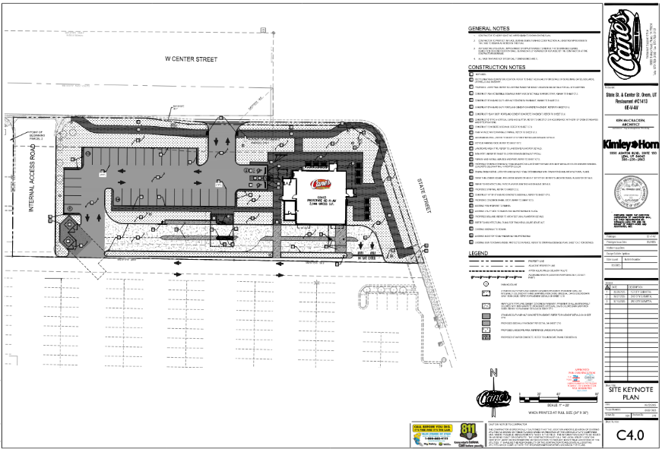

DRC Action: Derek Spencer moved to recommend the approval of the site plan for Raising Canes. Taggart Bowen seconded the motion. The motion passed unanimously.
Yes: Derek Spencer, Taggart Bowen, Chelsea Lindsey, Jared Hall, Aaron McKnight, Darren Pead
No: None

- Admin Approval – Canyon View Apartments Fiber – 1430 S Sandhill Road – Approved
Grace Bjarnson presented the Canyon View Apartments fiber installation project, which involves installing fiber along several streets. They confirmed that the project would require an engineering permit for traffic management after approval. The Development Review Committee recommended administrative approval for the project.

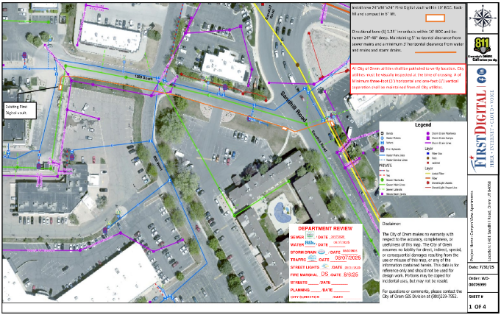
DRC Action: Aaron McKnight moved to recommend the approval of the Administrative Site Plan for Canyon View Apartments Fiber project. Chelsea Lindsey seconded the motion. The motion passed unanimously.
Yes: Derek Spencer, Taggart Bowen, Chelsea Lindsey, Jared Hall, Aaron McKnight, Darren Pead
No: None

- Admin Approval – Carillon Court – 62 East 1200 South – Approved
The Carolyn Court project, a senior housing facility, was discussed. Grace Bjarnson confirmed that the latest version of the plan involved redoing sidewalks and repaving asphalt, without altering storm drain systems, as existing sumps were already pre-treated. The Development Review Committee granted administrative approval for the project.
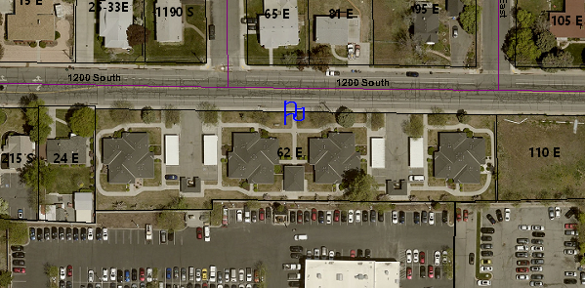
DRC Action: Chelsea Lindsey moved to recommend the approval of the Administrative Site Plan for the Carillon Court project. Darren Pead seconded the motion. The motion passed unanimously.
Yes: Derek Spencer, Taggart Bowen, Chelsea Lindsey, Jared Hall, Aaron McKnight, Darren Pead
No: None

- Admin Approval – Lumen P.092892 – 65 S 400 West – Approved
Grace Bjarnson introduced another Lumen project for fiber cable installation near 65 East, 400 West, highlighting that technical reviews confirmed correct drilling locations. The Development Review Committee recommended administrative approval for the fiber installations. The Development Review Committee granted administrative approval for the project.
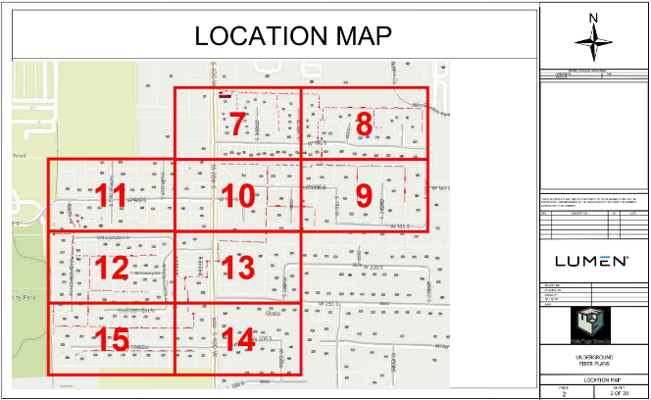
DRC Action: Taggart Bowen moved to recommend the approval of the Administrative Site Plan for the Lumen P.092892 project. Derek Spencer seconded the motion. The motion passed unanimously.
Yes: Derek Spencer, Taggart Bowen, Chelsea Lindsey, Jared Hall, Aaron McKnight, Darren Pead
No: None

- Admin Approval – Hartland Homestead Homes – 584 S 900 East – Approved
The discussion for Hartland Homestead Homes focused on the administrative approval for the installation of sidewalk and curb and gutter, which had not been previously installed on the property. Grace Bjarnson confirmed the correct address for the project was 584 South. The Development Review Committee recommended administrative approval for the installation.
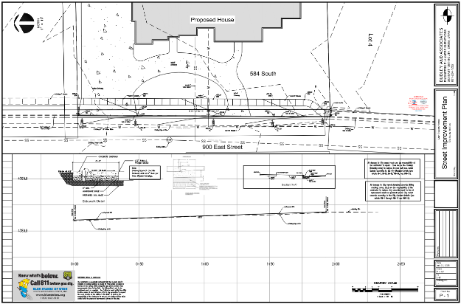
DRC Action: Darren Pead moved to recommend the approval of the Administrative Site Plan for the Lumen P.092892 project. Chelsea Lindsey seconded the motion. The motion passed unanimously.
Yes: Derek Spencer, Taggart Bowen, Chelsea Lindsey, Jared Hall, Aaron McKnight, Darren Pead
No: None

- Admin Approval – AT&T Upgrade – 950 N 1000 West – Approved
Grace Bjarnson presented AT&T's tower upgrade project, noting that it involves a minor change from the previous structure and that traffic coordination would be handled with an engineering permit. The Development Review Committee recommended administrative approval for the AT&T upgrade.
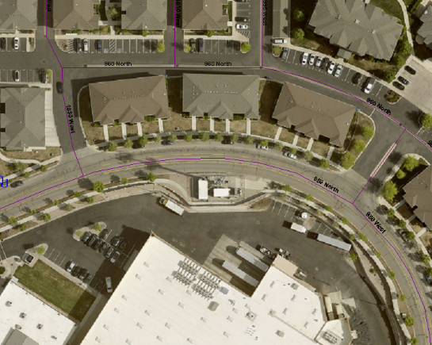

DRC Action: Derek Spencer moved to recommend the approval of the Administrative Site Plan for the Lumen P.092892 project. Aaron McKnight seconded the motion. The motion passed unanimously.
Yes: Derek Spencer, Taggart Bowen, Chelsea Lindsey, Jared Hall, Aaron McKnight, Darren Pead
No: None

- Admin Approval – Frontrunner 800 S – 1348 W 800 South – Approved
The Front Runner 800 South project was presented, involving the installation of a second set of tracks that will require road expansion. The Development Review Committee recommended administrative approval for the project.

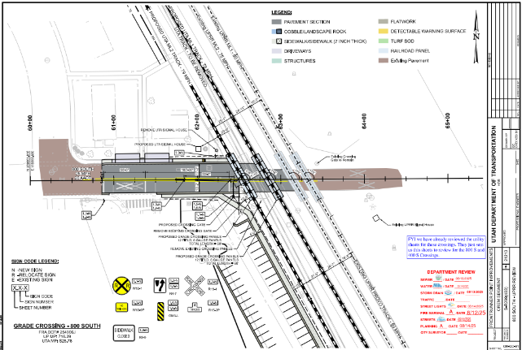
DRC Action: Derek Spencer moved to recommend the approval of the Administrative Site Plan for the Lumen P.092892 project. Aaron McKnight seconded the motion. The motion passed unanimously.
Yes: Derek Spencer, Taggart Bowen, Chelsea Lindsey, Jared Hall, Aaron McKnight, Darren Pead
No: None

- Plat Amendment – Vineyard Heights – 1010 W 400 North - Continued
The Vineyard Heights plan amendment, involving the addition of land to a property, was discussed, but it was decided to continue the project to a later date due to the need for more time. The Development Review Committee voted to continue the approval process for the project.
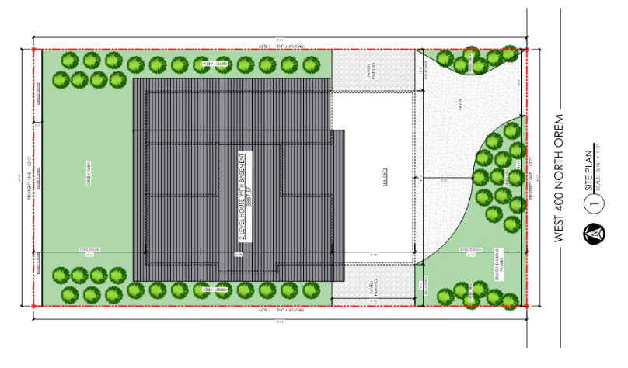

DRC Action: Aaron McKnight moved to continue the approval of the Administrative Site Plan for the Lumen P.092892 project. Derek Spencer seconded the motion. The motion passed unanimously.
Yes: Derek Spencer, Taggart Bowen, Chelsea Lindsey, Jared Hall, Aaron McKnight, Darren Pead
No: None

- Minutes: The minutes from the August 4th DRC meeting were presented for approval, with Grace Bjarnson noting that several adjustments had been made and sent via email. The Development Review Committee approved the minutes.

DRC Action: Chelsea Lindsey moved to approve the minutes. Derek Spencer seconded the motion. The motion passed unanimously.
Yes: Derek Spencer, Taggart Bowen, Chelsea Lindsey, Jared Hall, Aaron McKnight, Darren Pead
No: None

- Adjourn:

DRC Action: Taggart Bowen moved to approve the minutes. Darren Pead seconded the motion. The motion passed unanimously.
Yes: Derek Spencer, Taggart Bowen, Chelsea Lindsey, Jared Hall, Aaron McKnight, Darren Pead
No: None

Adjourn: 11:13 a.m.
Approved On: draft

