Kanosh Town Corporation held a Public Hearing in the Kanosh Town Hall at 6:30, Wednesday, June 11, 2025, at 55 North Main, Kanosh, Utah.

Members present:
Mayor Scott McDonald, Council members: David Whitaker, Neil Shumway, Josh Whitaker and Kanosh Town Clerk Cindy Turner, Kanosh Town Treasurer DeniAnn Whitaker.
Councilmember Dan DeGraffenried was unable to attend this meeting.

Others in attendance:
Geri Minton, Jim Kooy, Stan Koyle, Tim York, Jim Weaver, Shonda Robison, Sara Robison, Star Cummings, John Hogan, Debbie Hogan, Ben Coray, and Lorin Shumway

*As mandated by law, a Public Hearing was held before the adoption of the 2025-2026 fiscal year final budget, the public hearing is held to receive public comments in reference to the budget.
Note: There were no public comments received.

*The purpose of the Public Meeting following the Public Hearing was to discuss and gather input for the brush pile/burn pit. Townspeople offered several comments, primarily concerning the cost involved. the proposed location, and the monitoring of the site.

This Public Hearing/Meeting Concluded at 7:06 pm.

Kanosh Town held its regular council meeting at 7:10 p.m. on Wednesday, June 11, 2025, in the Kanosh Town Hall, located at 55 North Main, Kanosh, Utah.

Council member David Whitaker offered the opening ceremonies through an invocation.
Mayor Scott McDonald led everyone in attendance in the Pledge of Allegiance.

Minutes of the May 2025, meeting were read and approved as amended through a motion by Councilmember Josh Whitaker, Councilmember Neil Shumway provided a second to the motion, and all Council members in attendance voted in favor as noted below:
Mayor Scott McDonald Aye
Council members:
David Whitaker Aye
Neil Shumway Aye
Josh Whitaker Aye

Warrants for June 2025 were read, discussed, and approved to be paid through a motion by Councilmember Neil Shumway, Council member David Whitaker seconded the motion, and all Council members in attendance voted in favor as noted below:
Mayor Scott McDonald Aye
Council members:
David Whitaker Aye
Neil Shumway Aye
Josh Whitaker Aye

CERT:
*Kanosh CERT Captain Geri Minton noted the CERT members are working on getting ready for the 24th

*The CERT Team will not be participating in the Millard County Fair this year.
Fire Department:
Fire Chief Lorin Shumway reminded everyone Fire restrictions are in effect for portions of Utah as of Sunday, June 1, 2025.
- No open fires of any kind except within established public facilities in improved campgrounds, or picnic areas. -OR- In permanently constructed fire pits at private homes where running water is present.
- No smoking, except within an enclosed vehicle, trailer, or building, a developed recreation site, or while stopped in an area that is paved or free from dry vegetation.
- No fireworks, tracer ammunition, or other pyrotechnic devices including exploding targets.
- No cutting, welding, or grinding of metal in areas of dry vegetation.
- No operating a motorcycle, chainsaw, ATV, or other small internal combustion engine without an approved and working spark arrestor.

Information on municipal fireworks restrictions can be found here. https://firemarshal.utah.gov/department-services/fireworks-restricted-areas/ It is already extremely dry a big fire season is expected. A Heat advisory and red flag warning will be issued as Utah prepares for triple digital temperatures.

*Chief Shumway reported our Kanosh Department will be participating in a joint HAZMAT training with Scipio, Holden, and Fillmore at the Fillmore fire department tomorrow night.

*Last month there was discussion over the extreme costs associated with our continued use of services through Frontier Communications. Following a review of the services and the cost of the services, the fire department will be terminating all communication services through Frontier.

Planning and Zoning:
*Planning Commission spokesman Tim York presented the building permit of Joanna Herron (sister of Neil and Lorin Shumway), a building or apartment over a garage, there is already power and water on the property. All of the requirements have been fulfilled and reviewed by the Planning and Zoning Commission.

Council member Josh Whitaker motioned in approval of the building permit as presented, Councilmember David Whitaker seconded the motion, and all Council members in attendance voted in favor as noted below:
Mayor Scott McDonald Aye
Council members:
David Whitaker Aye
Neil Shumway Abstained
Josh Whitaker Aye

*Annexation:
Lorin Shumway and Neil Shumway each have a piece of property they would like to annex into the Town. The properties are connected and will be looked at as one annexation. Our Annexation specialist, Shonda Robison, has already started to work on the annexation, the properties are within the Town's general expansion plan.

Councilmember David Whitaker motioned in approval of moving forward with the annexation of the Shumway properties 8084-1 and 8081, Councilmember Josh Whitaker seconded the motion, and all Council members in attendance voted in favor as noted below:
Mayor Scott McDonald Aye
Council members:
David Whitaker Aye
Neil Shumway Abstained
Josh Whitaker Aye
.

*Mr. York commented referencing a previous discussion, that Local government zoning decisions are generally of two types: administrative and legislative. Request for variances, subdivision plat approval, and zoning decisions by zoning officials are examples of administrative zoning decisions. Due process safeguards are required in administrative decision-making, including the right to notice. Administrative land use decisions are judicial in nature, as the decision-maker determines the facts and applies the facts to the legal standards in the zoning ordinance.

Legislative decisions, on the other hand, are those that result in the adoption of a zoning ordinance, an amendment to the zoning ordinance, the rezoning of property, and the approval of a special use permit. These decisions must be made by the local governing authority. Administrative powers can easily be delegated and also sub-delegated. In short, to streamline the process, our Planning and Zoning Committee would like to use their legal power to approve building permits, if the land use application if the application conforms to the requirements of the Kanosh Town land use maps, zoning maps, and applicable land use ordinance in effect when a complete application is submitted and all fees have been paid. If there are any questions the decision would be referred to the Kanosh Town Council. Planning and Zoning would however meet with the Council members every month in an effort to keep everyone informed on any action taken.

This request will be reviewed and will appear as an agenda item for July. Any further discussion was tabled until next month. This action may require an ordinance or resolution; our attorney will be contacted before we meet again.

*General Plan Survey
Council members were given the opportunity to review this document before this June meeting. At the recommendation of the Council, the following will be removed before mailing:
#6
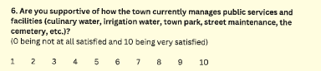

And 21 d. secondary water
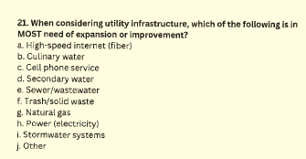

Kanosh Town does not operate irrigation water or any secondary water system.

See the document in its entirety below:
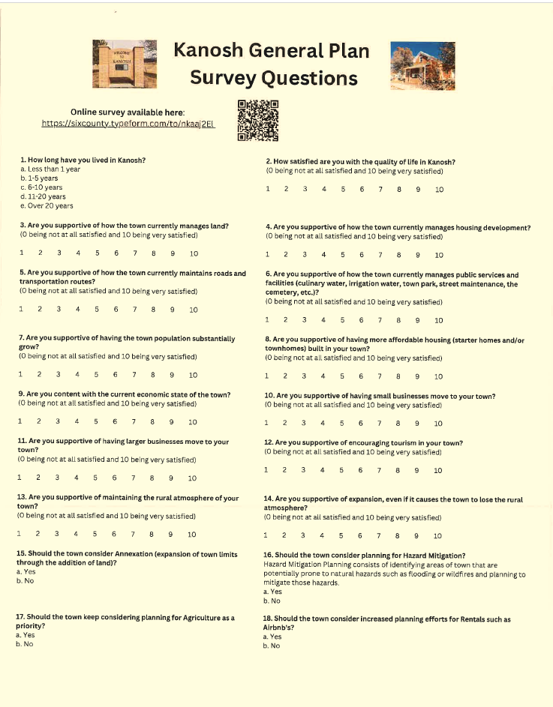
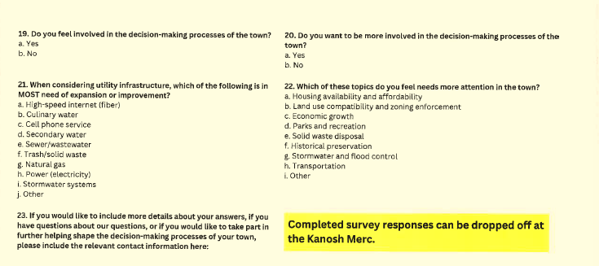

Ending Service with Frontier Communications.
*Kanosh Town Council members agreed to terminate our service through Frontier Communications, this termination of service would save Kanosh Town roughly 3000.00/ year. Kanosh Town has complimentary internet services through Fuller Internet Service.

Action taken from the public meeting:
*Following the public meeting addressing the proposal of a Brush pile, Council members agreed that the proposal was a good one however we are each currently paying to use the site in Fillmore. No action at this time.

Cost of Street signs on the north end of town:
Town employee Lorin Shumway obtained the following cost estimate for: Follow-up next month and confirm the actual number we need.
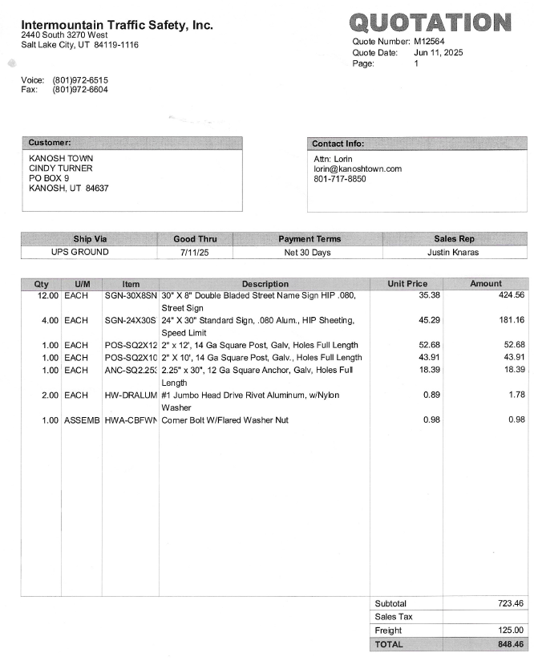

Dixie Power possible sale of powerline north of town.
Councilmember Neil Shumway has been in touch with Brandon Cummings; we all plan to go forward with the sale however we do not have a contract yet. Councilmember Shumway will follow up with Allen from Dixie Power.

Kanosh Town Address Changes:
Adam Britt has created a map of Kanosh, the homeowner of every address highlighted in yellow will be recommended to amend their addresses, the below indicates a rough draft of the letter that will be delivered to each of the highlighted addresses:


Review Electrical Rates and Reset Surcharge Rates based on review.
Following a review of our electrical rates, Councilmember Shumway noted that our six-month average did rise, the first time in a while, only by .01. Our current base rate is .12 residential and .13 commercial with a .02 surcharge. It is through resolution that we change the electrical base rate; the surcharge is reviewed monthly and can be increased or decreased upon review.
Council member Josh Whitaker motioned to increase the surcharge by .02 with the plan to review the rates and surcharge fee again next month Councilmember Neil Shumway seconded the motion, and all Council members in attendance voted in favor as noted below:
Mayor Scott McDonald Aye
Council members:
David Whitaker Aye
Neil Shumway Aye
Josh Whitaker Aye

Vacated road 250 East 200 North
Nothing new to report however we are working on moving forward.

Tier 2 URS Resolution 061125
Councilmember Josh Whitaker motioned to adopt Resolution 061125 Adopting Policy for the Utah Retirement System Participation, Councilmember David Whitaker seconded the motion, and all Council members in attendance voted in favor as noted below:
Mayor Scott McDonald Aye
Council members:
David Whitaker Aye
Neil Shumway Aye
Josh Whitaker Aye

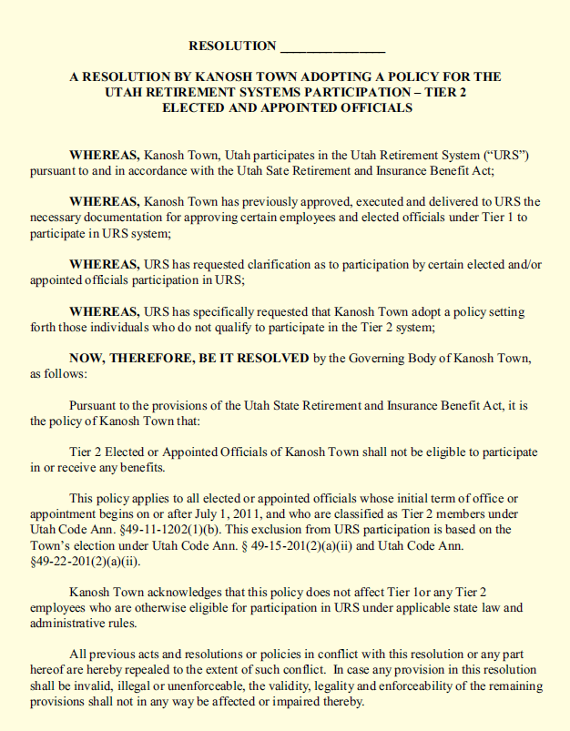
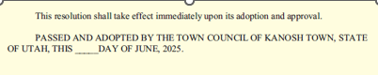

Dam SOP:
Councilmembers Josh Whitaker and Neil Shumway have met with Mr. Stan Koyle to continue working on the SOP. It is felt that the document is continually getting closer to adoption. Councilmember Neil Shumway will go through it with a fine-tooth comb before presenting the document to the council for review.

Proposed Water Rate Increase:

Mayor Scott McDonald presented the following proposed water rate table increase for council review:
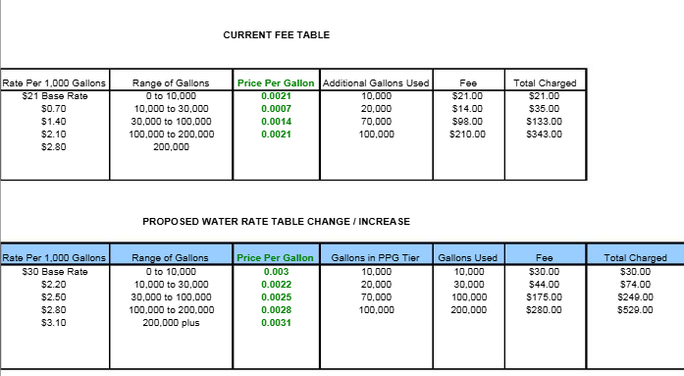

Mayor McDonald also provided the below Base Rate Comparable:
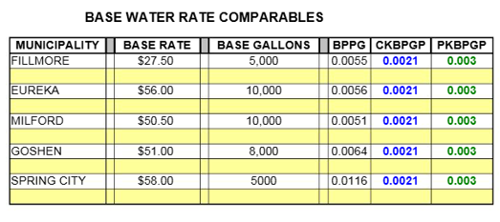

Before the adoption or implementation of a water rate increase, we will hold a Public hearing. In the public hearing, we will gather public input and comments, and there will be more discussion on this before anything happens.

24th of July celebration:
Things are all moving forward. We have the serving tongs, and two additional tables, the Pioneer Run is on track, contact has been made with the band and they are coming, and we even have the parade permit.

Councilmembers will meet at the fire station on the 22nd of July to prepare the meat.

Open the FY 25 budget.
Councilmember Neil Shumway motioned to open the FY25 budget and approve Resolution 061125A, Resolution to balance the 2024-2025 budget, Councilmember Josh Whitaker seconded the motion, and all Council members in attendance voted in favor as noted below:
Mayor Scott McDonald Aye
Council members:
David Whitaker Aye
Neil Shumway Aye
Josh Whitaker Aye

Following a review of the 2025-2026 Fiscal year budget Councilmember Josh Whitaker motioned to adopt the fiscal 24-25 fiscal year budget as amended. Councilmember Neil Shumway provided a second to the motion Council members in attendance voted in favor as noted below:
Mayor Scott McDonald: Aye
Council members:
Neil Shumway Aye
David Whitaker Aye
Josh Whitaker Aye

Departmental reports:
*Parks: the park looks exceptionally good, getting ready for the 24th celebration. The watering is going to be cut back, hopefully not shut off but cut back.
*The cemetery looked extremely good for Memorial Day. The water will be cut back on the cemetery as our water overflow drops.
Roads: Nothing new to report.
*Electric
UAMPS: We have received the forms needed to fill out and send in on the callback power. If we continue with what we have had in the past, we would be at 50 kw. Contact will be made with our UAMPS representative Eric Larsen to make sure 50 kw is adequate.
*Water: we have a certain amount of revenue we need to operate the system, still need to consider depreciation, while trying to put enough money away for future projects. We are continually working on getting Kanosh where we need to be financially. Councilmember David Whitaker will work with Mr. Coray in an effort to see what we need to do, to get closer to where we need to be financially.

Utility Delinquency Review:
Council members reviewed the monthly delinquency list. It was determined, again, to handle those accounts in arrears according to the established Town policy.

Public comment:
No public comments at this time.

Old business
Well project
*Ben Coray of Sunrise Engineering addressed the Councilmembers that the reviews are back from Rural Water and the Division of Drinking Water, on the Well project. Sunrise Engineering is responding to a few small comments that the District Engineer had, we now have their permission to advertise! So we can go ahead and start the process and get ready to go out to bid! We will advertise for about 6 weeks.

CCI Project:
Mayor Scott McDonald will be meeting with Fransen tomorrow to sign the required papers; it is moving forward.

Councilmember Neil Shumway motioned to move into closed session to discuss wages/employee/acquisition of real property Council members voted in favor as noted below through a roll call vote:
Mayor Scott McDonald: Aye
Council members
David Whitaker: Aye
Josh Whitaker: Aye
Neil Shumway: Aye

Council resumed the regular Council meeting at 10:15 p.m.

Action on closed session:
We have had communication with our attorney Justin Wayment, in regard to how to correctly manage the ongoing irrigation company project in a way that lets them get their work done but doesn't put the town in a bad spot.

Proposed pay increases for Kanosh Town Corporation Employees Lorin Shumway and Steven Adams.

Council member David Whitaker motioned in approval of the following hourly pay increases: Lorin Shumway will be increased to $27.50/hr and Steven Adams will be increased to 17.00/hr. Councilmember Josh Whitaker seconded the motion, and all Council members in attendance voted in favor as noted below:
Mayor Scott McDonald Aye
Council members:
David Whitaker Aye
Neil Shumway Abstained
Josh Whitaker Aye

Proposed pay increases for Kanosh Town Corporation-appointed employees.

Council member Neil Shumway motioned in approval of the following monthly pay increases for the appointed employees: Kanosh Town Clerk Cindy Turner will receive a $100.00/ month increase, the Kanosh Town Treasurer DeniAnn Whitaker will receive a $50.00/month increase, and the cemetery sexton Liz Whitaker will receive a $25.00/month increase. Councilmember Josh Whitaker seconded the motion, and all Council members in attendance voted in favor as noted below:
Mayor Scott McDonald Aye
Council members:
David Whitaker Aye
Neil Shumway Aye
Josh Whitaker Aye

There being no further business to come before the board, the meeting adjourned.

Scott McDonald Cindy Turner,
Kanosh Town Mayor Kanosh Town Clerk

