Present: Cynthia Archuleta-online (Sheriff), Lisa Ashman-online (District Attorney), Tyler Andrus-online (Assessor), Talia Butler-online (Public Works), Katy Fleury-online (Mayor Administration), Chris Harding-online (Auditor), Megan Hillyard-online (Administrative Services), Rashelle Hobbs-online (Recorder), Brad Park (Surveyor), Hoa Nguyen-online (Council), Zachary Posner (Information Technology), Robert Sampson-online (Community Services)
Representation Absent: Clerk, Human Services, Treasurer
Staff Present: Tony Jolley-online, Rina Shipley-online, Wendy Ormsby, Andrew Dudley-online, Lee Wilstead-online, Mark Miller-online, Cherie Root, Valina Eckley-online, Jon Thelen-online, Thomas Yeung-online
TOPIC | POINTS OF INTEREST
Welcome & Remote Meeting Instructions | Brad Park opened the meeting.  Cherie Root noted attendance online.  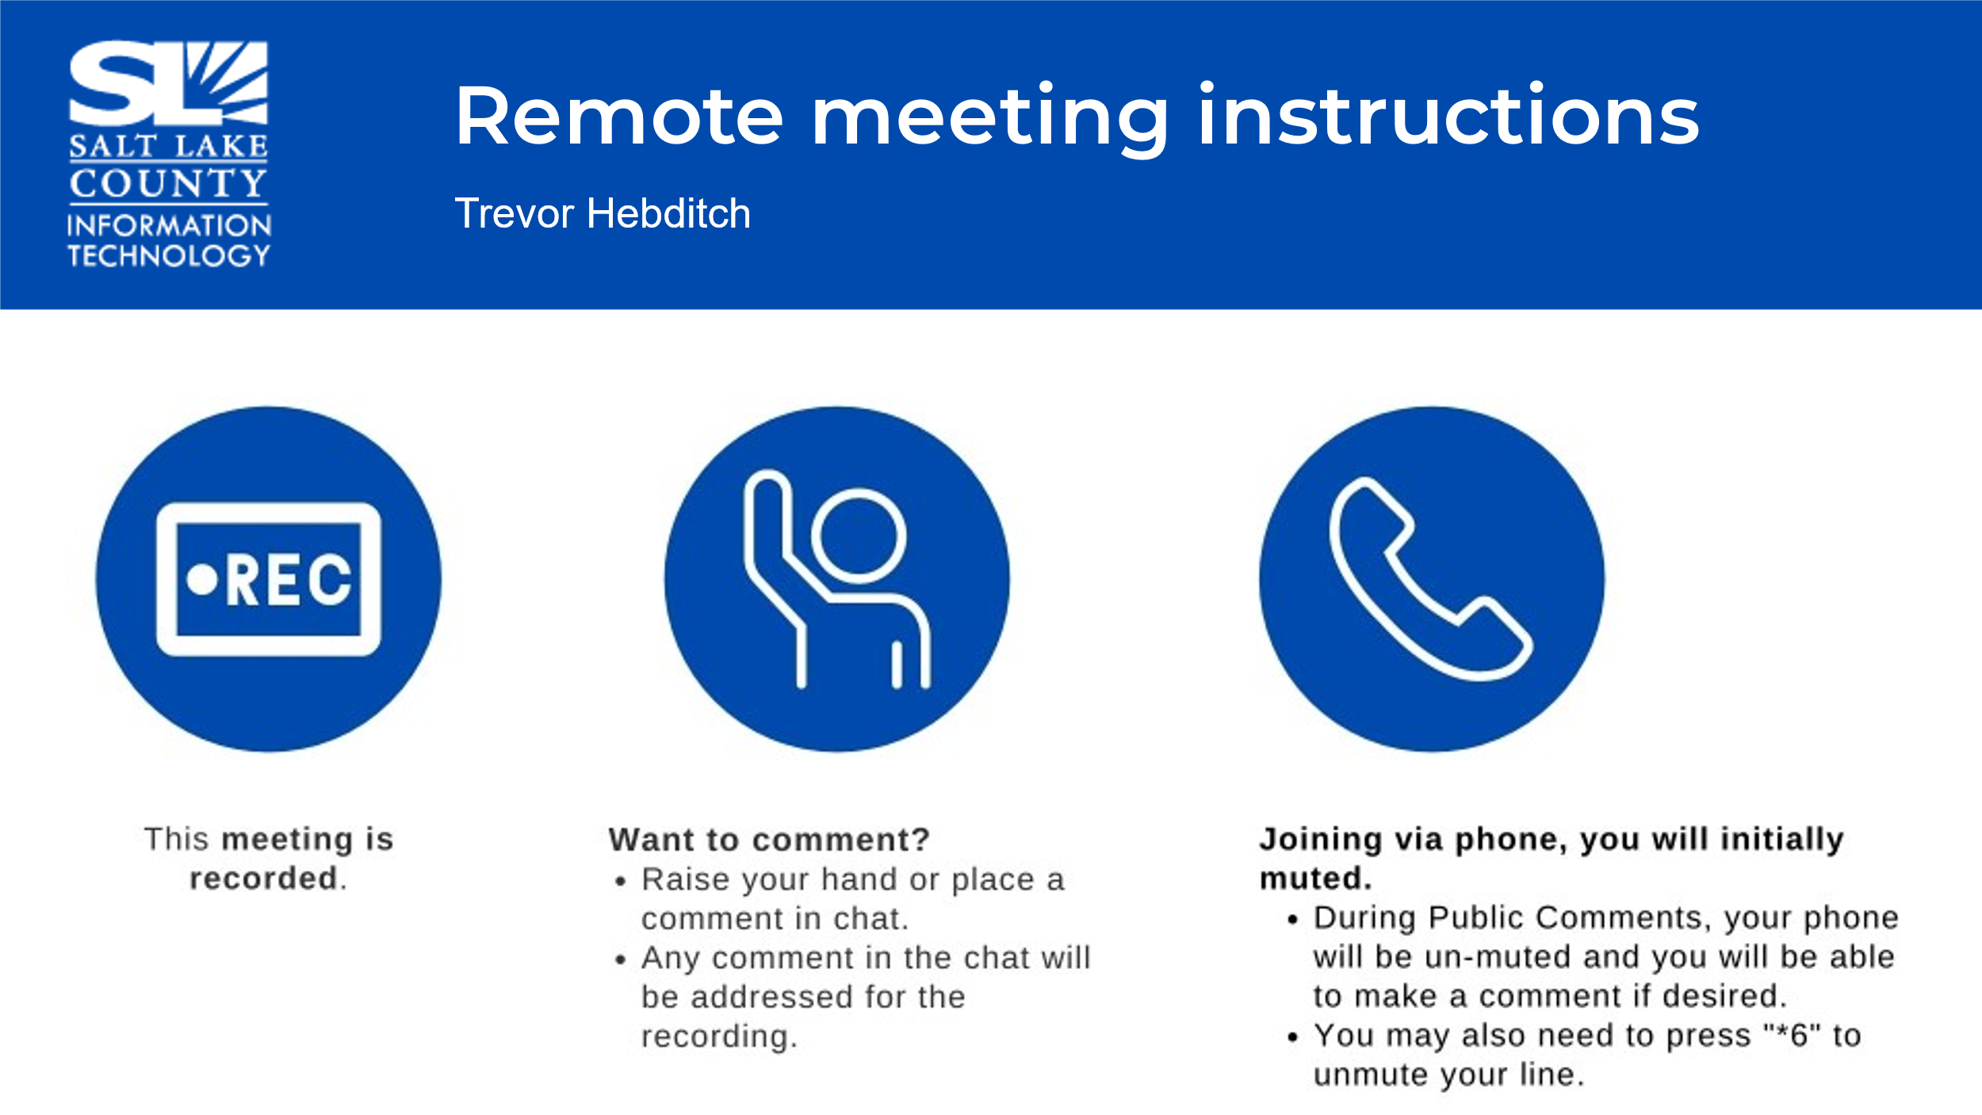
Public Comments  (Brad Park) | No comments.
Approval of minutes from April 24, 2025, meeting | Motion to approve the minutes by Rashelle Hobbs, Megan Hillyard seconds the motion. No discussion.  Motion passed unanimously.
Follow-up Items  (Cherie Root) | 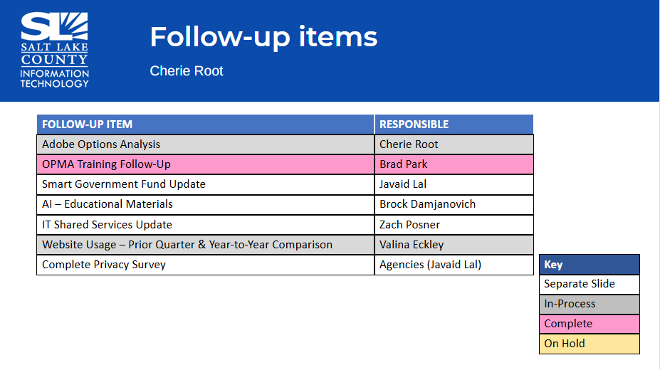
Shared Services  (Zach Posner)  Tech Check-In  (Zach Posner)  Digital Signatures  (Zach Posner) | Kira Moody has been running this, looking for efficiencies and optimizing tech. We’ve discovered we don’t know some of what is being used, and we need to know in order to give good service.  We held a Tech Check-in with the goal of building relationships outside of the IT Division. How to make sure our partners are getting value out of their services. We want to be of service and help departments get the most of their tech platforms and serve the public the best we can.  We have found some weaknesses in our digital signatures related to internal workflow. We are looking for approval, rather than official signatures. We can validate through logs, email, etc…
TAB Working Group Milestones  (Tony Jolley) | 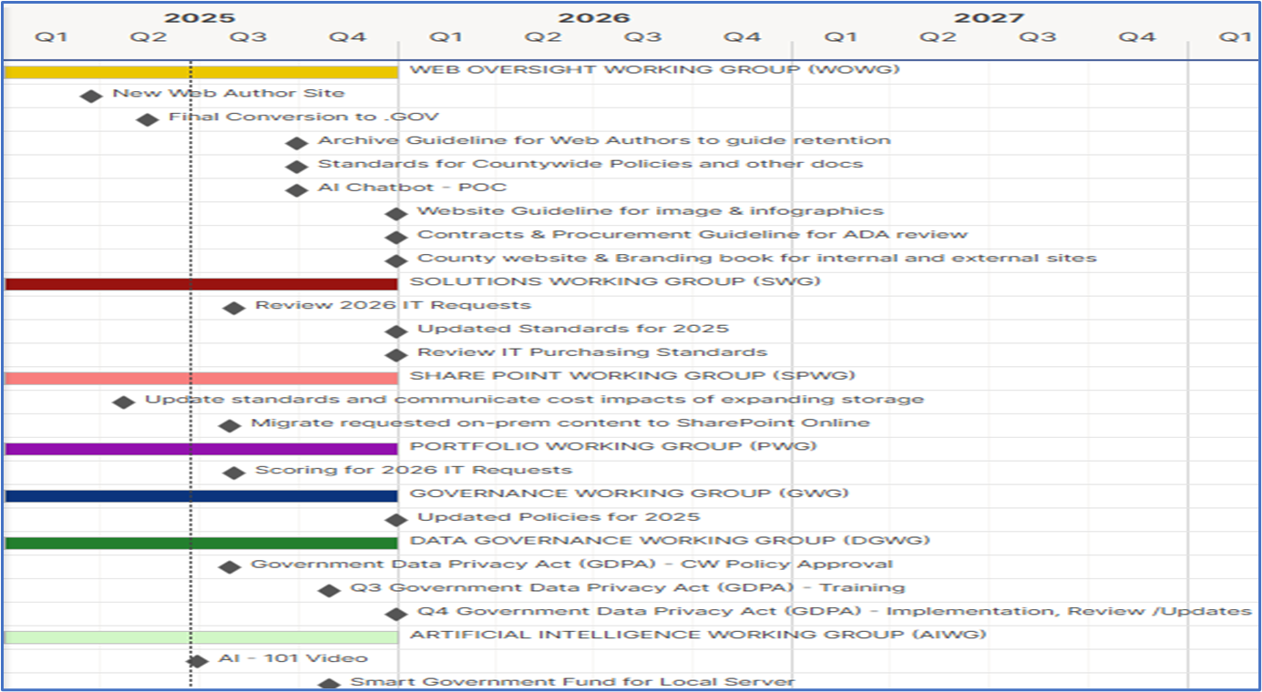
AI Working Group Update  (Brock Damjanovich)  Brock is from the Office of Regional Dev. He was invited to speak in Orlando for a 2025 Social Media Conference.  Megan: People ask me, “How is the County embracing AI?” As a group, consider how to filter up. There is interest in how we use AI efficiently. Two things: this group can submit ways we use AI and how we use it. In the Fall, we should do a spotlight to show the incredible work we are doing related to AI.  Brock: It’s dangerous not to talk about it. Throw me in to talk about it. I’m passionate. |   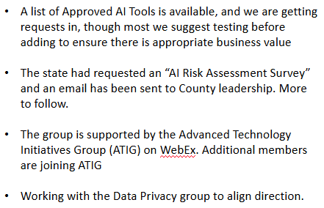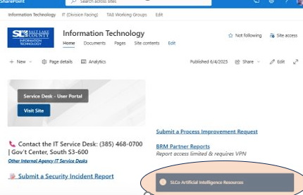
Portfolio Working Group Update  (Lee Wilstead) |   Zoom Grants Replacement RFP: (Highlights) Several depts looking for a better system, more adaptable. Each agency will set up 1 grant application. BTS team will assist. We work with ZAP to migrate Zoom Grants. It’s on track, it’s an exciting new state in grant management.  Jon Thelen: We think the new product can be used in other ways too, not just grants.  Jail Mail Scanning Systems: (Highlights) The jail is trying to stop illegal substances from coming into the jail. Outsourced scanning is expensive and takes time. They found a tool to scan on site. It will allow the scanning to be done at the jail, but the techs are not exposed to ionizing radiation. This protects humans and makes it much easier and less expensive overall to keep the jail safe.  Streamling SOP’s: (Highlights) Mayor’s Finance is looking for a tool to record processes in a more standardized way. This platform watches the steps and auto applies them. Looks interesting. $5000 of Smart Government Fund can pay for it. Mayor’s Finance will own it, but others can request a subscription.
Web Oversight Working Group  (Valine Eckley)  Highlights: We are excited to have “Sally” our county chatbot. As of March 24, 2025 Sally has had 1,112 conversations on the main county site page.  Jotform was the only platform that passed accessibility rating.  Q2 2025 Accomplishments:  - AI Chatbot deployment  - Brand Book in collab. with Mayor’s office. |   SLCo Chatbot Project  On April 15, 2025, a general knowledge AI chatbot was added to two pages of our website. It is on the main County front page and the Search page. ​  ​  We will continue to expand the reach of the chatbot functionality, adding it to more agencies and departments in the future. Animal Services launched their chatbot on May 19th, with the addition of promoting adoptable animals as their chatbot avatars. ​  ​  IT has completed the acquisition of an enterprise-level Jotform account. This should benefit many areas of the County besides the chatbot project. The account offers secure form signing and could potentially be a viable replacement for Adobe Sign. This option will need more research. ​  ​  Jotform may also replace the Typeform account currently used for surveys, saving the County money. There are many other benefits, which we will continue to explore.​  Brandbook: Website stays consistent with the brand book. And, to prevent inaccessibility we are looking to implement a standard so it maintains the highest level of efficacy.
Data Governance Update  (Javaid Lal)  Requesting Motion to Recommend Data Privacy Policy for Council Consideration |   Purpose​  To ensure that County Agencies collect and process personal data in a manner consistent with the Utah Government Data Privacy Act; Utah Code §§ 63A-19-101 et seq (“GDPA”).​  Scope​  This policy applies to all Salt Lake County Agencies, employees and contractors that collect, process or share personal data.​  ​  Policy Statement​  Salt Lake County recognizes that individuals who provide their personal data to the County have a fundamental interest in, and a reasonable expectation of, privacy regarding that information. ​  Motion to recommend the draft Countywide Policy on Personal Data Privacy to Council by Brad Park, Megan Hillyard seconds the motion. No further discussion.  Motion passed unanimously.  Next Steps:  Privacy Program Standard.  Launch Training Program
Smart Government Fund Update  (Javaid Lal)  Highlights: No dumb ideas, we are looking for ways to innovate and better serve the people of SL County. | 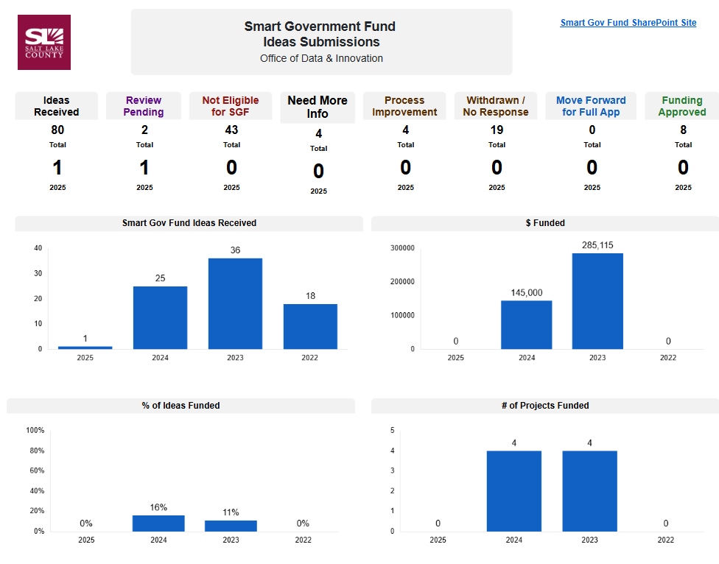  Applications Under Review  - Spanish TOP Star Support – Health ​  - Streamline SOP’s – Mayor’s Finance  New Ideas Received  - Implementation of Online Scheduling for CJS Clients – Criminal Justice Services​  - Salt Lake County Paint Recycle Program – Health ​  - Invoice Data Extraction & Automation (IDEA) – Regional Development​  - Using Generative AI to Improve Services – Information Technology​  - Linking County Assets to Facilities Work Orders (Phase 2) – Facilities Management​
Security Update  (Closed Session) | Motion to enter a closed session to discuss deployment of security personnel, devices, or systems by Rashelle Hobbs, Brad Park seconds the motion. No discussion.  Aye: Administrative Services, Assessor, Auditor, Community Services, District Attorney, Mayor Administration, Public Works, Recorder, Sheriff, Surveyor  Nay: None  Roll Call: (Absent: Clerk, Human Services, Treasurer)  Motion passed unanimously.  Motion to exit the closed session by Brad Park and Rashelle Hobbs, seconded.  Motion passed unanimously.
Other Business?  (TAB Members)  Zach: We are at the end of the .Gov migration. One task and then it is over. There was some hard coded stuff that took some time, but the partners were great.  Security items:  Reminder: DO NOT save passwords in text files, documents, or other non-secure systems. | 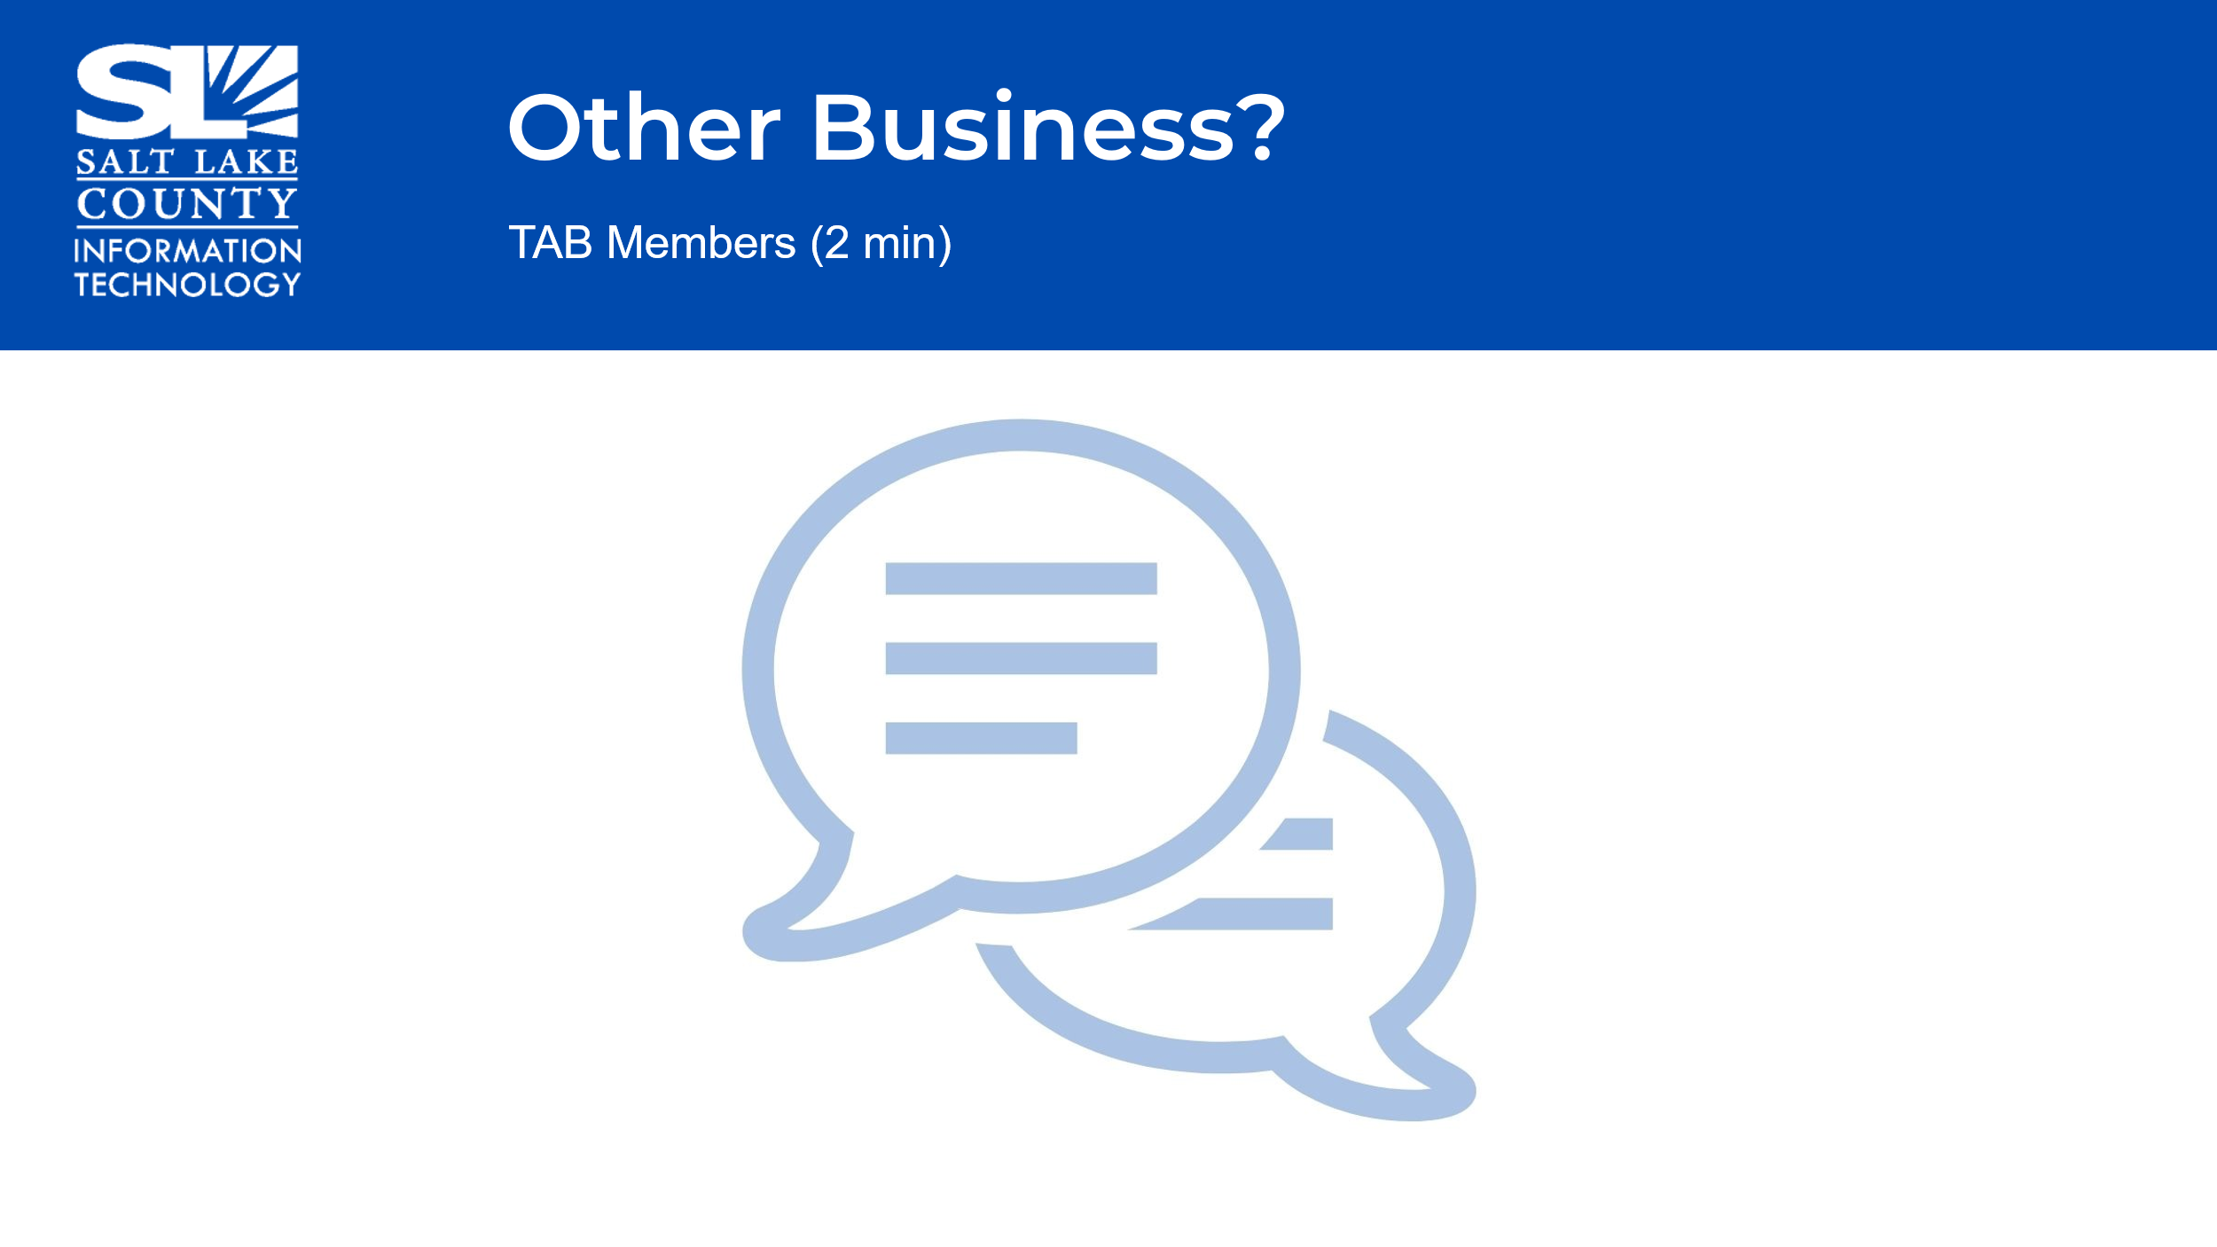
Upcoming Meeting Schedule for 2025  (Wendy Ormsby)  Webex Meeting Invites for TAB 2025 have been sent out.  *Two sessions in August are Combined Sessions with GIS Steering. These sessions focus on budget for the upcoming year. | 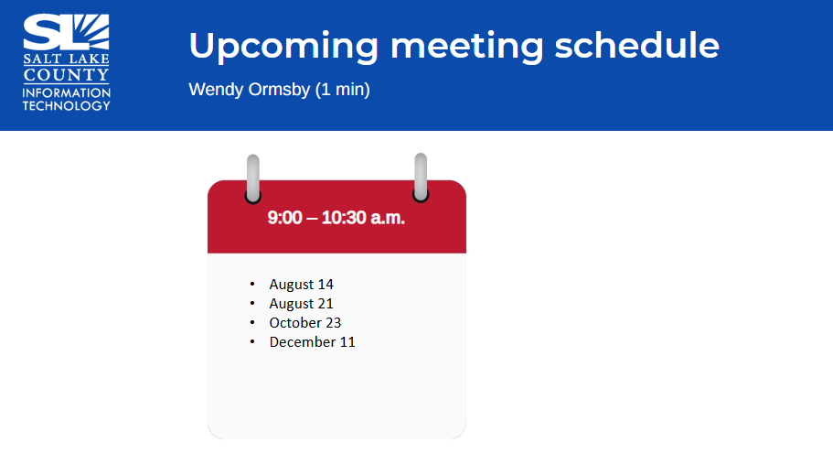
Review Action Items  (Wendy Ormsby)  There are three action items from this meeting  1) Javaid will put the policy on Council’s agenda.  2) Megan requested AI presentations.  3) Valina will request accessibility language to be included in RFPs. | 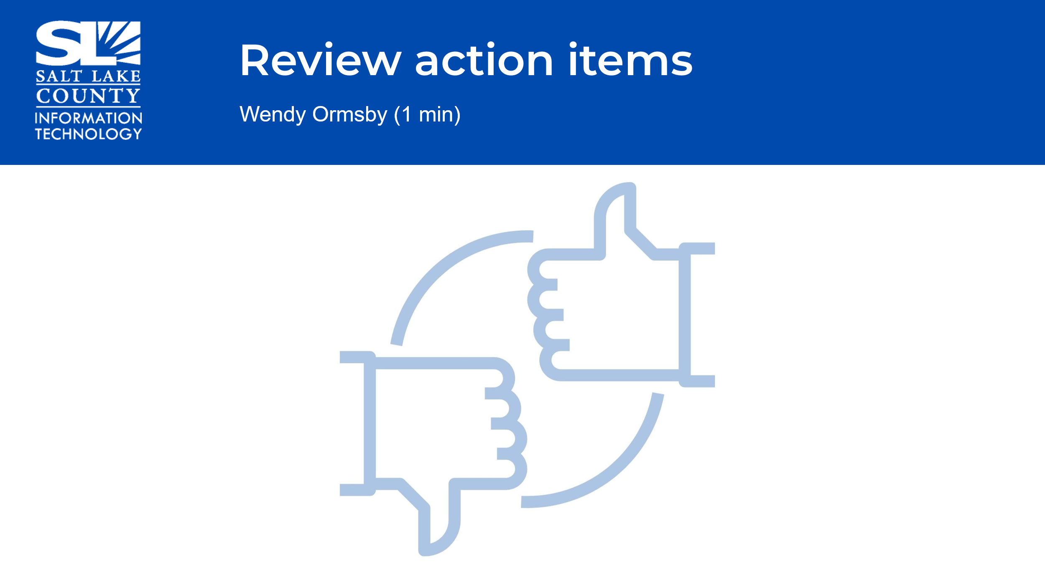
Next TAB meeting:  August 14, 2025. | 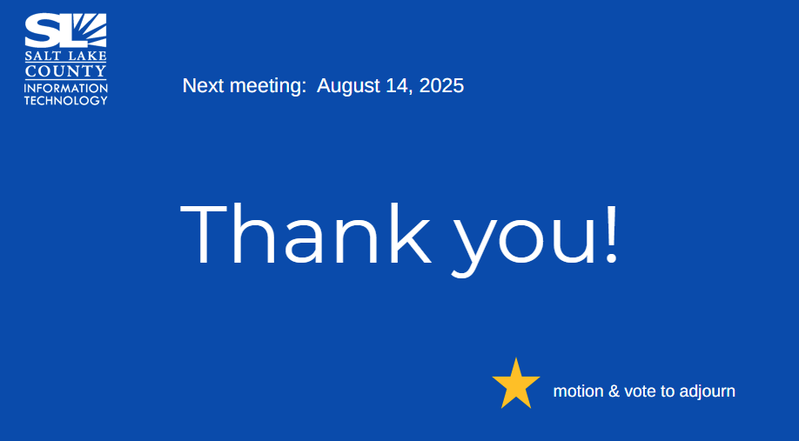
End of Session | Motion to adjourn the meeting by Chris Harding. No objections. Meeting adjourned. So moved.
Submitted by Wendy Ormsby

