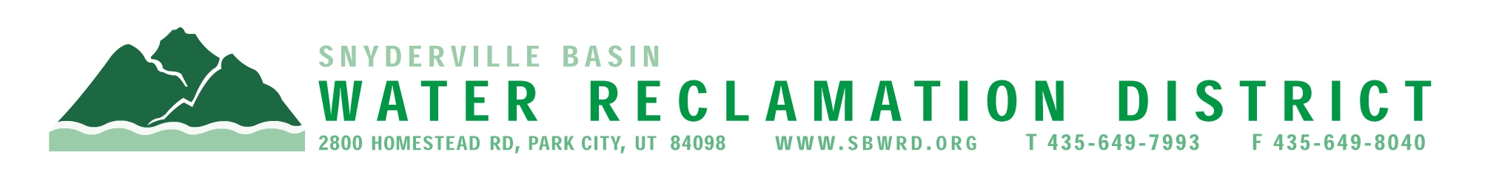
BOARD OF TRUSTEES MEETING

AGENDA

August 18, 2025
** District Office**
5:00 p.m.

** The meeting is open to the public and will also be
conducted electronically using Microsoft Teams**

** For information on how to connect to the meeting, please call 435.649.7993 or email
Dan Olson @ dolson@sbwrd.org by 4:30 p.m. on Monday, August 18, 2025**

I. CALL TO ORDER

II. CONSENT AGENDA – Approval of Board Meeting Minutes for July 21, 2025

III. PUBLIC INPUT

IV. APPROVAL OF EXPENDITURES – Bills in the Amount of $2,087,257.95

V. SUBDIVISION PROJECTS
Estimated LEA REs Year to Date: # Above Splitter 1.3; # ECWRF 23.33; # SCWRF 43; Total 67.33
Proposed this Meeting: # Above Splitter 0; # ECWRF 0; # SCWRF 0; Total 0

VI. DISTRICT MANAGER
- Action Items
  - Consider Approval of Resolution #153 – Consolidated Fee Schedule
  - Consider Approval of Delinquent User Accounts to the Summit
County Treasurer
- Information Items
- Financial Statement
- Impact Fee Report

VII. FUTURE AGENDA ITEMS
- Projects
- Operations
- Finance
- Governmental Matters

VIII. ADJOURN

If you are planning to attend this public meeting and, due to a disability, require reasonable accommodation in understanding, participating in or attending the meeting, please notify the District twenty-four or more hours in advance of the meeting, and we will try to provide whatever assistance may be required. Board members may appear telephonically.

AGENDA NARRATIVE

August 18, 2025

Item: VI.A.2. Authorize Certification of Delinquent User Accounts to the Summit County Treasurer
Discussion: We have a list of delinquent accounts for certification to the Summit County Treasurer. The number of accounts and total amounts due for 2025 are as follows, with prior-year comparisons:

Year No. of Accounts Total Amount Median Amount

2025 168 $ 67,573.80 $308

2024 136 $ 64,289.06 $422
2023 136 $ 55,398.08 $342
2022 178 $ 77,320.96 $226
2021 149 $ 54,136.41 $247
2020 177 $ 66,796.51 $218
2019 162 $ 61,887.65 $318
2018 266 $ 150,250.59 $217
2017 266 $ 105,516.64 $311

The exact number of accounts and total delinquent amount is subject to change up until final Board approval. Customers who make payments after Board approval, but before County Treasurer final lien attachment, will be dropped from this list. Staff makes every effort with customers to reduce the number of delinquent accounts and related balances.

Recommendation: Staff recommends authorization of delinquent accounts to be certified to the Summit County Treasurer.

