Monthly Fire District Report EMS
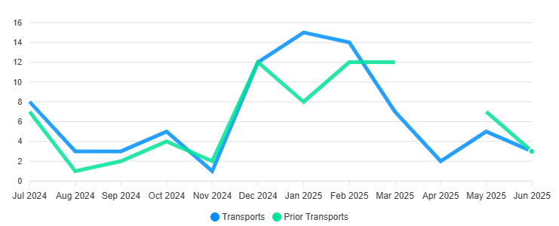
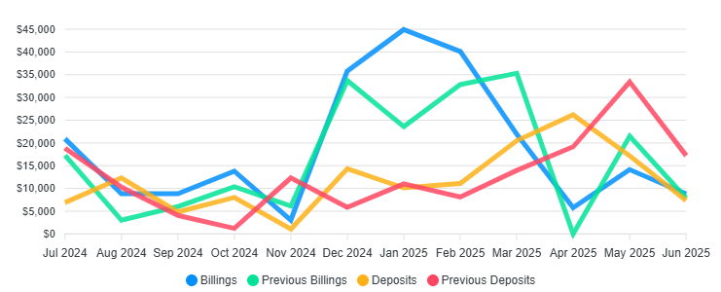

Transports 46 / Billed $135,678.58 / Collected $92,402.28 / YTD

Monthly Calls for Service
ACCIDENT PI 3
ALLERGIC 1
BREATH PRB 1
FIRE ALARM COMM 1
FIRE BRUS DD 1
FIRE INVES DD 2
FIRE SMOKE DD 1
MEDICAL 2
SAR HAZARD 5
SAR RIVER 2
SEIZURES 1
TRAUMA 1
UNCONSCIOUS 1
Grand Total 22

NFFD Trends
3 Year Monthly Call Average /20.3 22 Calls May, Calls year to date 168

Wildland Revenue/Info 2025

Fire 2025 Billed
Prepo Cal/Eaton $134,713.75
Kansas $48,356.89
Texas $73,432.90
Tooele RX (X3) $11,025.00
South Dakota $73,561.92
Southern Cal CNF $97,501.17
Northern Cal $118,041.07
Southern Cal CNF (2) $98,172.32
France Canyon III $64,989.62
France Canyon VI $73,134.08
Utah Task Force 1 III
Utah Task Force 1 VI
Totals(Gross) $792,928.72

Notes of Interest

Architectural plans (Start of 2025)
Structural Firefighter 1-2 Class (Completed)
EMT-A Class (Completed)
S-212 Chain Saw Class (Completed)
Mitigation Fuels State Grant (Approved)

*PARKING PROBLEMS*
NON-EMERGENCY # Utah County Sheriff’s Office: (801) 851-4100
NON-EMERGENCY # UHP Salt Lake/Utah County: (801) 887-3800

