Monthly Fire District Report EMS
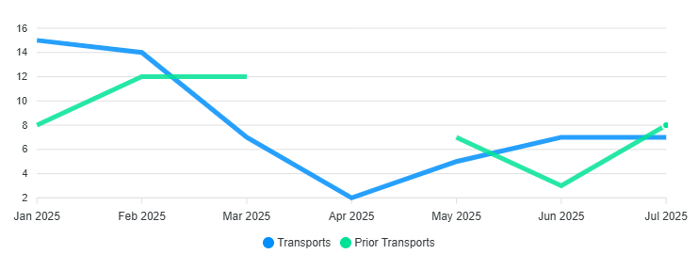
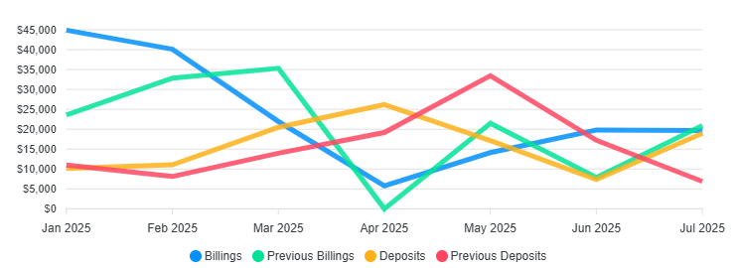

Transports 57 / Billed $166,383.57 / Collected $111,394.34 / YTD

Monthly Calls for Service

ACCIDENT PI 1
CHEST PAIN 1
FALLS 5
FIRE INVEST 1
FIRE OUTSIDE SM 1
HEAT COLD 1
HEMORRHA 1
M Fire Alarm R 1
MEDICAL 2
OVERDOSE 1
SAR HAZARD 10
SAR RIVER CREEK 1
TRAUMA 6
UNCONSCIOUS 1
UNK PROB 1
Grand Total 34
NFFD Trends
3 Year Monthly Call Average /30.3 34 Calls , Calls year to date 208

Wildland Revenue/Info 2025

Fire 2025 Billed

Prepo Cal/Eaton $134,713.75
Kansas $48,356.89
Texas $73,432.90
Tooele RX (X3) $11,025.00
South Dakota $73,561.92
Southern Cal CNF $95,569.55
Northern Cal $118,041.07
Southern Cal CNF (2) $101,875.38
France Canyon III $73,136.14
France Canyon VI $64,273.42
Utah Task Force 1 III $112,893.38
Utah Task Force 1 VI $67,780.70
Monroe Canyon Mar $34,607.08
Utah Task Force 3 III $92,943.04
Utah Task Force 3 VI $62,329.99
Southern Cal PREPO
Beulah Marsella $7,670.87
Beulah E-213

Totals(Gross) $1,172,211.08

Notes of Interest

Architectural plans (Start)
Lexipol policy
Vector Solutions
O.R. Contract

*PARKING PROBLEMS*
NON-EMERGENCY # Utah County Sheriff’s Office: (801) 851-4100
NON-EMERGENCY # UHP Salt Lake/Utah County: (801) 887-3800

