Approved Minutes

Newborn Hearing Screening Advisory Committee

Meeting information:
May 13, 2025

Join Zoom Meeting
https://utah-gov.zoom.us/j/89333301750?pwd=WmJiRHE4YnlKR2kxbU5wM2hySWo0Zz09
Meeting ID: 893 3330 1750
Passcode: Cr!18TxF
or Dial IN: +1 312 626 6799 US
Meeting ID: 893 3330 1750
Passcode: 40288063

Adrienne Johnson | Annette Stewart | Ashleigh Sorenson | Aubri Ogden
Brittany Chandler | Charlene Frail-McGeever | Eliza Hintze | Eric Christensen
Fara Bitter | Jeff Jackson | Jordan Schramm | Karl White
Kevin Baird | Lara Waite | Lauri Nelson | Sally Ormsby
Stephanie Morgan | Taunya Paxton | Taylor Enochson | Todd Huffman
Committee Members Present:

Excused/Absent:
Chris Furner | DeeDee Zaelit | Erin Zinkhan | Jacinda Merrill
Shelby Jimenez

Staff:
Holley Ezzell | Jenny Pedersen | Krysta Badger | Max Sidesinger
Shannon Wnek | Stephanie McVicar

Guests:
Barrett Johnson | Carrie Martinez | Chierstin Luettinger | Dana Gonzalez
Lynette Roper | Úrsula Pérez | Amber - ASL Interpreter | Makenzie - ASL Interpreter

Minutes: Alexis Weight, Secretary

Topic | Discussion
Welcome | Stephanie Morgan opened the meeting at 9:03 am and welcomed the Committee.  Krysta Badger assisted in taking attendance.
Approval of Minutes | The minutes from the February 11th, 2025, meeting were reviewed.  Adrienne Johnson made the motion to approve the minutes as written.  Karl White seconded the motion. The motion passed unanimously.
Public Comment | No public comments
Committee Member Changes | Membership - Open Seats  - Family Physician  - Public Health Nurse  - D/HH Individual  Dr. McVicar stated that there is a person interested in filling the D/HH Individual spot. Her name is Nicole Pilling, and Dr. McVicar reminded the committee of the email Krysta Badger recently sent out, introducing Ms. Pilling and asking the committee members to send their votes electronically by replying yay or nay to Ms. Badger’s email. Dr. McVicar also read Ms. Pilling’s bio to the committee.
0-8 Care Coordination | Carrie Martinez-Wolf, Integrated Services Program Coordinator, introduced Ursula Perez and Dana Gonzalez, the newest Care Coordinators in her program. Ms. Martinez-Wolf then presented on 0-8 Care Coordination services.  Copies of the presentation and program flyers can all be found in this meeting’s notice on the Public Notice Website.  - What does the 0-8 Care Coordination program do?  - Care coordination, assessment, referrals, and educational resources for children  - No cost  - No need to apply – no eligibility  - The 0-8 Care Coordinator will:  - Research for the most appropriate resources  - Provide education and information on  - development  - behavior management  - services  - Provide advocacy and follow-up as needed  - With the client’s permission, the 0-8 Coordinator will loop client information back to:  - The client’s medical home and social service providers  - Childcare agency and providers  - Early care and education providers, and  - Assist the family to apply for additional services  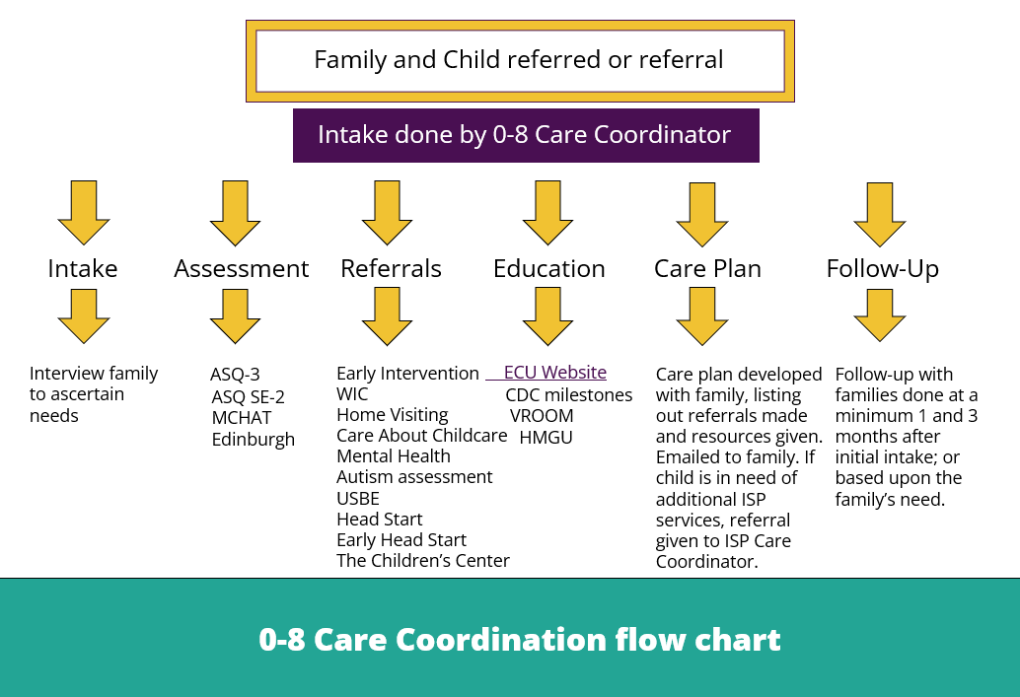  - Referrals  - PDG Grant Participating LHD’s and Internal  - Referral call comes in from Internal programs, families and providers. Intake will establish if the referral is internal ISP 0-8 Care Coordinator or one of the participating Local Health Departments (LHD). If the family lives in the area of one of the participating LHD’s, the family will receive a “Soft Hand-off” to LHD care coordinator for intake and care coordination.  - Non-PDG Grant Participating LHD and External  - Referral call comes in from any external partner which can include Pediatricians and private programs and services and the 6 other non-participating LHDs. Once location of the family is established, the referral will go to either one of the participating 7 LHD’s or the internal ISP 0-8 Care Coordinators for intake and care coordination.  - Referral Information:  - Email care.coordination@utah.gov or call 801-273-2804  - To make a referral simply send basic referral information:  - Name of child, DOB, address, guardian name, phone, email, and basic referral needs  - 0-8 Care Coordination Contact Information  - Program email: care.coordination@utah.gov  - Program phone: 801-273-2804  - 0-8 Care Coordination staff:  - Carrie Martinez-Wolf - 385-271-6728, carriemartinez@utah.gov  - Elma Thomas - 385-454-3265, elmathomas@utah.gov  - Alondra Barragan - 385-271-6086, apbarragan@utah.gov  - Dana Gonzalez - 801-273-2863, danagonzalez@utah.gov  - Úrsula Pérez - 801-273-2852, uperez@utah.gov
Maternal / Mental Health Resources | Chierstin Luettinger, Health Program Specialist Intern, presented on the Utah Women’s and Newborns Quality Collaborative (UWNQC). Copies of the presentation and mental health resources flyer can be found in this meeting’s notice on the Public Notice Website.  - UWNQC is a statewide network of professionals, hospitals, and clinics dedicated to improving the health outcomes for Utah women and babies using evidence-based practice guidelines and quality improvement processes.  - Mission: Save lives in Utah by improving perinatal health outcomes.  - How do we do it?  - Quality improvement, committees/partnerships, community engagement, data, health equity, and education  - Why is this important?  - The U.S. has the highest maternal mortality rate among high-income countries, and it continues to rise  - Perinatal mental health conditions are the leading cause of pregnancy-related deaths  - Affecting as many as 1 in 5 perinatal individuals, maternal mental health conditions are the most common complications of pregnancy and the first year following childbirth  - Why are urgent care centers vital to display mental health resources?  - The rapid growth and frequent use of urgent care clinics help meet the patient where they are  - 2019: 11,481 urgent care centers saw 175 million cases  - 2022: 14,075 urgent care centers saw 206 million cases  - Utah’s behavioral health systems need more focus on prevention, early intervention, and coordinating points of access by better integrating physical and behavioral health  - Utah maternal mental health  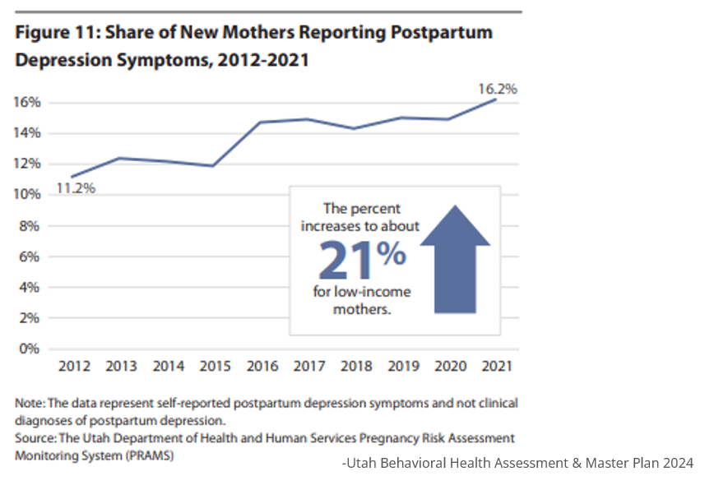  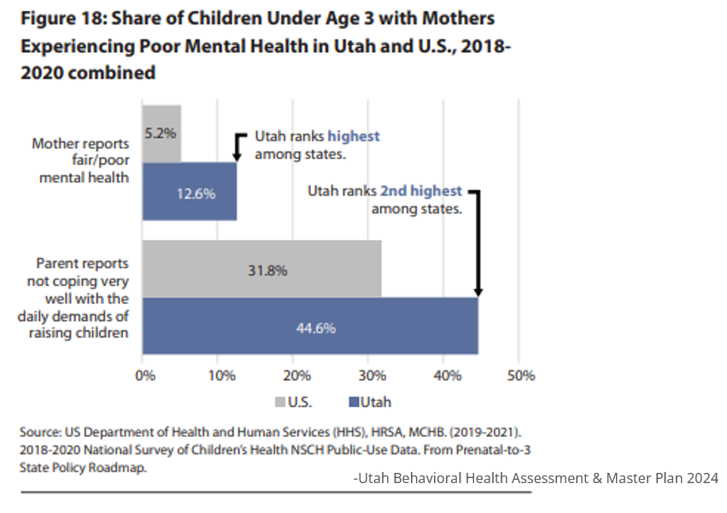  - Symptoms of depression:  - Feelings of anger or irritability  - Appetite and sleep disturbance  - Crying and sadness  - Feelings of guilt, shame, or hopelessness  - Loss of interest, joy, or pleasure in things you used to enjoy  - Possible thoughts of harming yourself  - Symptoms of anxiety:  - Overwhelmed and irritable  - Constant worry and racing thoughts  - Feeling like something bad is going to happen  - Disturbances of sleep and appetite  - Having scary and unwanted thoughts  - Dizziness, hot flashes, and/or nausea  - Possible thoughts of harming yourself  - Mental health can affect all of us  - More than 700 Utahns died by suicide in 2023. This is the second-highest number on record after 2022.  - A 2021 study by the CDC found about 30% of family caregivers experienced serious suicidal ideation in the previous month. The study also found that caregivers of people with chronic health conditions or cognitive complaints were more than 3 times more likely to experience suicidal ideation than non-caregivers.  - Compared to non-healthcare workers, registered nurses are 64% more likely to die by suicide, with an estimated annual suicide rate of 16.0 individuals per 100,000 nurses. (Sep 28, 2023 JAMA)  - Mental Health Resources:  - Crisis Outreach – 988 Suicide and Crisis Lifeline  Call or text 988 or go to 988.utah.gov  - 988 is confidential, free, and available 24/7/365, connecting those experiencing a mental health, substance use, or suicidal crisis with trained crisis counselors  - Utah Maternal Mental Health Referral Network  maternalmentalhealth.utah.gov  - A search engine for providers in Utah who have specific training in perinatal mental health.  - USARA - Utah Support Advocates for Recovery Awareness  utahrecovers.org or call 1-385-210-0320  - Supporting, empowering, advocating for, and celebrating individuals and families in recovery from the effects of substance use disorders.  - Crisis receiving centers - uacnet.org/receiving-centers  - Free immediate in-person access to mental health services for up to 24 hours  - 24/7 community center staffed by therapists, nurses, and peer support counselors to provide treatment for individuals experiencing emotional, mental health or substance use crisis.  - Mobile crisis outreach team (MCOT) – Call 988  - A mobile crisis outreach team (MCOT) is a unit made up of a therapist and a peer support counselor who are deployed to help someone in the middle of a mental health or substance use crisis.  - Arriving in an unmarked car allows individuals to maintain privacy.  - Stabilization and mobile response for children and teens  Call 1-833-723-3326 or 988  - What can a mobile crisis response team do?  - Make sure you and your child or teen are safe right now  - Provide a crisis assessment. This tells you what kind of help your child or family may need  - Create a safety plan in case of another crisis or challenge  - Connect your family to other helpful resources  - Utah Warm Line – When you want to chat for peer support  Call 1-833-SPEAKUT (toll free)  - A listening ear for callers as they process personal struggles.  - Provides connections to others who have been in similar situations.  - Free, available 8 am to 11 pm, 7 days a week  - Behavioral Health Navigation Line – To connect to a therapist  Call 1-833-442-2211  - UWNQC Contact Information  For more information, or to request printed copies of resources:  - Email: uwnqc@utah.gov  - Phone: 801-657-7890  The committee discussed Ms. Luettinger’s presentation.  Topics of discussion included:  - Where to obtain the flyer that lists mental health resources. A copy of the flyer can be found in this meeting’s notice on the Public Notice Website  - Utah’s statistics for mental health and why Utah ranks so low
EHDI* Updates | Dr. McVicar reviewed EHDI updates  - Federal funding  - We successfully submitted application in March for a new 5-year CDC EHDI project.  - Current funding expires June 30th.  - CDC EHDI at the national level experienced the reduction in workforce that occurred on April 1st, 2025.  - Communication from the CDC EHDI team stopped after April 1st.  - Per an email from the Division for Human Development and Disability (DHDD), the review of applications for the project we just applied for is on hold and it’s unclear whether a review of applications will occur.  - Although there is funding through June 30th, there is currently no funding come July 1st.  - Other federal EHDI grant is through HRSA. We received a notice of award at the end of March for a second year of funding for a 5-year project  - HRSA grant is April 1st through March 31st.  - Only funded at 45.5%, due to the federal government’s continuing resolution status. The same thing happened last year.  - We’re hopeful to receive the rest of the funding, just like last year.  - On the local EHDI level  - The state EHDI team has been getting out and across the state doing site visits with hospitals, both in-person and virtually.  - HB 363, regarding the newborn screening law  - Took effect May 7th  - The law changed the retention of dry blood spot. When a heel stick is taken, parents now have to consent to allow extended dry blood spot storage, through 7 years.  - If parents don’t consent or don’t sign, the dry blood spots will automatically be destroyed at 90 days.  - Education must be provided before all three screenings are done.  - Information on universal newborn screenings can be found on The Early Hearing Detection and Intervention (EHDI) Program site.
Parent Consultant Updates | Ms. Sorenson and Ms. Ogden went over parent updates:  - Family contacts  - March: 64 calls  - April: 47 calls  - May: 67 calls  - National EHDI Conference  - Presented: Family Support: Making it Work in Utah!  - Takeaways  - Learning about other State EHDI Programs  - Micro Mentoring: D/HH Youth  - Ambassadors  - Growing Parent Leaders  - Locally/Parent Volunteer Network  - Parent Networking Event  - Parent Panel during lunch  - Active on social media pages (FB and IG: @UtahEHDI) where various information on topics like ASL, listening and spoken language, general D/HH hearing tips, spotlights to young adults and families in the D/HH community, and other resources can be found.  - 2025 Spring Activity  - Co-hosted with PIP  - April 10th at The Museum of Natural Curiosity at Thanksgiving Point  - 223 People in attendance  - Deaf Mentors and D/HH Youth Ambassadors  - SLCC Interpreting Program Volunteers  - For Love and Language Book Donations  - Still on the lookout for deaf youth ambassadors - teens and young adults who would be willing to share their stories, come out to events, and interact with D/HH families.  - Parent Email Newsletter  - April Newsletter  - Sent to parents and professionals  - 803 in English  - 38 in Spanish  - Next newsletter is June  - Newsletters go out at the beginning of every other month  - If you would like to be added to the newsletter mailing list, email: ehdiparents@utah.gov  - 2025 Summer Activities  - Co-hosting with PIP  - 36 Activities for the whole summer  - Meetups, movies at USDB campuses, and field trips  - All across the state  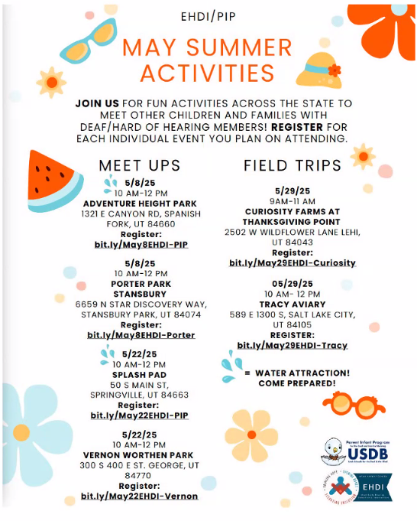
National EHDI Conference | Brittany Chandler, Parent Scholarship recipient, shared her experience as a parent at the National EHDI Conference:  - Introduction  - Parent of 4 children, one of which is deaf and has a cochlear implant  - Conference Evaluation  - Didn’t like  - Not much free time  - Lack of networking use on the event app  - Liked  - Deep-dive sessions  - Variety of applicable topics  - Associated with amazing people who understand  - Love seeing the many ways the conference provided access through captioning, interpreters, etc.  - The powerful plenary sessions  - Sessions Summary – 16 Sessions to choose from  - She had two questions she asked herself to help her decide on which sessions to attend:  1. Which of these sessions best set up my 4-year-old daughter and me for success?  2. As someone who works to support parents of deaf and hard-of-hearing children, which of these sessions best helps me understand the perspective and experience of deaf and hard-of-hearing individuals and their parents?  - The most meaningful sessions helped her understand the perspective of DHH individuals better  - What is sticking with her?  - IDEA Law  - “A child with a disability has a right to a free, appropriate, public education that includes specially designed instruction to meet the child’s unique needs.”  - Advocacy – how to be and advocate as a parent and teach your children to self-advocate  - If she had to summarize the conference in two words, they would be:  - Educational  - Empowering
NCHAM Updates / National EHDI Conference Recap | Dr. Karl White provided NCHAM updates and recapped the National EHDI Conference  - The 2026 National EHDI Conference will take place March 15th–17th, 2026, in Jacksonville, FL  - Dr. White went over the 2025 National EHDI Conference Evaluation Report, which can be found at the following link: ehdiconference.org/includes/2025/EvaluationSummary_EHDI2025.pdf  - NCHAM strives to assist conference attendees with networking opportunities after each conference  - The conference planning committee will meet in June 2025  - Abstract submissions for presentations and posters at the 2026 EHDI Annual Conference will open July 2025  - NCHAM welcomes input from those not on the planning committee. If you have ideas for plenary speakers or instructional sections, contact the committee at ehdiconference.org or Dr. White at karl.white@usu.edu.  - The planning committee has discussed reaching out to organizations and groups who have not been as involved in past conferences. These include, but are not limited to:  - The Regional Acquisition of Language (REAL) Project  - The National Deaf/Blind Center  - The Coalition for Global Hearing Health  - The American Cochlear Implant Alliance  - A lot of uncertainty at the federal level, which will affect the state level  - Dr. White explained how the continuing resolution works.  - Dr. White recommended contacting your congressional representatives as a private citizen if you feel that HRSA and CDC funding is important to the EHDI program.  - The sky hasn’t fallen yet. We ought to be optimistic.  - The Joint Committee on Infant Hearing (JCIH) is organizing now to do another position statement over the next couple of years. There may be some changes in committee structure and membership.  - If you have any issues that you would like to be addressed, you can reach out to Dr. McVicar and she can pass it along to JCIH, as she is the director of Utah’s hearing program, which is one of the groups that is a part of the JCIH.
Future Agenda Items | Ms. Morgan suggested we have an update on funding at a future meeting.  - Dr. McVicar said that guest speaker, Dr. Jeff Jackson, the Medicaid representative, will present at the next committee meeting.  - Ms. Morgan asked Eliza Hintze about a possible restructuring of Baby Watch and asked if she’d like to present on that. Ms. Hintze said she’ll be happy to do a presentation at the next meeting in August.
Next Meeting | August 12, 2025
Adjourn | Karl White made a motion to adjourn the meeting. Charlene Frail-McGeever seconded the motion. The meeting adjourned at 10:43 am.
Minutes Approved | August 12, 2025

Note: These minutes are not intended to be a verbatim transcript but are to record the significant features of the business
conducted in this meeting. Discussed items are not necessarily shown in the chronological order they occurred.

