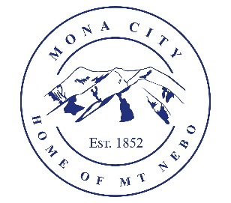
Mona City
435-623-4913
www.monautah.gov
20 West Center Street Mona, Utah

Mona City Council Meeting Agenda
Tuesday, August 12, 2025
Mona City Building – 20 West Center
7:00 p.m.

- Pledge
- Prayer
- Approval of July 8, 2025, City Council Meeting Minutes
- Approval of July 15, 2025, Meet the Candidate Night Minutes
- Action Items:
  - Ordinance 2025-10b: updates to MCC 10-9-3: Lighting Standards – defining requirements for commercial outdoor lighting
  - Resolution 2025-18: Update to Mona City Personnel Policy – updates to Section VII: Benefits & Section IIX-f: clothing allowance
  - Resolution 2025-19: Cable Television Franchise Agreement
- Miscellaneous Items:
  - Sydney Lynn – Run for Life 5K
  - Alex Rugg – Centracom line update
  - Troy Linton – questions on sign ordinance
- Secretary:
  - Building use for 12-step program
- Planning and Zoning
  - Greg & Stephanie Baker – Building Permit – 639 S 200 E
  - MCC 9-3: Sign Regulations
- Director of Finance
  - Approval of Finances
- Recorder
- Gas & Water & Roads
- Sewer
- Council Reports
- Public Comment
- Adjournment

CERTIFICATE OF POSTING
This agenda is hereby properly advertised on this 11th day of August 2025 by posting copies in the following places: the Mona City Office, on the Mona City website at monautah.gov, at the United States Post Office Mona City Branch, and on the Utah Public Notice Website at www.utah.gov/pmn/index.html.

_____________________________________
Alicia Hills, Mona City Recorder
Upon Request, in compliance with the Americans with Disabilities Act, reasonable accommodations for individuals with disabilities will be provided. For assistance, please call 435-623-4913.

