CITY OF OREM
DEVELOPMENT REVIEW COMMITTEE MINUTES
August 4, 2025

The following items are detailed in these minutes:
- Plat Amendment – Raising Canes – 11 West Center Street – Approved
- Plat Amendment – Cascade Vista Plat C – 435 North 850 East – Approved

Place: Aspen Conference Room (Floor 2) – City Hall Building – 56 North State Street, Orem Utah, 84057

11:02 a.m. Jared Hall called the meeting to order.

Those Present: Derek Spencer, Chris Clements, Taylor Taggart, Taggart Bowen, Chelsea Lindsey, Jared Hall, Steve Norman, Randy Bell - DRC Members. Grace Bjarnson – Associate Planner.

Those Excused: Gary McGinn, Aaron McKnight, Rick Sabey, Rebecca Gourley

- Plat Amendment – Raising Canes – 11 West Center Street – Approved
Chris Bick/Kimley Horn applied for a plat amendment to combine the lots located generally at 11 West Center Street. This amendment will allow a site plan for a new Raising Cane’s to continue in review.

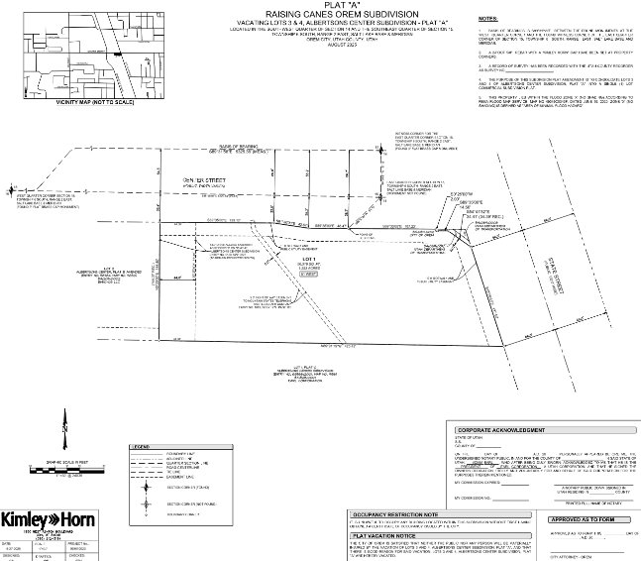

DRC Action: Steve Norman moved to pass the plat amendment for Raising Canes. Chelsea Lindsey seconded the motion. The motion passed unanimously.
Yes: Derek Spencer, Chris Clements, Taylor Taggart, Taggart Bowen, Chelsea Lindsey, Jared Hall, Steve Norman, Randy Bell
No: None

- Plat Amendment – Cascade Vista Plat C – 435 North 850 East – Approved
Cynthia Farnworth applied for a plat amendment to correct lot lines at 438 North 850 East to reflect current ownership.
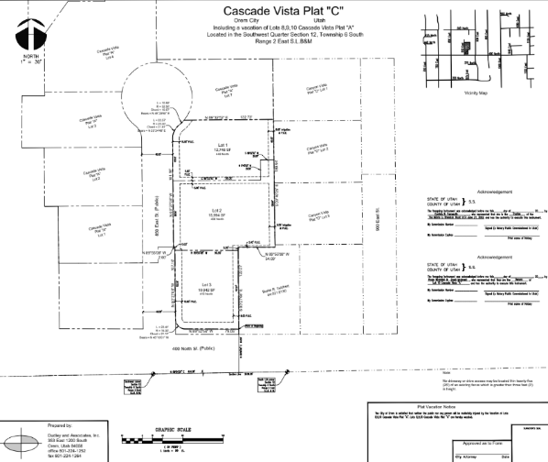

DRC Action: Taylor Taggart moved to pass the plat amendment for Cascade Vista Plat C. Chris Clements seconded the motion. The motion passed unanimously.
Yes: Derek Spencer, Chris Clements, Taylor Taggart, Taggart Bowen, Chelsea Lindsey, Jared Hall, Steve Norman, Randy Bell
No: None

- Minutes: The minutes for the previous meeting on July 21st, 2025, were sent to the committee via email.

DRC Action: Steve Norman moved to approve the minutes. Taggart Bowen seconded the motion. The motion passed unanimously.
Yes: Derek Spencer, Chris Clements, Taylor Taggart, Taggart Bowen, Chelsea Lindsey, Jared Hall, Steve Norman, Randy Bell
No: None

- Adjourn:

DRC Action: Chelsea Lindsey motioned to adjourn; Taylor Taggart seconded the motion.
Yes: Derek Spencer, Chris Clements, Taylor Taggart, Taggart Bowen, Chelsea Lindsey, Jared Hall, Steve Norman, Randy Bell
No: None

Adjourn: 11:08 a.m.
Approved On:

