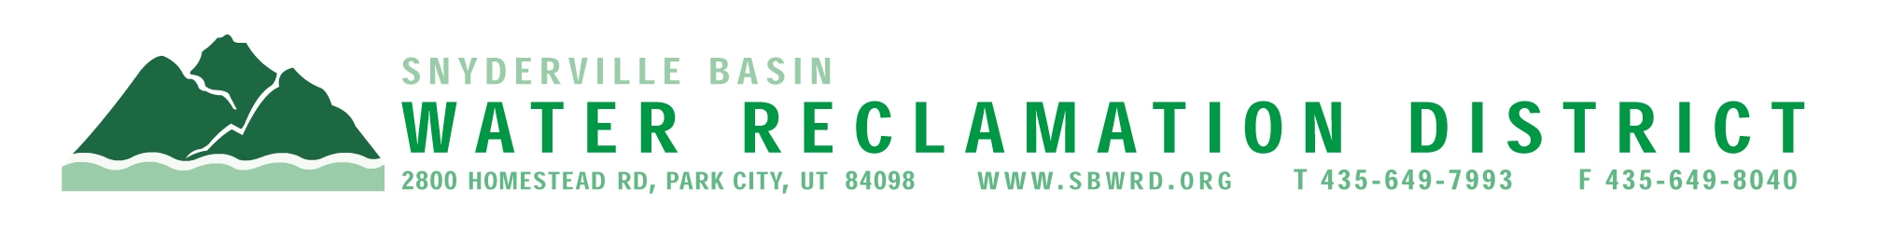

BOARD OF TRUSTEES MEETING

AGENDA

July 21, 2025
** District Office**
5:00 p.m.

** The meeting is open to the public and will also be
conducted electronically using Microsoft Teams**

** For information on how to connect to the meeting, please call 435.649.7993 or email
Dan Olson @ dolson@sbwrd.org by 4:30 p.m. on Monday, July 21, 2025**

I. CALL TO ORDER

II. CONSENT AGENDA – Approval of Board Meeting Minutes for June 23, 2025

III. PUBLIC INPUT

IV. APPROVAL OF EXPENDITURES – Bills in the Amount of $1,068,023.90

V. SERVICE AWARDS – Cody Snyder – 30 years

VI. SUBDIVISION PROJECTS
Estimated LEA REs Year to Date: # Above Splitter 1.3; # ECWRF 23.33; # SCWRF 43; Total 67.63
Proposed this Meeting: # Above Splitter 0; # ECWRF 0; # SCWRF 0; Total 0

VII. DISTRICT MANAGER
- Information Items
- Financial Statement
- Impact Fee Report

VIII. CLOSED SESSION – Discuss pending or reasonably imminent litigation (added to agenda)

IX. FUTURE AGENDA ITEMS
- Projects
- Operations
- Finance
- Governmental Matters

X. ADJOURN

If you are planning to attend this public meeting and, due to a disability, require reasonable accommodation in understanding, participating in or attending the meeting, please notify the District twenty-four or more hours in advance of the meeting, and we will try to provide whatever assistance may be required. Board members may appear telephonically.

