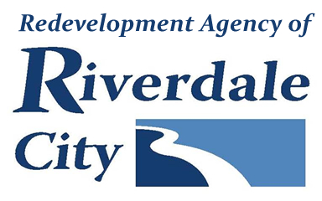
RIVERDALE CITY RDA BOARD
CIVIC CENTER - 4600 S. WEBER RIVER DR.
Tuesday, August 5, 2025

Board Meeting (Time approximate following City Council meeting which starts at 6:00 p.m.)

A. Welcome & Roll Call

B. Public Comment

(This is an opportunity to address the Riverdale Redevelopment Agency regarding your concerns or ideas. Please try to limit your comments to three minutes.)
C. Presentations & Reports

D. Consent Items
1. Consideration to approve meeting minutes from:
July 15, 2025 RDA Board Meeting and Work Session
E. Action Items
1. Discussion and possible action regarding Riverdale Senior Center and senior lunches.

2. Consideration of Resolution #R2025-06 approving a Real Estate Purchase Contract for the purchase of property located at 4600 South 600 West, Riverdale, Utah.

F. Comments
G. Adjournment
________________________________________________________________________________________________In compliance with the Americans with Disabilities Act, persons in need of special accommodation should contact the City Offices (801) 394-5541 X 1232 at least 48 hours in advance of the meeting. The Public is invited to attend RDA Meetings.
Certificate of Posting
The undersigned, duly appointed City Recorder, does hereby certify that the above notice and agenda was posted on this 1st day of August at the following places: 1)the Riverdale City Hall Noticing Board, 2) the Riverdale City Website at http://www.riverdalecity.com/, 3) the Public Notice Website: http://www.utah.gov/pmn/index.html

Michelle Marigoni
Riverdale City Recorder

