NOTICE OF ELECTION CANVASSING AND CERTIFICATION – CITY COUNCIL
August 19, 2025

NOTICE IS HEREBY GIVEN that the City of Fairview, Utah City Council will canvass and certify the 2025 Municipal Primary Election results during its regularly scheduled meeting on August 19th, 2025 at 7:30PM.

Posted and Signed this 4th day of August, 2025

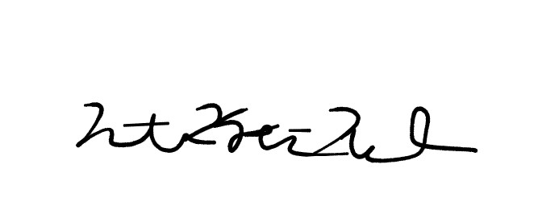

_______________________________
Nathan Kent Nelson, Fairview City Recorder

Please contact the City of Fairview, Utah at Recorder@fairviewcity.com or 435-427-3858 for additional information.

