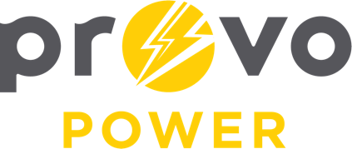
AGENDA
ENERGY BOARD MEETING
PROVO POWER
251 W 800 N
Monday, August 4, 2025
4:00 P.M.

- Welcome & Introductions – Chairman Gary Winterton
- Review & Approval of Minutes – May 5, 2025
- APPA Report – Julie Rash
- APPA Report – Katrice MacKay
- Gillespie and Draper Substations Update – Tad Smallcomb
- Financial Report – Scott Bunker
- KPI Report – Scott Bunker
- Strategic Plan Update – Scott Bunker
- Manager Report – Scott Bunker
- Calendar & Scheduling
  - Next Board Meeting: September 8th, 2025

A copy of the agenda was posted in the Civic Center, and the Provo City Library, on July 30, 2025, and also delivered to the Mayor,
City Council Members, required news media, and adjacent cities in
compliance with the Utah Code 52-4-202

