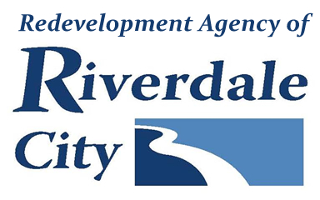

RIVERDALE CITY REDEVELOPMENT AGENCY – TAXING ENTITY COMMITTEE AGENDA
RIVERDALE FIRE DEPARTMENT - 4334 PARKER DR., RIVERDALE, UTAH
MONDAY – AUGUST 4, 2025

3:00 p.m. – Taxing Entity Committee Meeting

A. Welcome & Introductions

B. Consideration of Minutes
1. Consideration of minutes from the April 30, 2025 meeting

C. TEC Board Business
1. Second Review of proposed Amended West Bench RDA Budget

- Consideration and adoption of Resolution TEC 2025-01 approving the Amended West Bench RDA Project Area Budget

D. Other Matters of Business
E. Adjournment

In compliance with the Americans with Disabilities Act, persons in need of special accommodation should contact the City Offices (801) 394-5541 at least 48 hours in advance of the meeting.

Certificate of Posting
The undersigned, duly appointed City Recorder, does hereby certify that the above notice and agenda was posted within the Riverdale City limits on this 1st day of August, 2025 at the following locations: 1) Riverdale City Hall Noticing Board 2) the City website at http://www.riverdalecity.com/ 3) the Public Notice Website: http://www.utah.gov/pmn/index.html.

Michelle Marigoni
Riverdale City Recorder

