DVF SSD Minutes July 17, 2025

- Call to order: 7:00pm by Alan Burns, Chairman. Roll call: Alan Burns, Curt Shelley, Jack Kuntz, Mark Smasal. Absent: Pat Johnson. Pledge led by Jody Truax

- Approval of Agenda: Motion to Approve by Mark Smasal, second by Curt Shelley. Approved.

- Approval of June 19 and June 30, 2025 Meeting Minutes: Motion to Approve by Mark Smasal, second by Jack Kuntz. Approved

- Treasurer’s Report, Curt Shelley, Treasurer: Month ending 30 June 2025, cash basis:
- General fund: $310,768
- Capital Project accounts: $46,060
- Total: $356,828
- Month Receipts (Gen Fund): $212,666
- Month Expenses (Gen Fund) : $160,200
- YTD 2025 Operating Income (All sources): $947,293
- YTD 2025 Operating Expenses: $815,616
- YTD MOU and Grant Income only: $677,404
- 2025 A/R, Fees outstanding: $37,248

- Fire Chief’s Report, Fire Chief Chris Rieffer:
- Training Division under Deputy Chief d’Ambrosio is essential:
- Interns commit to 4 shifts/month. Keeps costs down and provides necessary coverage
- EMT-A 1 class is in last week
- New Fire Academy class starts 1st week of August
- EMT-A 2 class starts 1st week of September
- Cooperation with other districts is ongoing for training

- Deployments: 4 Units of our Firefighters are currently deployed
- Rescue 131 Ambulance: Forsyth fire
- REMS Team: Forsyth fire
- Engine 1351: Forsyth fire
- Engine 1361: White Sage fire
- Deployments earn the revenue to operate the Department
- Invoices YTD to DNR (Department of Natural Resources = $385,179
- Working for 21-day turnaround for payments
- When YTD deployments are invoiced = $765,179
- EMS/Paramedic transport application ongoing
- 171 calls YTD. Current staffing enables full staffing at Fire Station while deployments are ongoing
- Extra staffing on Brush 131 on “red flag” days when danger is high to enable quick response at any emergency or brush fire.
- At current rate of deployments, 2025 revenue goals expected to be achieved/exceeded.
- Fire Marshall position has been activated, Chief Hennessey named. Already functioning. Scope of responsibility will be defined moving forward.
- Grants: applications submitted and in process, including SAFER grant to assist with staffing.
- Forsyth fire: 80 – 85% contained, recent rain has helped, perimeter not expanding.
- Question: Western Fire District? Dead
- Question: How are our deployed firefighters holding up under extended deployments? Holding up well. Crews are/will be rotated.
- Question: Observation(s) on Forsyth Fire?
- A good example of how fast DVFR responded, and coordinated with St George and Washington City fire units, and others.
- It takes days for State, Federal agencies to respond. Initial attack must be done by local Departments.
- Through the Forsyth experience, the framework is set for fast response and coordination with St George, Washington, other departments to attack and contain a similar incident in our area.
- DVFR can deploy and coordinate fast on large incidents, mitigating loss.
- Member of the Month, June 2025: Dein Brush

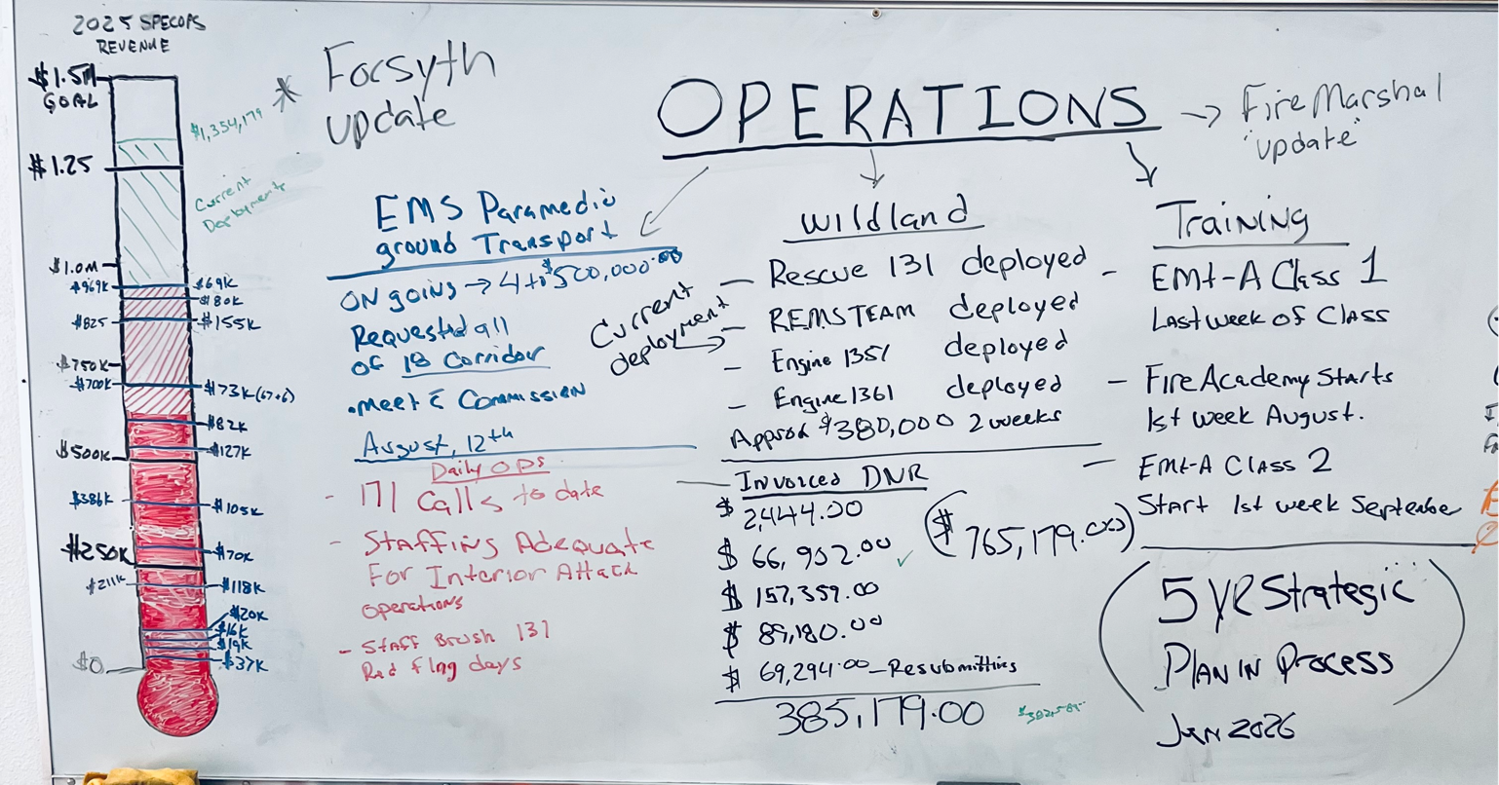

- Update, fuels mitigation, flood channel, Washington County Water Conservancy District, Fire Chief Chris Rieffer: Before/After photos of fuels reduction efforts were shown. Significant removal, clean drainage channel, fire break – very prompt response from WCWCD. Very important to keep flood channels clear! Department can coordinate fuels removal with neighboring properties.

- Discussion and vote, adopt proposed updates to District Policy and Procedure Manual, Mark Smasal, Member: Mark has made a significant effort to update the Policies and Procedures Manual for:
- Training of new Board members
- Updating outdated policies and procedures, and identifying and integrating new ones. There were inconsistencies found that needed to be corrected.
- A consistent format throughout the entire document is needed.
- The updated format can be easily updated and kept current and relevant.
- Mark was complimented on the scope of work and the result.
- Motion to Approve the revised Policies and Procedures manual by Mark Smasal, second Jack Kuntz. Approved.

- Update, transition of bookkeeping services to Affinity HR, Curt Shelley, Treasurer: A long time coming, a lot of work. Update letter sent to all residents. Outgrew CAM’s ability to provide bookkeeping/accounting services. Affinity’s platform based on QuickBooks. Transition appears to be very satisfactory, ongoing. Training time for August for Board members? Yes, essential. Chief Wolfe will set up. 2 “approvers” required to authorize payments, consistent with good accounting and audit procedures.

- Update, Public Information and Outreach Committee, Pat Johnson, Clerk. In Pat’s absence, update by Chief Wolfe: Tri-fold brochure in process.

- Insurability Committee progress report, Curt Shelley, Treasurer: Work ongoing, the Forsyth fire necessitates reevaluation of insurability status, may impact our community. Will be an ongoing process for some time including valuable input from our Community Fire Council. The newly appointed Fire Marshall continues efforts to raise ISO 2 rating to ISO 1, FireWise work hours reporting, fuels mitigation all contribute. DVFR working to minimize losses and maintain insurability at reasonable rates. DNR mapping is outdated, working to update in our favor. New construction must comply with WUI code.

- Public Comment, Alan Burns, Chair
- Guidelines restated by Chairman
- Roger Edington: bracket to mount TV
- Brent Carlon: culvert half-filled with debris, not priority for County
- Drea Markham: budget changes year to year? Questions on other items that are covered in monthly meetings.
- Still awaiting definitive interpretation of HB0048 from WA County

- Adjournment: Motion by Curt Shelley, second Mark Smasal: Adjourned 8:18pm.

