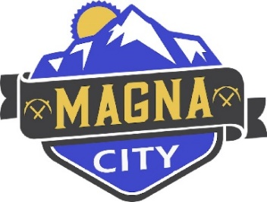
MAGNA CITY COUNCIL SPECIAL MEETING AGENDA
July 30, 2025

Webster Center
8952 West Magna Main Street
Magna, Utah 84044

PUBLIC NOTICE IS HEREBY GIVEN that the Magna City Council will hold a Special Meeting for presentation, discussion, and possible action at 5:00 PM on the 30th day of July 2025 at the Webster Center, 8952 West Magna Main Street Magna, Utah as follows:

** Portions of the meetings may be closed for reasons allowed by statute. Motions relating to any of the items listed below, including final action, may be taken.

5:00 PM – PUBLIC MEETING
- CALL TO ORDER
- DETERMINE QUORUM

- CLOSED SESSIONS AS ALLOWED PURSUANT TO UTAH CODE §52-4-205
  - Discussion of the character, professional competence or physical or mental health of an individual.
  - Strategy sessions to discuss pending or reasonably imminent litigation.
  - Strategy sessions to discuss the purchase, exchange, or lease of real property.
  - Discussion regarding deployment of security personnel, devices, or systems; and
  - Other lawful purposes as listed in Utah Code §52-4-205

- ADJOURN

POSTED: July 29, 2025

