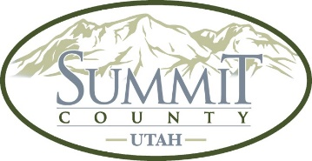

Notice is hereby given that a quorum of the Snyderville Basin Cemetery District may be present

at the closed session of the Summit County Council.

Closed session will be held at Summit County Courthouse, 60 N Main Street,

Coalville, UT 84017,

Wednesday, July 30, 2025, at 3:50 PM

