
Memorandum
To: Planning Commission
From: Dennis L. Marker, City Administrator
Date: October 18, 2024
Re: Rezoning of 79 acres from A-1 to CC and R-2
PUBLIC HEARING ITEM

The Planning Commission discussed this during their June meeting. The purpose of this meeting is to receive public comment about the proposal, discuss any comments received relative to the item, and formulate a recommendation to the City Council on the request.

The Request
Mr. Jim Sanders has filed a rezoning request on behalf of Kirsten Sanders Candland, which acts as Trustee for the subject property (see attached map). The property is currently zoned A-1, which is primarily a single-family residential zone requiring 40-acres per lot. The request is to rezone the southeasternmost 10 acres along Highway 28 to accommodate a professional medical clinic coming to Gunnison, and the remainder of the property would be zoned R-2 for some residential development by a future buyer of the land.

Action Needed
The Planning Commission is required to conduct a public hearing and provide a recommendation to the City Council on all rezoning requests before the City Council can take action on the request. The City Council is the final approving authority for any rezone request.

Background
The Sanders family has been working to sell their property for many years now. The property has a limited access point on Highway 28 (approximately 800 feet north of 300 North) and fronts onto the old county highway (aka. “Indian Road) connecting to 200 West at approximately 400 North. The northern portion of the property has limited development potential without a major investment in water and sewer infrastructure, and grading work through bedrock. The proposed 10-acre medical office site would also need to extend water and sewer facilities through neighboring properties before it can be developed.
Other than the medical office use, the family has not provided a plan for the remainder of the property. The A-1 zone would permit only one residence on the property, while the R-2 zone may facilitate up to 200 single-family homes (3 units/acre) (see Figure 1). The Our Valley Our Vision plan envisions residential development interspersed with green spaces and densities near 4 units per acre (see Figure 2). It must be noted that the Our Valley Our Vision Plan does not include non-residential uses for these properties, but rather encourages non-residential uses to be directed toward historic downtowns or the regional commerical node of 600 South Main Street (See Figure 3).
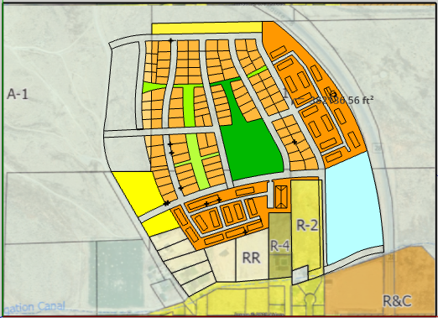
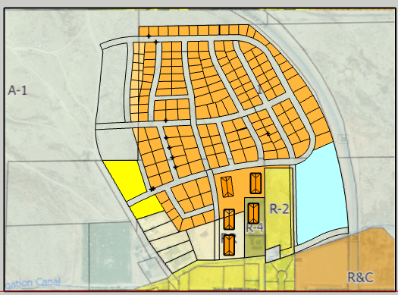
Figure 2: Concept layout for a clustered single-family and townhome development with parks and trails open space, assuming all utilities and right-of-way for roads are available. Also assumes that Trust Lands is a willing partner.
Figure 1: Concept layout for a standard R-2 residential development, assuming all utilities and right-of-way for roads are available. Also assumes that Trust Lands is a willing partner.

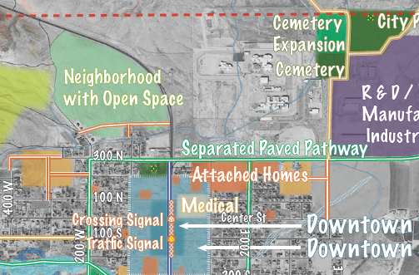

Figure 3: Clip of the Our Valley Our Vision map showing the subject property as "Neighborhood with Open Space" while other areas are marked for Downtown and Medical uses.

Standards of Review
The standards for the Commission to use in reviewing a rezone request are outlined in section 603 of the Land Use Ordinances. Because there is no proposed development plan to go along with the request, it is difficult to ascertain compliance with all the standards:

 | Standard | Proposal Status
1. | The effect of the proposed amendment on the overall well-being of the city. | There is no proposed development plan to determine what affects there might be from the rezone. An additional medical facility in town would be a positive contribution to the community, but there is too much unknown for the rest of the property. The Our Valley Our Vision plan indicates medical uses are to be near downtown, while the subject property would be primarily residential uses with supporting parks and open space amenities.
2. | The effect of the proposed amendment on the public health, welfare, and safety.
3. | The effect of the proposed amendment on the interests of the City, and its residents. | There is no plan for the property, and thus, it is unknown if rezoning will contribute positively to the interests of the city.
4. | The ability of the City, and other service providers, as applicable, to provide all infrastructure, facilities, and services required by the proposed uses and activities allowed by the proposed amendment. | This cannot be determined unless we know what the overall development proposal will be. There is a significant difference between the utilities needed for an A-1 and R-2 development.
5. | Compatibility of the proposed uses, if applicable, with nearby and adjoining properties. | TBD
6. | The suitability of the properties for the uses and activities proposed. | TBD
7. | The effect of the proposed amendment on the existing goals, objectives, and policies of the General Plan, and listing any other revisions to the City’s Land Use Ordinances, and any other Ordinances required to implement the amendment. | The Our Valley Our Vision Plan, which was adopted by the City Council into the General Plan, shows all of the subject properties as Neighborhood with Open Space. A professional office use is not consistent with the anticipated future land use.  The R-2 zone request would allow for densities slightly lower than those of the Our Valley Our Vision plan, but does not provide a regulatory basis to promote nor require open spaces and amenities as contemplated in the General Plan. Applying the R-2 before a development proposal is submitted, and before the city has the regulatory framework to establish open space requirements, may limit the potential of having open space and amenities as contemplated by the General Plan.

Recommended Action
It is recommended that the Planning Commission forward a recommendation to the City Council to DENY the rezoning request based on the following findings:
Findings
- The Planning Commission is responsible for reviewing rezoning requests against the application standards found in Section 603 of the Land Use Ordinance
- The applicant has not submitted development plans sufficient for the Planning Commission to reasonably determine if the standards of Section 603 are or can be met. More specifically,
- how the rezone request will affect the overall well-being of the city,
- the potential effects upon the public health, welfare and safety,
- the potential effects on the interests of the city and its residents,
- the infrastructure and service demands required if development should occur under the requested zones,
- the compatibility of future developments with nearby and adjoining properties, and
- the suitability of the properties for the uses and activities proposed.
- The proposed medical office use on the subject property is not consistent with the preferred future land use of the property as shown in the adopted Our Valley Our Vision plan.
- Applying the R-2 zone to the property before a development proposal is submitted, and before the city has the regulatory framework to establish open space requirements, may limit the potential of having open space and amenities in this area of the city as contemplated by the General Plan.
