Milford City Council Special Meeting
Tuesday, June 26, 2025 8:00 AM
Milford City Hall, 26 South 100 West
Milford, Utah 84751

Members Present: Mayor Nolan Davis, Council Members, Russell Smith, Scott Symond, Les Whitney, and Terry Wiseman.
Absent: Council Member Ian Spaulding entered the executive session at 8:59 AM.
- Follow-up conversations with management regarding employee evaluations
Mayor Davis called the meeting to order at 8:04 AM.
MOTION: Council Member Scott Symond moved to enter into Executive Session for the purpose of discussing personnel. Motion was seconded by Council Member Les Whitney. Roll call votes: Council Member Terry Wiseman – yes, Les Whitney – yes, Scott Symond – yes, Russel Smith – yes. Motion passed unanimously. Council Member Ian Spaulding was not in attendance at this time.

City Recorder Seifers was excused for the closed portion at 8:05 AM.
Council Member Ian Spaulding entered the executive session at 8:59 AM

MOTION: Council Member Russell Smith moved to leave Executive Session and reconvene in an open meeting at 9:41 AM. Motion was seconded by Council Member Terry Wiseman. Roll call votes: Council Member Ian Spaulding – yes, Terry Wiseman – yes, Les Whitney – yes, Scott Symond – yes, Russel Smith – yes. Motion passed unanimously.

- Action on items discussed
- A special meeting will be scheduled for 9 AM July 8 to follow up on the budget and schedule one-on-one meetings with any employees wanting to meet with council.

- Adjournment

Meeting Adjournment ~ as there was no further business the meeting adjourned at 9:43 AM.
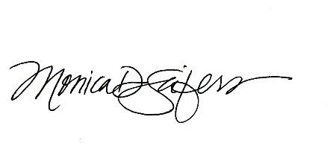
APPROVED by the City Council on the 15th day of July, 2025

MONICA D. SEIFERS, City Recorder

