Milford City Council Special Meeting
Tuesday, July 8, 2025 9:00 AM
Milford City Hall, 26 South 100 West
Milford, Utah 84751

Members Present: Mayor Nolan Davis, Council Members Russell Smith, Scott Symond, Les Whitney, Ian Spaulding, and Terry Wiseman.
Absent: None
Staff: City Recorder Seifers
Call to Order
Mayor Davis called the special meeting to order at 9:12 AM.

Further Discussion on operating budget FY 2025-2026 and city operations and one-on-one sessions with employees.
Mayor Davis called for a motion to enter into an Executive Session for the purpose of discussing employee evaluations and meeting with employees.

MOTION: Council Member Scott Symond moved to close the open meeting and enter into an Executive Session for the purpose of discussing employee evaluations and meeting with employees. The motion was seconded by Council Member Russell Smith. The motion carried with the following votes:
Yes: Russell Smith, Scott Symond, Terry Wiseman, Ian Spaulding
No: None
Absent: None

City Recorder Monica Seifers left the meeting, all members of the legislative body were present.
Monica Seifers met with the council followed by Foreman Stewart.

MOTION: Council Member Scott Symond moved to close the Executive Session and reconvene the special meeting at 11:39 AM. The motion was seconded by Council Member Russell Smith. The motion carried with the following votes:
Yes: Russell Smith, Scott Symond, Terry Wiseman, Les Whitney, Ian Spaulding
No: None
Absent: None

Council Member Ian Spaulding moved after feedback from the foreman of the crew to adjust two of the employees merit percentages based on further information and better calculations and the policy regarding merit raises should be reviewed in the upcoming year. Council Member Les Whitney seconded the motion. Mayor Davis summarized that the council will go ahead and adjust the merit raise and completely re-evaluate the merit raise policy by next year. All were in favor, motion carried.

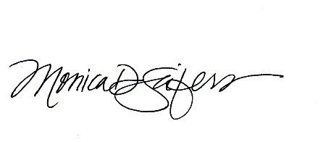
Meeting Adjournment ~ as there was no further business the meeting adjourned at 11:41 AM.
APPROVED by the City Council on the 15th day of July, 2025

MONICA D. SEIFERS, City Recorder

