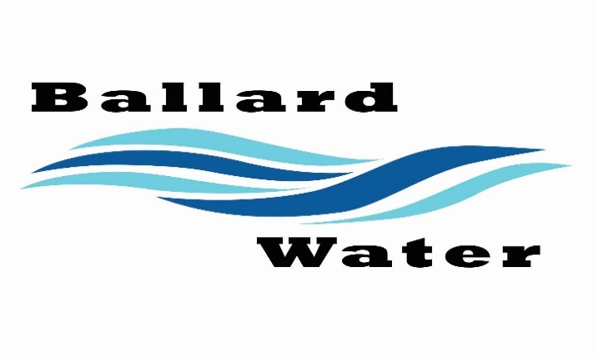

Board Chairman

Mark Reidhead

Board Members

Cory O’Driscoll

Andrew Ercanbrack

Ronny Rich

Jesse Danley

2381 E. 1000 S.

Ballard, UT 84066
Phone: (435) 722-3393
Email: amcdonald@ballardcityut.gov

Water District Work Meeting

June 10, 2025, 5:30 pm

Item

CALL WATER BOARD MEETING TO ORDER

Welcome and Roll Call - Deferred

Prayer – Deferred

Pledge of Allegiance- Deferred

- CONSERVATION RATE –
Chairman Mark Reidhead indicated that Ben Mower has turned on the water to utilize Roosevelt City water. The tribe is in the process of fixing some issues with their line and there have been issues with keeping our tanks at capacity for our residents.
The cost that Roosevelt City is charging us is $2.50 per 1,000 gallons and the bill has gone up drastically. In addition to the utilizing the Roosevelt line, we received a letter from the Tribe that indicated they are looking at raising our rate to the $2.50 that we pay Roosevelt.
We went through our current rate schedule and decided that we should come up with a conservation rate schedule during drought and unexpected times of water issues.
After discussing different scenarios, it was decided that we leave the base rate at the $65.00 rate for the first 5,000 gallons. Then raise the increments as follows.
From $2.10 per 1,000 to $3.50 per 1000 , 8,001 to 12000 gallons
From $3.00 per 1,000 to $4.00 per 1000, 12,000 to 25,000 gallons
$5.00 per 1,000, 25,001 to 50,000 gallons
$7.00 per 1,000, 50,000 and over
Keep the commercial base the same at 102.00 base up to 5,000 gallons.
Then from $2.20 per 1,000 to $3.50 per 1000, 5,001 to 30,000 gallons
$$3.50 per 1,000 to $5.00 per 1000, 30,001 and over
Out of district keep current pricing.
We will present these changes in a Public Hearing on June 24, 2025.

- MORATORIUM ON NEW CONNECTIONS -
There was a discussion regarding putting a 90-day moratorium on new connections until the drought is over. If you have not purchased water for new development, you cannot have water right now. We need to work through the Tribe contract before we sell water.

Meeting was adjourned at 7 p.m.

_________________________________ ____________________
Chairman Mark Reidhead Date

_________________________________ ____________________
Secretary Anissa McDonald Date

Approved Signed Copy filed in the Ballard City Offices

