DRAFT CITY OF OREM
DEVELOPMENT REVIEW COMMITTEE MINUTES
July 14th, 2025

The following items are detailed in these minutes:
- Admin Approval – Crown Castle SLT 125 – Located generally at 1200 S 580 West – Passed
- Admin Approval – Walmart EV Charging Stations – Located generally at 1355 Sandhill Rd – Passed
- Final Plat – Rands Subdivision – Located generally at 470 N 300 West – Passed
- Admin Approval - Centurylink P.092901 – Located generally at 892 S 100 West - Passed
- Minutes for June 30th, 2025, meeting - Approved.

Place: Aspen Conference Room (floor 2) – City Hall Building – 56 North State Street, Orem Utah, 84057

11:01 a.m. Jared Hall called the meeting to order.

Those Present: Aaron McKnight, Jared Hall, Rick Sabey, Steve Norman (Norm), Daren Pead, Daren Spencer - DRC members. Grace Bjarnson, Rebecca Gourley – Associate Planner.

Those Excused: Taggart Bowen, Chelsea Lindsey, Chris Clements, Blake Fenn, Gary McGinn, Mark Kilner, Taylor Taggart

- Admin Approval – Crown Castle SLT 125 – Located generally at 1200 S 580 West – Passed
Jeremy Ives applied to swap 2 existing Ericsson 2203 radios for 2 Ericsson 4435 radio located generally at 1252 W University Parkway in the BP zone. 3-4 hours of traffic control assistance will be needed. All comments during the DRC review have been met. This was in the last DRC meeting where Chris Clements noticed we had used an incorrect address.
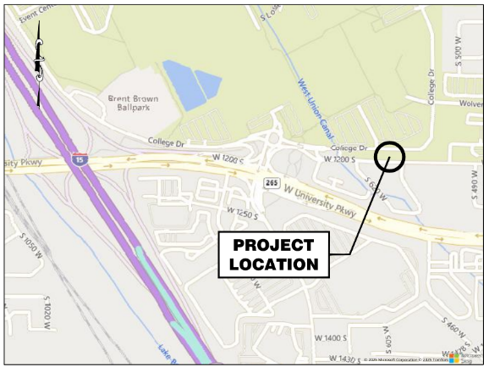

DRC Action: Steve Norman moved to recommend approval of the administrative site plan for Crown Castle SLT 125 located generally at 1200 S 580 West in the BP zone. Dereck Spencer seconded the motion. The motion passed unanimously.
Yes: Aaron McKnight, Jared Hall, Rick Sabey, Steve Norman (Norm), Daren Pead, Daren Spencer
No: None

- Admin Approval – Walmart EV Charging Stations – Located generally at 1355 Sandhill Rd – Passed
Julie Hekking applied to install EV charging stations in the Walmart parking lot located generally at 1355 Sandhill Rd in the HS zone. All comments during the DRC technical review have been met.
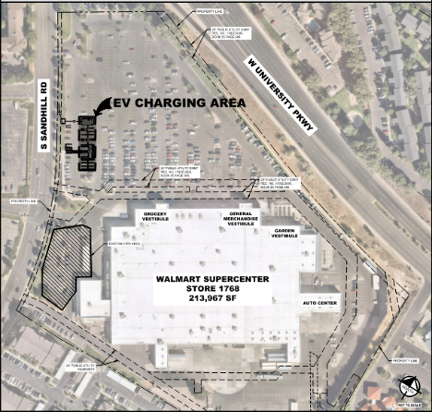

DRC Action: Derek Spencer moved to recommend approval of the administrative site plan for Walmart EV Charging Stations located generally at 1355 Sandhill Rd in the HS zone. Aaron McKnight seconded the motion. The motion passed unanimously.
Yes: Aaron McKnight, Jared Hall, Rick Sabey, Steve Norman (Norm), Daren Pead, Daren Spencer
No: None

- Final Plat – Rands Subdivision – Located generally at 470 N 300 West– Passed
Jeff Rands applied to create a flaglot located generally at 470 N 300 West in the R7.5 zone. All comments during the DRC technical review have been met.

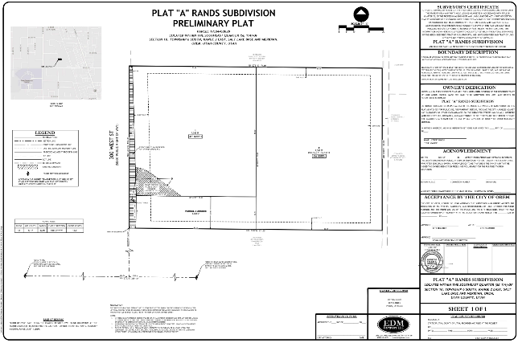
DRC Action: Steve Norman moved to recommend approval of the Final Plat of Rands Subdivision located generally at 470 N 300 West in the R7.5 zone. Rick Sabey seconded the motion. The motion passed unanimously.
Yes: Aaron McKnight, Jared Hall, Rick Sabey, Steve Norman (Norm), Daren Pead, Daren Spencer
No: None

- Admin Approval – CenturyLink P.092901 F2 – Located generally at 892 S 100 West – Passed
Kelsey McKay/Niels Fugal Sons applied to install fiber cable for Centurylink located generally at 892 S 100 West in multiple zones. All comments during the DRC review have been met. Aaron Mcknight asked if we still had a franchise agreement with Centurylink. Jared Hall replied that the city does.

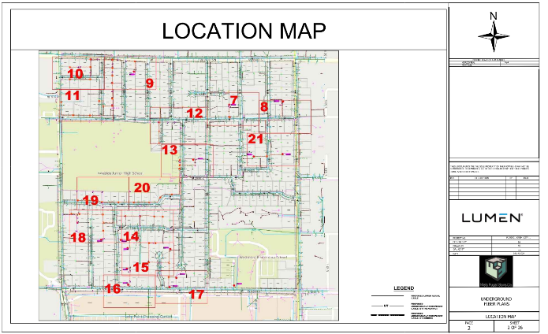

DRC Action: Rick Sabey moved to pass the administrative site plan for Centurylink P.092901 located generally at 892 S 100 West in multiple zones. Steve Norman seconded the motion. The motion passed unanimously.
Yes: Taggart Bowen, Chris Clements, Aaron McKnight, Blake Fenn, Jared Hall, Rick Sabey, Steve Norman (Norm)
No: None

- Minutes: The minutes for the previous meetings on June 30th, 2025, were sent to the committee via email.

DRC Action: Aaron McKnight moved to approve the minutes. Derek Spencer seconded the motion. The motion passed unanimously.
Yes: Taggart Bowen, Chris Clements, Aaron McKnight, Blake Fenn, Jared Hall, Rick Sabey, Steve Norman (Norm)
No: None

- Adjourn:

DRC Action: Rick Sabey motioned to adjourn; Steve Norman seconded the motion.
Yes: Taggart Bowen, Chris Clements, Aaron McKnight, Blake Fenn, Jared Hall, Rick Sabey, Steve Norman (Norm)
No: None

Adjourn: 11:07 a.m.
Approved On: Draft

