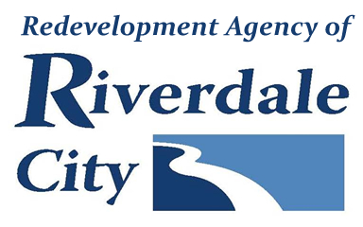
RIVERDALE CITY RDA BOARD
CIVIC CENTER - 4600 S. WEBER RIVER DR.
Tuesday, July 15, 2025

Board Meeting (Time approximate following City Council meeting which starts at 6:00 p.m.)

A. Welcome & Roll Call

B. Public Comment

(This is an opportunity to address the Riverdale Redevelopment Agency regarding your concerns or ideas. Please try to limit your comments to three minutes.)
C. Presentations & Reports

D. Consent Items
1. Consideration to approve meeting minutes from:
June 3, 2025 RDA Board Meeting and Work Session

E. Action Items
1. Consideration of Resolution #R2025-05 approving a Letter of Concurrence and Match Agreement with the Wasatch Front Regional Council.

2. Consideration to adjourn into a closed session pursuant to UCA 52-4-205 (d) and (e), to discuss the sale or purchase of real property.

F. Comments
G. Adjournment
________________________________________________________________________________________________In compliance with the Americans with Disabilities Act, persons in need of special accommodation should contact the City Offices (801) 394-5541 X 1232 at least 48 hours in advance of the meeting. The Public is invited to attend RDA Meetings.
Certificate of Posting
The undersigned, duly appointed City Recorder, does hereby certify that the above notice and agenda was posted on this 11th day of July at the following places: 1)the Riverdale City Hall Noticing Board, 2) the Riverdale City Website at http://www.riverdalecity.com/, 3) the Public Notice Website: http://www.utah.gov/pmn/index.html

Michelle Marigoni
Riverdale City Recorder

