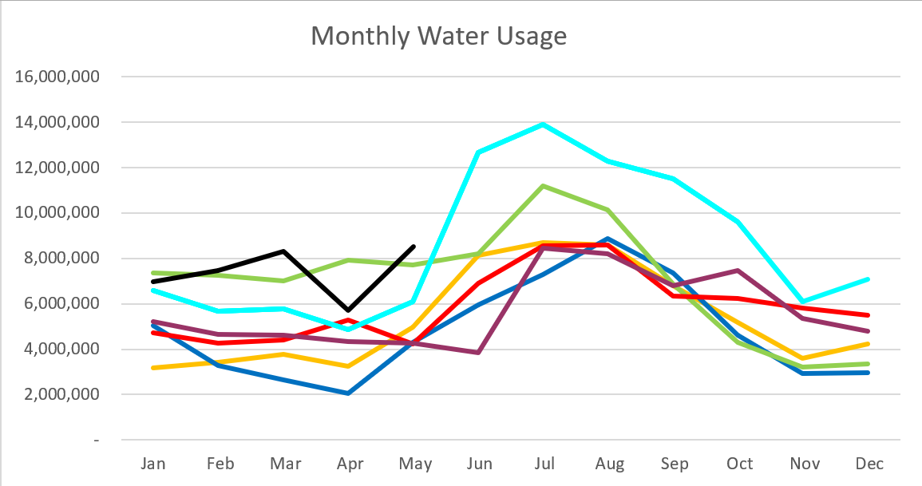
2025 - Black
2024 – Light Blue 2023 – Purple
2022 – Red 2021 – Yellow
2020 – Blue 2019 – Green

May 2025

35%

40%
30%
30%

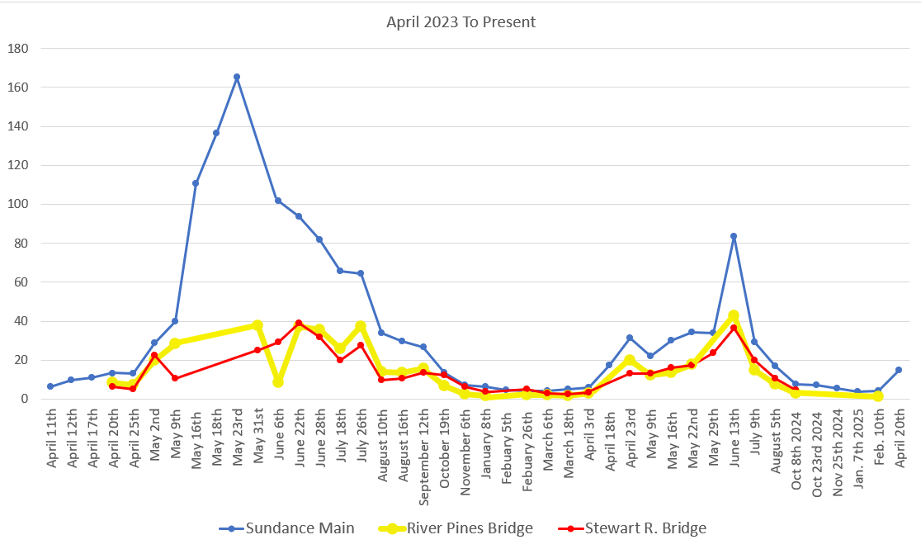
C
F
S

Water Department Information for May
- Our overall water consumption is higher compared to past years.
- Aspen Grove wet-well levels are averaging 8.02 feet for May 2025 which is slightly higher than last month. This time last year, in May 2024, our average was 8.63 feet.
- Stewart Spring is averaging 104 gpm for May 2025, which is higher than last month. This time last year it was averaging 55 gpm for May 2024.
- Stewart spring overflow is running 126 gpm for the month of May which is up from last month. Total, Stewart Spring produced an average of 230 gpm for May.
- Unaccounted water
  - Upper Pressure Zone
    - Still at zero.
  - Lower Pressure Zone
    - We have seen a huge decrease in uncounted water from last month, going from 40% down to 17%.
  - Stewart Zone
    - We do have an increase on this side, put all of our usage also when up. We still have one known leak on this line to address, having to work with homeowners first.
    - Overall, our uncounted water is actually down 5% system wide.
- We have replaced 231 meters so far as of May 10th, 2024. And 213 meters are on cellular endpoints now.
- Aqua Engineering is working on the design of the Drinking water treatment facility.
- We have a CMGC out to bid for the water treatment facility.
- Aqua is working on master meters and updating the master plan.
- We fixed a leaking Hydrant on Children's Road. While fixing it we located 2 buried valves.
- We are working with the homeowners on Stewart Road to see if we can have them connect to the new high-pressure line and abandon the main line with a water leak.
- We have been working on a water conservation plan to submit to the State.
Wastewater Department Information for May
- We have one lab for May, all were within limits.
- One of two the EQ mixing pump went out and we have one on order for replacement. We are looking into other mixing options.
- Finalizing the asset document for the DEQ loan.
- Lift station cleaning was completed while Sundance was shut down.
- Constuction:
  - All non-essential supplies from the plant are now at Aline Storage.
  - They are getting close to having the excavation complete.
- Still getting pricing on:
  - HVAC system
  - Possible secondary sludge press

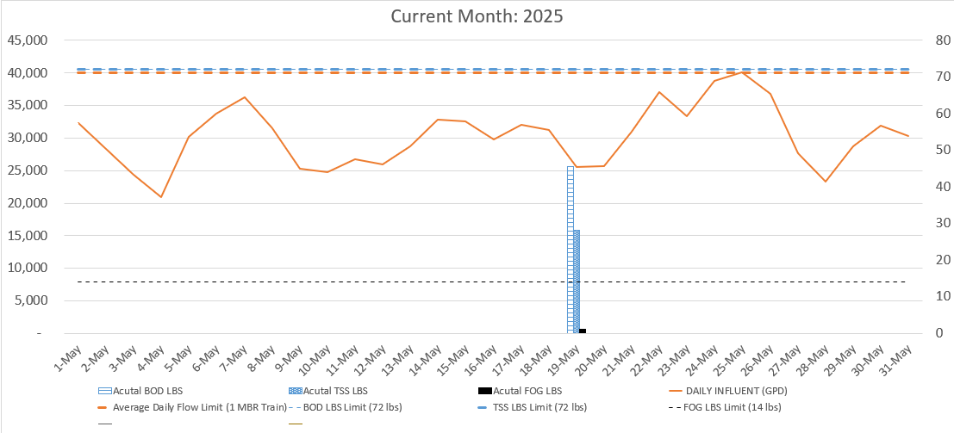

AVERAGE DAILY FLOW (GPD) | 30,253
HIGHEST DAILY FLOW (GPD) | 40,167

