DVF SSD Minutes 19 June 2025

1. Call to order: 7:00pm by Alan Burns, Chairman. Roll Call: Curt Shelley, Alan Burns, Pat Johnson, Mark Smasal, Jack Kuntz. Pledge: Jeff Truax

2. Approval of Agenda: Motion: Curt Shelley, second Pat Johnson, Approved
3. Approval of May 15, 2025 Meeting Minutes: Motion: Mark Smasal, second Curt Shelley, Approved

4. Treasurer’s Report, 31 May 2025: Curt Shelley, Treasurer: see attached

5. Fire Chief’s Report, Fire Chief Chris Rieffer: The Chief’s report this month was wide-ranging and comprehensive. The whiteboard was Chief Rieffer’s primary reference during this month’s report, and a photo of it is attached:

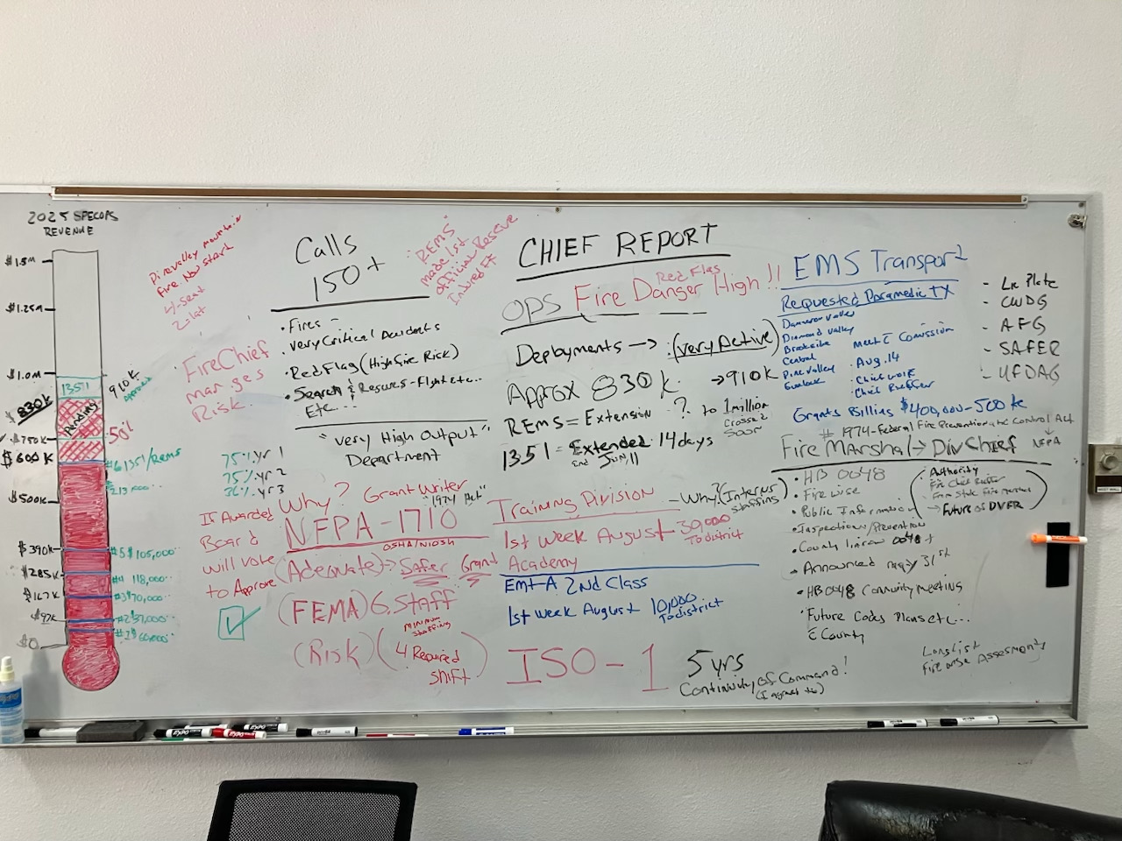

In addition to a lively description of the whiteboard highlights, the following are noted:
- Application for a SAFER grant has been submitted. This is important for staffing. Grant assistance is provided over a 3-year period. Status will be updated.
- Fire danger is HIGH
- Ryan d’ Ambrosio has been functioning as the Hwy 18 corridor Incident Commander. He is able to do this because of his proven experience, radio comm capabilities with multiple agencies, ability to call in other departments and air assets in the event of a large event.
- Ongoing coordination with Diamond Valley Fire in EMS training academies allows classes to run concurrently
- Of the 150+ incidents this year, there have been 6 structure fires, with DVFR providing aggressive interior attack as needed.
- At the recent Pinion Hills structure fire, Chief d’Ambrosio was at the scene within 2 minutes. Multiple assets deployed, aggressive tactics contained the fire to the structure and prevented it from spreading to other properties.

6. Presentation, discussion, and vote, Canopy Employee Assistance Program (EAP) Administrative Asst. Chief Wolfe: State regulations now being enforced require all Departments (including volunteer) to provide counseling to firefighters, and in some case past firefighters and family members. The current arrangement with S&S Counseling is not satisfactory, and could be potentially costly. The Canopy program costs $7 per month/employee with $400 monthly minimum. Can be implemented by 1 August 2025. Motion to approve by Pat Johnson, second by Curt Shelley. Approved.

7. Discussion and Resolution vote, R-2025-0619 establishment of Fire Marshal: Due to the dynamic nature of emergency services in Dammeron Valley and the Highway 18 corridor, and to position DVFR to have influential input into future decision and policymaking, the timetable to appoint a Fire Marshall is accelerated and it is now timely. It will not initially be a paid position, but may as the scope of the responsibility evolves. Motion to authorize Chief Reiffer to appoint a Fire Marshall: Motion by Curt Shelley, second by Mark Smasal: Passed.

8. Update, transition of bookkeeping services to Affinity HR, Curt Shelley, Treasurer:
a. The transition from CAM to Affinity HR is proceeding and should be effective 1 July 2025. The transition has been a major undertaking. Thanks to Curt Shelley for his continuing efforts to move this through.
b. New bank accounts at Zions First National Bank have been set up to expedite deposits of checks and payments.
c. A QuickBooks link for visibility of transactions by Board members has been set up. Initial login assistance is available from Hunter Wolfe.
d. Alan Burns suggested a working meeting to familiarize Board members with new systems, controls, and access.
9. Update, Public Information and Outreach Committee, Pat Johnson, Clerk/Records Officer: deferred to Hunter Wolfe: Work continues, scope of the initial tri-fold brochure may change due to current and unfolding events. It is important to get accurate information out to residents and neighbors. A comprehensive booklet will be available mid-2026, to allow capture of all relevant 2025 data.

10. Insurability Committee progress report, Curt Shelley, Treasurer:
a. “Fire Season never ends” could be the new phrase
b. The current status of wildland fires, Firewise, the new Fire Marshall, and HB0048 all impact current and future insurability
c. Utah has the 5th lowest insurance rates, but ranks #2 for new builds in high risk areas. These trends will be monitored.
d. Work of the Insurability Committee is ongoing and of critical importance to future insurability at affordable costs.

11. Public Comment, Alan Burns, Chair
a. Denise Truax: Status of Ready/Set/Go. Pinion Hills HOA restrictions on tree removal.
b. Jody Truax: Where can homeowners go to get current information, Chief Hennessey. Chief Rieffer noted we have “continuous and uninterrupted fire suppression”.
c. Brent Carlon: insurance cancelled because of high risk, but an alternative found. During Pinion Hills incident, access to hydrant was a concern, but didn’t impede for very long. Chief Rieffer will be contacting Dammeron Valley Water Works. Consolidation of districts – no longer a consideration.
d. Trish Sheffield: explanation of codes and acronyms used: Pat Johnson will provide Chief Hennessey’s list to her.

12. Adjournment: 8:47pm Motion: Pat Johnson, second Mark Smasal.

