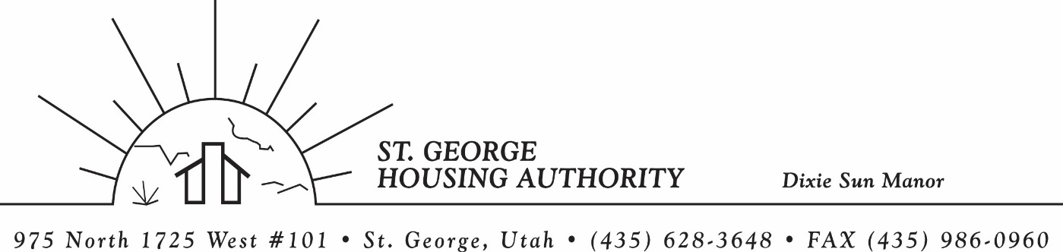
BOARD MEETING
DIXIE SUN MANOR 975 N. 1725 W. # 101
Tuesday May 13, 2024

PRESENT: Mike Barben, Kenny Miller, Greg Whitehead, Tom Cover, Jane Fehrenbacher, Jimmie Hughes, Gloria Shakespeare.

EXCUSED: Tom Cover

MINUTES: Minutes of Board Meeting held April 8, 2024 were reviewed. Motion made by Gloria Shakespeare to approve minutes as reviewed, motion seconded by Kenny Miller. Motion carried.

Review Housing Assistance Report for May 2025: Mike Barben handed out the HAP reports for May 2025. Board members were able to see the money spent for the months on rental assistance, see the average unit cost, and verify the units leased for the month. The board was also able to ask questions and have a discussion about portability, C of C, VASH, EHV, & Mainstream Vouchers. Each board member present signed off on the HAP payments and month end totals.

Review current 2024-2025 budget: Mike Barben handed the board a copy of the fiscal year 2024-2025 SGHA budget. The board was able to see how the SGHA is doing in the current fiscal year budget. Mike reported that for the most part, SGHA was right on budget, and let the board ask questions on any of the items on the report. The board has asked Mike to provide and present the most recent budget accounts at each board meeting. By providing the current budget monthly, the board can see how the SGHA is keeping up with the current budget throughout the whole year. The board thought it would be great to ask questions and be on top of what the SGHA is doing financially. Greg Whitehead asked Mike if he could break the budget down into separate programs to verify which programs are doing well and which ones are needing help.

Utah NAHRO Conference: Gloria Shakespeare reported that the Utah NAHRO conference was held April 15th-17th in St. George, Utah at the Marriott hotel. Gloria shared some of the things she learned at the conference with the rest of the board. The main topic Gloria shared about was AI (Artificial Intelligence). Gloria shared that most businesses are moving to AI and that we needed to be aware of the change and make sure we are on board. Gloria shared a statistic that 30% of the businesses right now will be out of business by 2045 because of AI. The board agreed with Gloria and a great conversation occurred. Mike encouraged all board members to attend next spring’s NAHRO Conference.

Discuss and approve 2025-2026 SGHA Budget: Mike reported that he had sent each board member a copy of the new 2025-2026 budget to review before the board meeting. Mike also handed each board member a copy of the budget for today’s discussion. The board had some great suggestions on a few things to change on the budget. Here were the suggested changes to the budget. 1. Increase the office rent from $600 a month to what is fair market value for 2000 square office space. Greg Whitehead made a motion for this change. Gloria Shakespeare seconded the motion. Motion carried. 2. Decrease the percentage Duplex pays for SGHA employees to 1%, and 3. Increase Executive Director pay 9%. 4. Other items the board would like to change within the next year is putting SGHA employees on a similar pay grade range that the City of St. George does for their employees. The board asked Mike Barben to get with the HR department at the city to discuss ranges for all employees. The board feels this is a fair way evaluate each employee and give appropriate pay increases based on other similar jobs from around the city and state. Mike agreed to do this. The board would also like to explore more ways to utilize and maximize our admin funds so that it is accessible to use for the authority’s benefit.

Jane Fehrenbacker report on DSM: Due to time constraints, Mike asked if Jane could report on DSM at the next board meeting. A Public Hearing was scheduled for 9:30 am and the board meeting needed to be closed.

Report from Jimmie Hughes on City of St. George: Due to time constraints, Mike asked if Jimmie could report on City of St. George at the next board meeting. A Public Hearing was scheduled for 9:30 am and the board meeting needed to be closed.

Motion made by Greg Whitehead to close the meeting. Kenny Miller seconded the motion. Motion carried. Meeting adjourned at 9:30 a.m. Next board meeting will be June 10, 2025 at 8:30 am.

9:30 am Public Comment Hearing on SGHA 2025-2026 Budget

PRESENT: Mike Barben, Kenny Miller, Greg Whitehead, Tom Cover, Jane Fehrenbacher, Jimmie Hughes, Gloria Shakespeare.

EXCUSED: Tom Cover

Greg Whitehead SGHA chair opened the Public Comment meeting. Mike Barben mentioned that the SGHA Public Comment Hearing was advertised in the Spectrum newspaper for three days, letting the public know the time and place of the meeting. The board waited until 9:45 am for anyone from the public to comment on the SGHA 2025-2026 budget. Nobody showed up for the meeting so Greg Whitehead made a motion to close the Hearing. Jimmie Hughes seconded the motion. Motion carried. Meeting adjourned at 9:50 am.

SGHA Re-opened Board Meeting to discuss Executive Director Pay Scale

PRESENT: Mike Barben, Kenny Miller, Greg Whitehead, Tom Cover, Jane Fehrenbacher, Jimmie Hughes, Gloria Shakespeare.

EXCUSED: Tom Cover

Greg Whitehead SGHA Board Chair asked Mike Barben to leave the room as the board wanted to discuss and evaluate Mike Barben for a pay increase. On Monday May 12, 2025, three of the SGHA board members…. Kenny Miller, Jimmie Hughes and Greg Whitehead met with City of St. George HR department to discuss a better and fair way to do pay increases for SGHA employees. The board was able to get a sample of similar sized housing authorities and compare pay scales for Executive Directors. The board also met with the HR department of St. George to compare similar responsibilities to get a permanent pay range for Mike Baben. The pay range was based off a table the city gave out. The number used for Mike Barben was 66 which is a table ranging in pay scale of $75,00 to $113,000. The board agreed on a salary of $94,203 for SGHA Executive Director. Jimmie Hughes made a motion for the pay increase. Jane Fehrenbacher seconded the motion. Motion carried. The SGHA board also asked Mike Barben to meet with the City of St. George HR department to get a pay range for each of the remaining employees for future pay increases. Mike agreed to do this and report back to the board. Mike Barben thanked the board for their generosity.

Motion made by Greg Whitehead to close the meeting. Gloria Shakespeare seconded the motion. Motion carried. Meeting was adjourned at 10:30 am. Next board meeting will be June 10, 2025 at 8:30 am.

