



Site Plan Review
Meeting Date July 7, 2025, 7 pm 1528 Sunset Road, Lake Point, UT 84074
Applicant Jim Taggart
Request Commercial Site Plan Review
Property Address 8610 Commerce Drive, Lake Point Utah 84074
Parcel 25-012-0-0501
Acreage .75
Zone Commercial Highway
Prepared by Jamie Olson
Presented by Jamie Olson

Scope of Decision- This is a legislative matter to be decided by the land use authority Lake Point City Council upon receiving a recommendation from the Planning and Zoning Commission and a review from the DRT Committee.
Request Summary
- The applicant requests a Site Plan Review for a Commercial building
- The Zoning is CG- Commercial General and is an allowed use under Ordinance 2023-23
- The Site plan is for a Wend’y fast food restaurant with a drive thru
- The building is about 3,012 square feet
- THe Building Height is approximately 18’17”
- There are about 23 parking stalls

General Plan Considerations
This application does not go against anything in the Lake Point General Plan adopted in
Ordinance 2024-05 on April 10, 2024.

DRT Committee Review and Findings
- Building Official approved
  - No concerns
- Engineering approved, and any comments or corrections made.
  - Minor recommendations that could be addressed in the building permit application
  - Parking stall measurements- adjustments were made to comply with code
- Fire Marshal approved, and any comments or corrections made
  - Questions concerning the fire hydrant and the location. The location was adjusted so it was within 150 feet of the hydrant.
- Staff approved, and any comments or corrections
  - Jamie requested the applicant contact Reagan to get plan approval. Reagan was okay with the plan.
  - Jamie checked in a few times as the applicant was working on Utility approvals.
- Any public feedback
  - No public feedback to report
- Utility Will Serve Letters
  - Getting Oquirrh Mountain Water District approval took some time, as they needed to acquire shares to accommodate the needs of the site. They also did not get the plans for approval until recently, but this was reviewed and resolved quickly.
- Traffic Report not required
- Complies with proposed use under current zoning -state ordinance and use

Development Review Team (DRT) Approvals

The following departments have reviewed the site plan application which provides the subject for this staff report, and it has been found to be appropriate for review by the Lake Point City Planning Commission and/or City Council.

Fire Marshal (Buck Peck)
Recorder (Jamie Olson)
Engineering (Dan Fechner)
Building Official (Kelly Brown)
Rocky Mountain Power
Questar Gas
Lake Point Improvement District
Oquirrh Mountain Water Company

Conclusion
- The Wendy’s site plan follows the required zoning, building, engineering and fire codes. It has been a time-consuming process to get to this point, and it has been a pleasure to work with Jim Taggart's team.
- This plan is in harmony with the General Plan

Recommendation

Based on the findings and conclusion listed in this report, and recommendation from Planning and Zoning, staff recommends the City Council review the request and approve the Site Plan Review Application for applicant Jim Taggart.

Supporting Document

Parcel Location and CG Zone Boundary

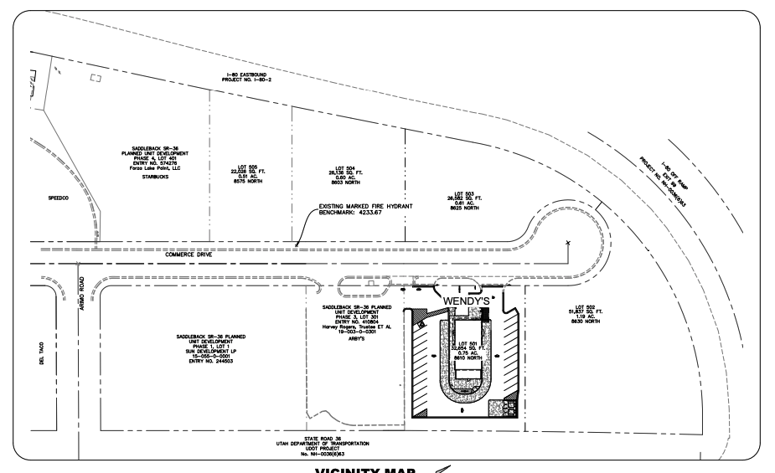

Site Plan of Building

