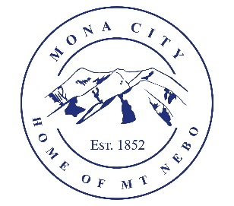
Mona City
435-623-4913
www.monautah.gov
20 West Center Street Mona, Utah

Mona City Council Meeting Agenda
Tuesday, July 8, 2025
Mona City Building – 20 West Center
7:00 p.m.

- Pledge
- Prayer
- Approval of June 24, 2025, Public Hearing & City Council Meeting Minutes
- Action Items:
  - Ordinance 2025-10: updates to Mona City Code 8-6: Private Storm Water Facility
  - Ordinance 2025-12: updates to Mona City Code 10-2-2 & 10-6-1: Land Use Matrix
  - Resolution 2025-16: Electronic Meetings
  - Resolution 2025-17: Update to Mona City Personnel Policy
- Miscellaneous Items:
  - Todd Quarnberg – new principal introduction
  - Jonathan Jones – Nebo Regional Water Project/Irrigation Water
  - Mona Celebration Grand Marshall nomination
- Planning and Zoning
  - Gail Harvey – Greenhouse with electrical & water – 684 South 400 West
- Director of Finance
  - Approval of Finances
  - Quarterly Report
- Recorder
  - Meet the Candidate Night Tuesday, July 15th @ 7:00 pm
  - City Council Meeting on July 22 has been cancelled
  - Primary Ballots mailed on July 22
- Gas & Water & Roads
- Sewer
- Council Reports
- Public Comment
- Adjournment

CERTIFICATE OF POSTING
This agenda is hereby properly advertised on this 7th day of July 2025 by posting copies in the following places: the Mona City Office, on the Mona City website at monautah.gov, at the United States Post Office Mona City Branch, and on the Utah Public Notice Website at www.utah.gov/pmn/index.html.

_____________________________________
Alicia Hills, Mona City Recorder

Upon Request, in compliance with the Americans with Disabilities Act, reasonable accommodations for individuals with disabilities will be provided. For assistance, please call 435-623-4913.

