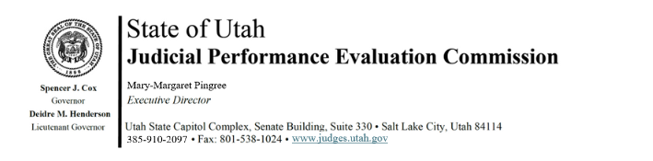
Judicial Performance Evaluation Commission
AGENDA
Tuesday, July 8, 2025
9:00 am-12:00
Hybrid Meeting *

Members: Lisa Watts Baskin, Mallory Bateman, Christine Durham, Christian Hansen, Blair Hodson, Ally Isom, Curtis M. Jensen, Sonya Martinez-Ortiz, Gil A. Miller, Mary Noonan, Bridget Romano, Tom Ross, Mike Smith

Staff: Madison Klein, Jamie Nelson, Chris Russell, Mary-Margaret Pingree, Cameryn Coffee, Paul Tonks

9:00 a.m. Welcome Bridget Romano
Approval of Minutes – May 13, 2025

9:05 a.m. Updates & Announcements Bridget Romano
Mary-Margaret Pingree
Madison Klein

9:20 Interim Meetings Discussion Madison Klein
Mary-Margaret Pingree

10:00 Appellate Evaluations and Test Bridget Romano
Mary-Margaret Pingree

10:30 JPE 2.0 Recommendations Chris Russell
Mary-Margaret Pingree
11:15 Strategic Plan Updates Mary-Margaret Pingree

11:30 Adjourn

Next Meeting: Tuesday, September 9, 2025
9:00 a.m. – 12 noon
Large Conference Room, 3rd Floor, Senate Building
*Anchor Location: Senate Building, Suite 330, CCJJ Large Conference Room

