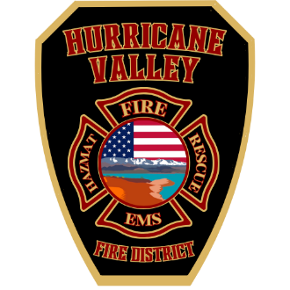
Hurricane Valley Fire
Special Service District
202 East State Street. Hurricane . Utah 84737
(435) 635-9562

NOTICE OF MEETING CANCELLATION
Notice is hereby given that the regularly scheduled Hurricane Valley Fire Special Service District Board Meeting
For Monday, July 7, 2025
Has Been CANCELED.

Thank you for your understanding.

