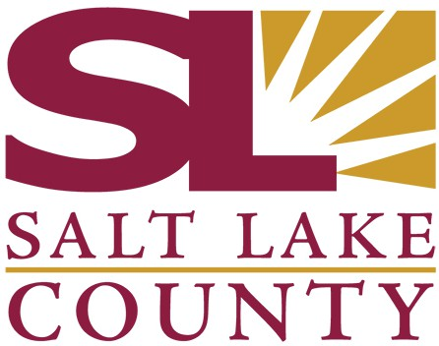

SALT LAKE COUNTY
2001 South State Street Salt Lake City, UT 84114
(385) 468-7500 TTY 711

Meeting Minutes

Tuesday, May 6, 2025
1:30 PM

N2-800

Board of Equalization

Board of Equalization Meeting Minutes May 6, 2025

CALL TO ORDER
Present

Call In

PUBLIC COMMENT
There was no public comment

Board Member Suzanne Harrison, Board Member Arlyn Bradshaw, Board Member Aimee Winder Newton, Board Member Carlos Moreno, Chair Dea Theodore, Vice Chair Laurie Stringham, Board Member Natalie Pinkney, and Board Member Ross Romero
Board Member Sheldon Stewart

APPROVAL OF BOE MINUTES

  - Acceptance of BoE minutes for April 29, 2025 25-2889
Attachments: 042925 BoE minutes Presenter: Roswell Rogers, Senior Advisor
Board Member Harrison and Board Member Moreno were absent for the vote.
A motion was made by Board Member Bradshaw, seconded by Board Member Pinkney, that this agenda item be approved. The motion carried by a unanimous vote.

APPROVAL OF ASSESSOR AND HEARING OFFICER RECOMMENDATIONS

  - Approval of Assessor and Hearing Officer Recommendations 25-2887
Attachments: 050625 Weekly Counts
050625 BoE Weekly Report 050625 BoE Value Adjustments
Presenter: Brad Neff, Tax Administrator
A motion was made by Board Member Winder Newton, seconded by Board Member Stewart, that this agenda item be approved. The motion carried by a unanimous vote.

EXEMPT PROPERTY RECOMMENDATIONS

