

NOTICE OF PUBLIC HEARING
PUBLIC NOTICE is hereby given that Milford City Council will be holding a public hearing as part of a regular Council Meeting at the Council Chambers, Milford City Office, 26 South 100 West, Milford City, Utah 84751 at 4:00 p.m. on Tuesday, July 15, 2025.
The purpose of the hearing is to hear public comments concerning petition to vacate a portion of an alley as shown on the Milford Town Plat running north and south through Block 5, Lewis Addition. Map Below.

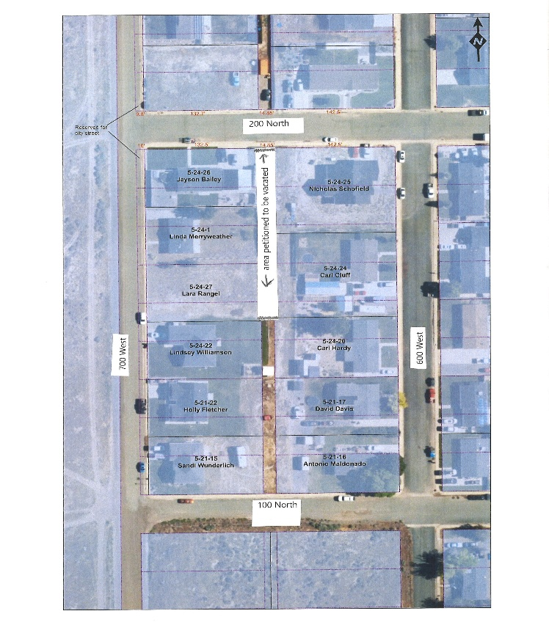
Dated this 30th day of June, 2025.
CERTIFICATE OF DELIVERY & POSTING
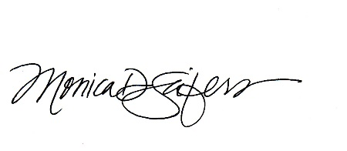
The undersigned, duly appointed and acting City Recorder does hereby certify that the above Notice of Public Hearing was posted in three public places within the Milford City Limits on this 30th day of
June 2025. These public places being 1) Milford City Office; 2) U.S. Post Office; and 3) Milford Public Library. The foregoing Notice and Agenda was also delivered to each member of the governing body and posted at utah.gov.pmn, on the city Facebook page linked to www.milfordcityutah.com.

_______________________________
MONICA D. SEIFERS
MILFORD CITY RECORDER

In compliance with the Americans with Disabilities Act, the City of Milford will make efforts to provide reasonable accommodations to disabled members of the public in accessing City programs. Request for assistance can be made by contacting the City Recorder at 435.387.2711 at least 24 hours in advance of the meeting to be held.

