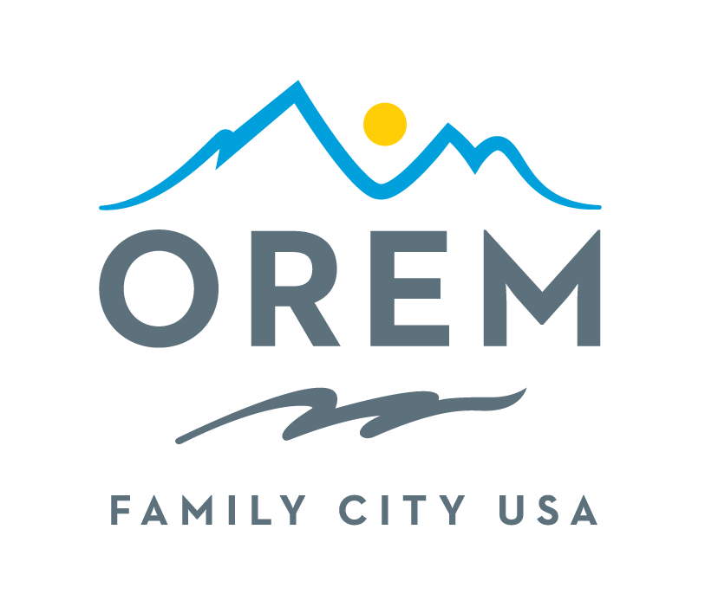
CITY OF OREM
ADVISORY BOARD/COMMISSION
MEETING AGENDA

This meeting may be held electronically to allow a board/commission member to participate.
PUBLIC BODY: Events Advisory Commission
DATE: Thursday, July 10, 2025 ROOM: City Council Conference Room #1002
Right next to the City Council Chambers
TIME: 4:00 p.m. - 5:30 p.m. ADDRESS: 56 North State Street, Orem, Utah

AGENDA ITEMS:

Welcome Ashlie Mann

Review and Approve Minutes from May 8, 2025 Ashlie Mann

- City Updates
  - Term limits for Commission Members Bryce Merrill
  - Commission Assignments for Upcoming Events Kenice Whitaker
- Commission Updates
  - Action Commitment Reporting Kenice Whitaker
  - Asks Kenice Whitaker
- Oremfest Evaluation by Event
  - Overall Public Feedback Kenice Whitaker
  - Car Show Rodney Gardner
  - Pool Party Sydney Bailey
  - Orchard’s Jam Paula Pili
  - Children’s Crafts Debby Lauret
  - Boutique Vendors Christie Ekins
  - Food Vendors Jim Orr
  - Baby Contest Kami Burgess
  - Drone Show and Fireworks Sydney Bailey
  - Parade Kenice Whitaker
  - Fireworks Tent Ashlie Mann & Ashley Shumway
  - Stage Entertainment Pete Wolfley
  - Facilities Brooke Williams
  - Volunteers Laura Bascom
- Memorial Day Evaluation Rodney Gardner
- Review Action Items Kenice Whitaker

Next Meeting – August No Meeting but September 11, 2025 Ashlie Mann
Adjournment Ashlie Mann

THE PUBLIC IS INVITED TO PARTICIPATE IN ALL CITY MEETINGS.

If you need special accommodation to participate in Advisory Commission meetings
Please contact us on the City's website at orem.org or call (801) 229-7000 at least three working days.
prior to the meeting. This agenda is available on the Utah Public Notice website at utah.gov/pmn.

