Present: Zachary Posner (Information Technology), Richard Jaussi (Auditor), Hoa Nguyen-online (Council), Megan Hillyard (Administrative Services), Talia Butler-online (Public Works), Rashelle Hobbs-online (Recorder), Sheila Srivastava-online (Treasurer), Chris Stavros (Assessor), Robert Sampson (Community Services), Lisa Ashman-online (District Attorney), Brad Park (Surveyor), Katy Fleury-online (Mayor Administration)
Representation Absent: Clerk, Sheriff, Human Services
Staff Present: Tony Jolley-online, Rina Shipley-online, Wendy Ormsby, Andrew Dudley-online, Lee Wilstead-online, Mark Miller-online, Trevor Hebditch, Cherie Root, Sam Sedivec-online, Valina Eckley-online, Nick Loomans-online, Jon Thelen-online, Thomas Yeung-online
TOPIC | POINTS OF INTEREST
Welcome & Remote Meeting Instructions | Brad Park opened the meeting.  Cherie Root noted attendance online.  Trevor Hebditch shared the following slide:  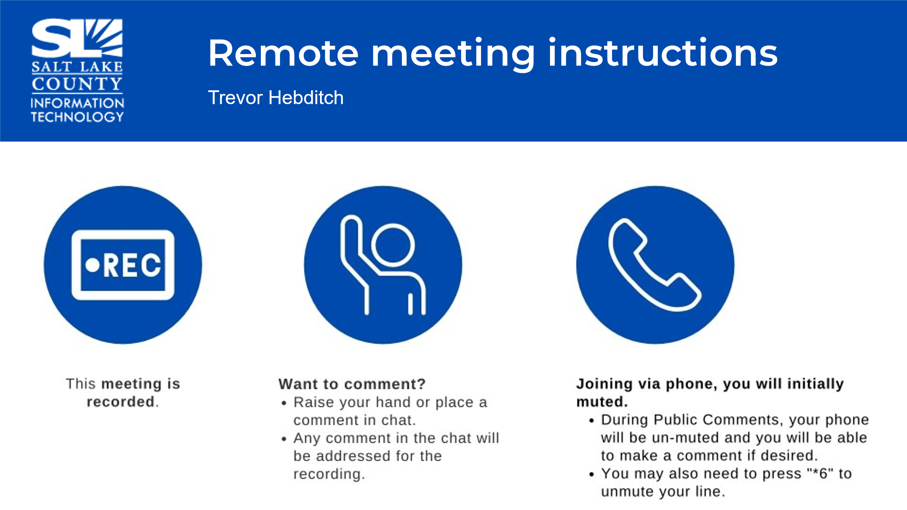
Public Comments  (Brad Park) | No comments.
Approval of minutes from February 27, 2025, meeting | Motion to approve the minutes by Chris Stavros, Megan Hillyard seconds the motion. No discussion.  Motion passed unanimously.
Follow-up Items  (Cherie Root) | 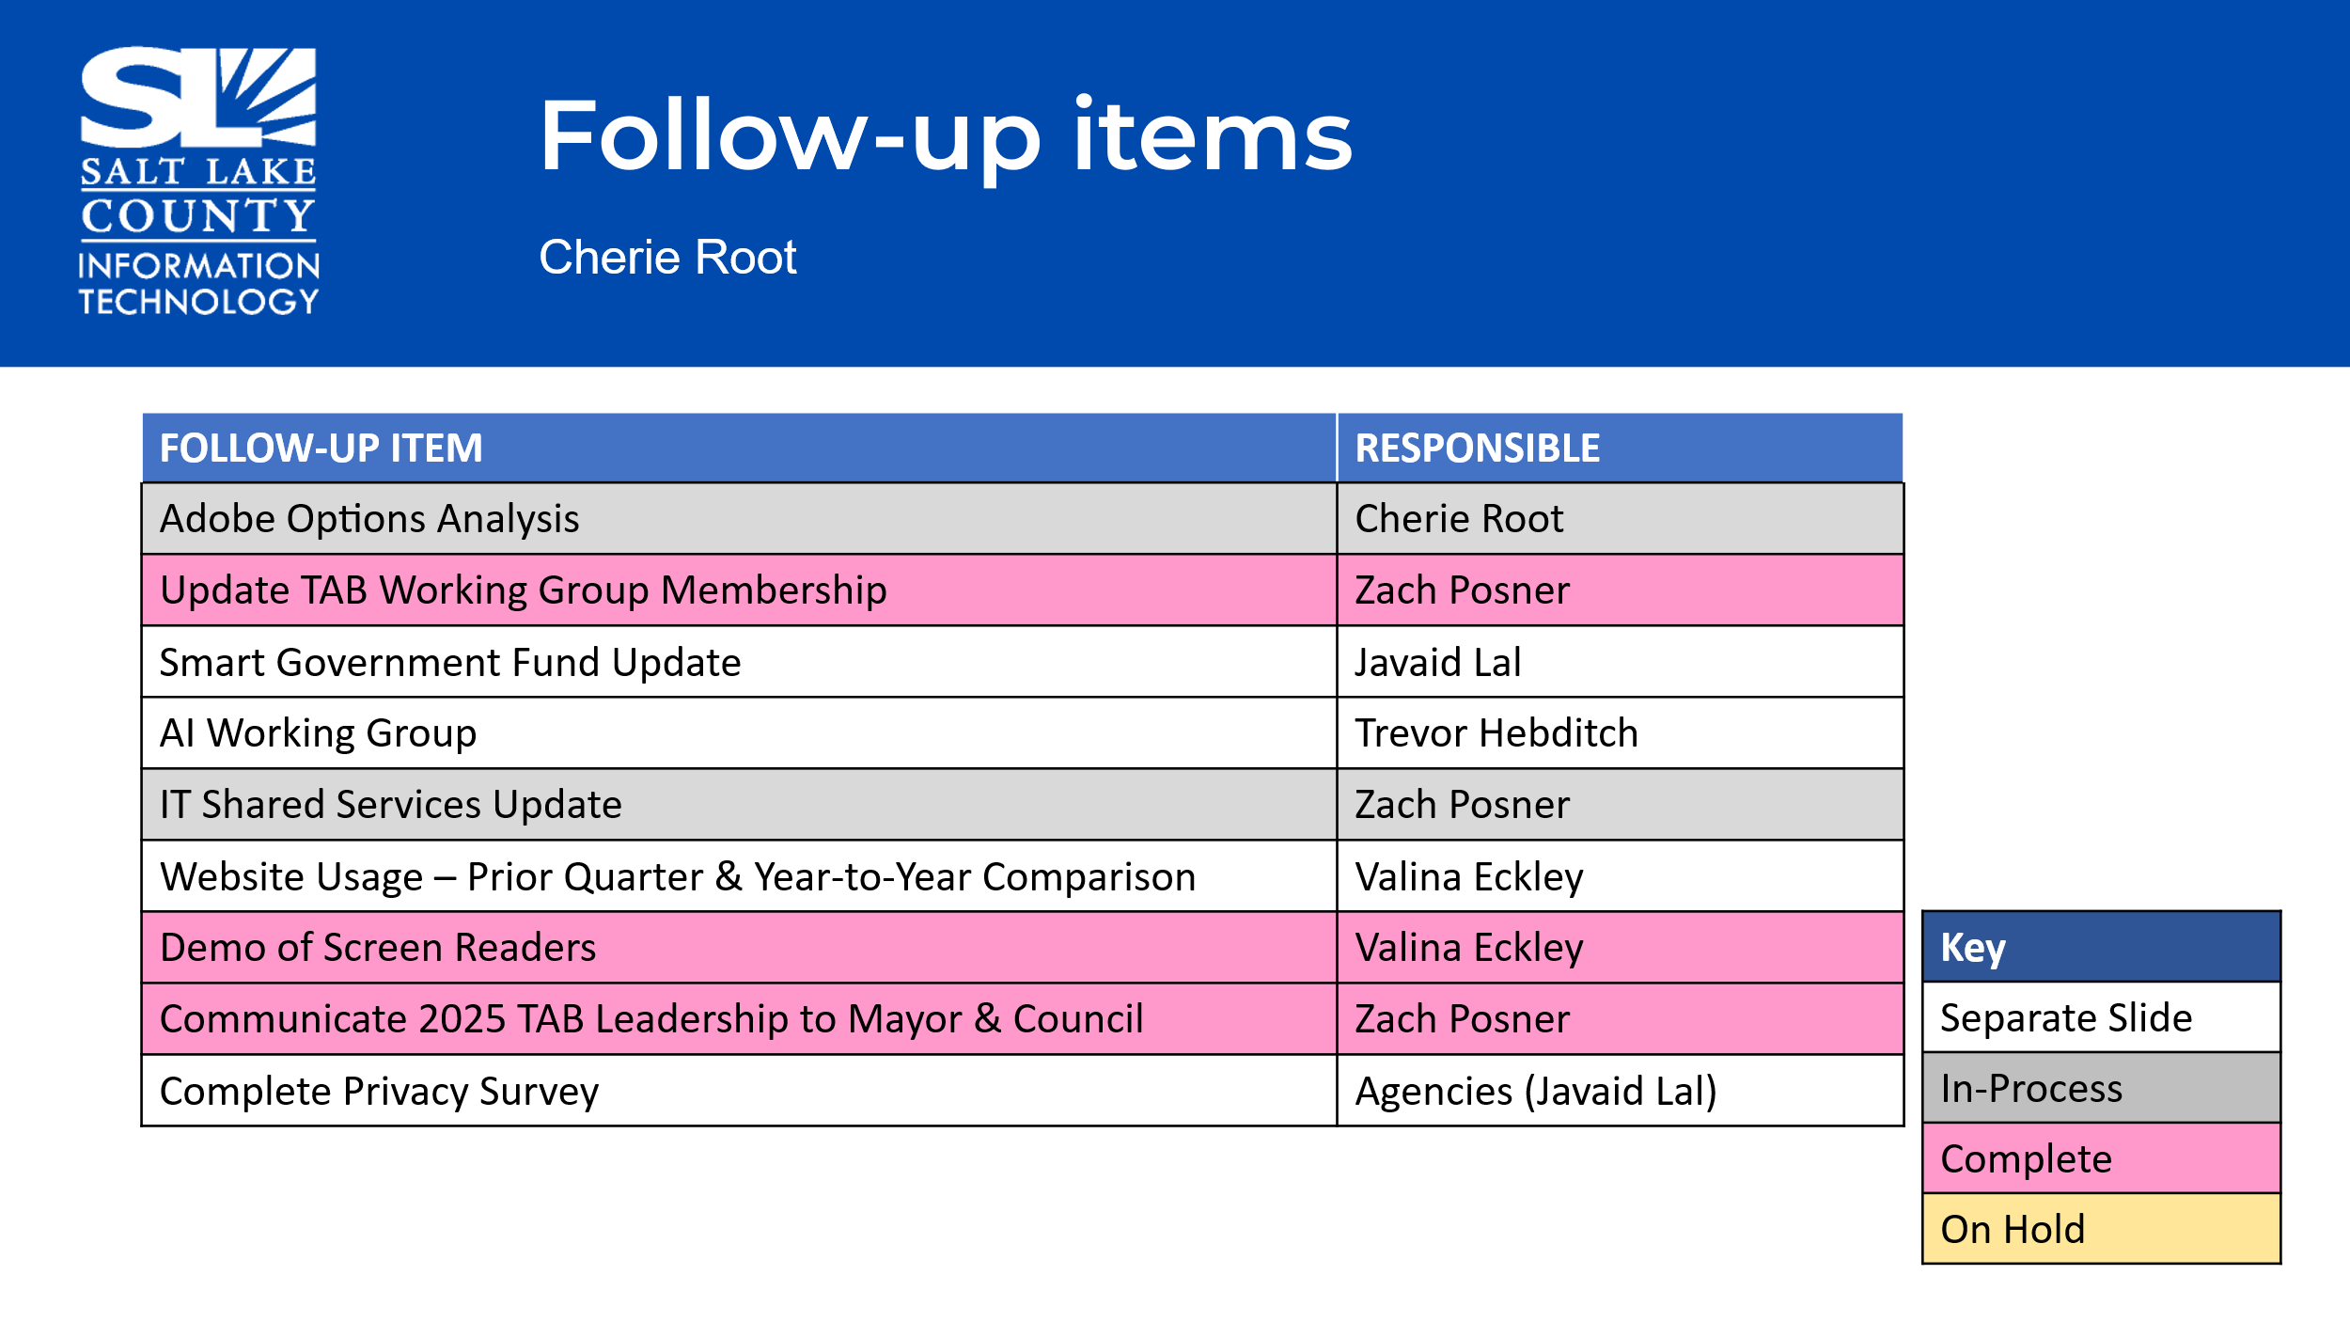
Technology Positions Countywide  (Nick Loomans) | 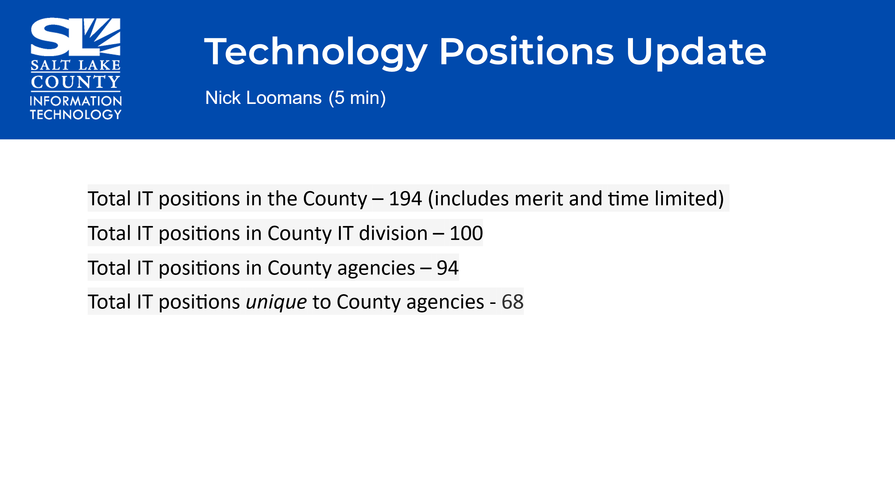  During 1st quarter, the Assessor’s Office reclassed an existing vacant non-IT position into the IT job family as a GIS Specialist, Criminal Justice Services reclassed a Service Desk position within their division to a non-IT position, and the Recorder’s Office reclassed an existing vacant non-IT position into the IT job family as a Business Analyst. IT reduced a TL programmer position because it was no longer needed for the project it was assigned to. The only other changes were reclassifications within the technology positions that an agency already had (IT & DA).
Open Public Meetings Act (OPMA) Training  (Dianne Orcutt) | https://www.youtube.com/watch?v=QNVBuXB7vkM  OPMA (Open & Public Meetings Act) Quiz
TAB Working Group Milestones  (Tony Jolley) | 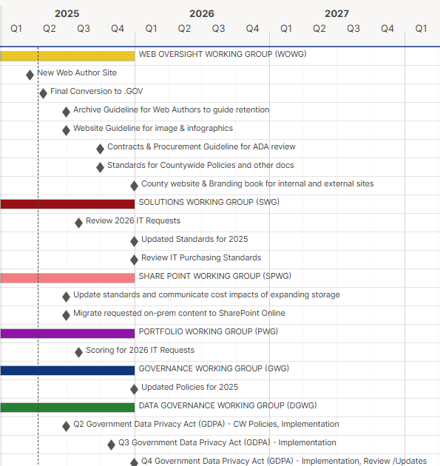
AI Working Group Update  (Trevor Hebditch)  Highlights:  AI Working Group formed to put guidelines in place re: the county’s use of AI. You can find a link on SharePoint to ask questions of members or submit ideas. We’ll help you and your groups to make sure you are meeting the criteria. Links will be shared that give tips for using AI.  The group is working to approve spaces for AI use.  Solutions Working Group  (Rina Shipley)  The Data Classification & Protection standard was deferred to a future meeting to make sure it is not in conflict with the GDPA (Government Data Privacy Act), so there was no vote taken on it at this meeting. | 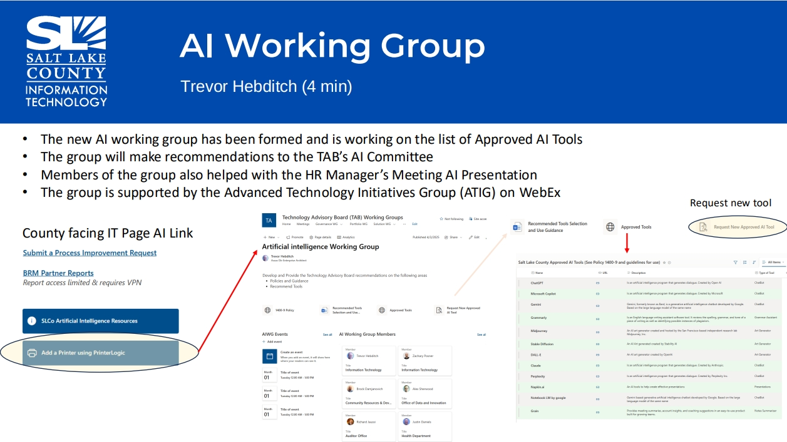  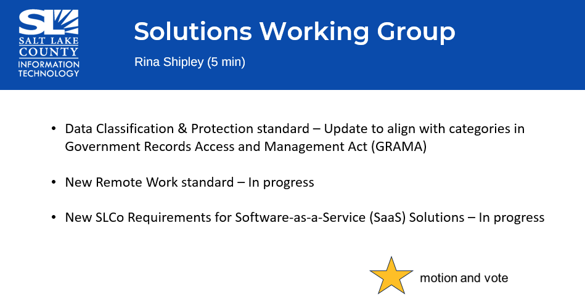
Portfolio Working Group Update  (Lee Wilstead)  Highlights: Power Details tracks employees/overtime; allows to bill for big events that have police. This allows more efficiency and an intuitive platform for public use.  ZoomGrants—narrowed to 3 vendors. | 
SharePoint Update  (Lee Wilstead)  There is a new dashboard available for agencies to monitor SharePoint usage.  Web Oversight Working Group  (Valina Eckley)  Highlights: If your team would like a deep dive into analytics, statistics, and date re: website, let us know.  We’ve been working on branding and the guidebook to give our website better cohesiveness. You can see calendars, subscribe to specific calendars, find guidelines for training.  Better functionality and ease of finding information, like Parks and Rec’s programs, for example. | 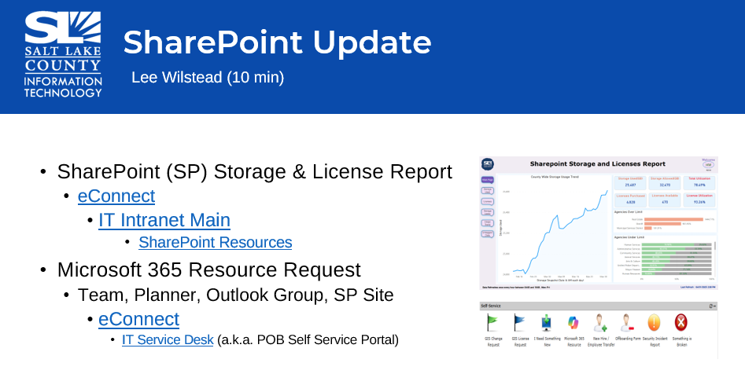  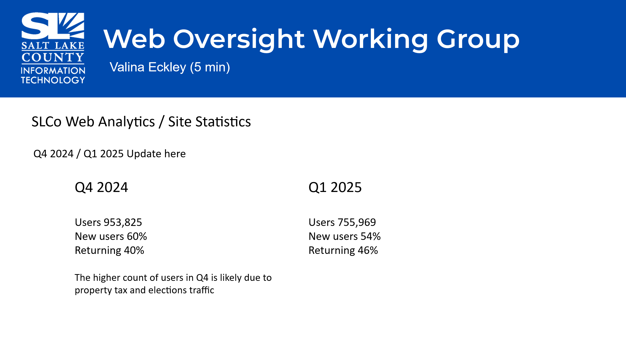  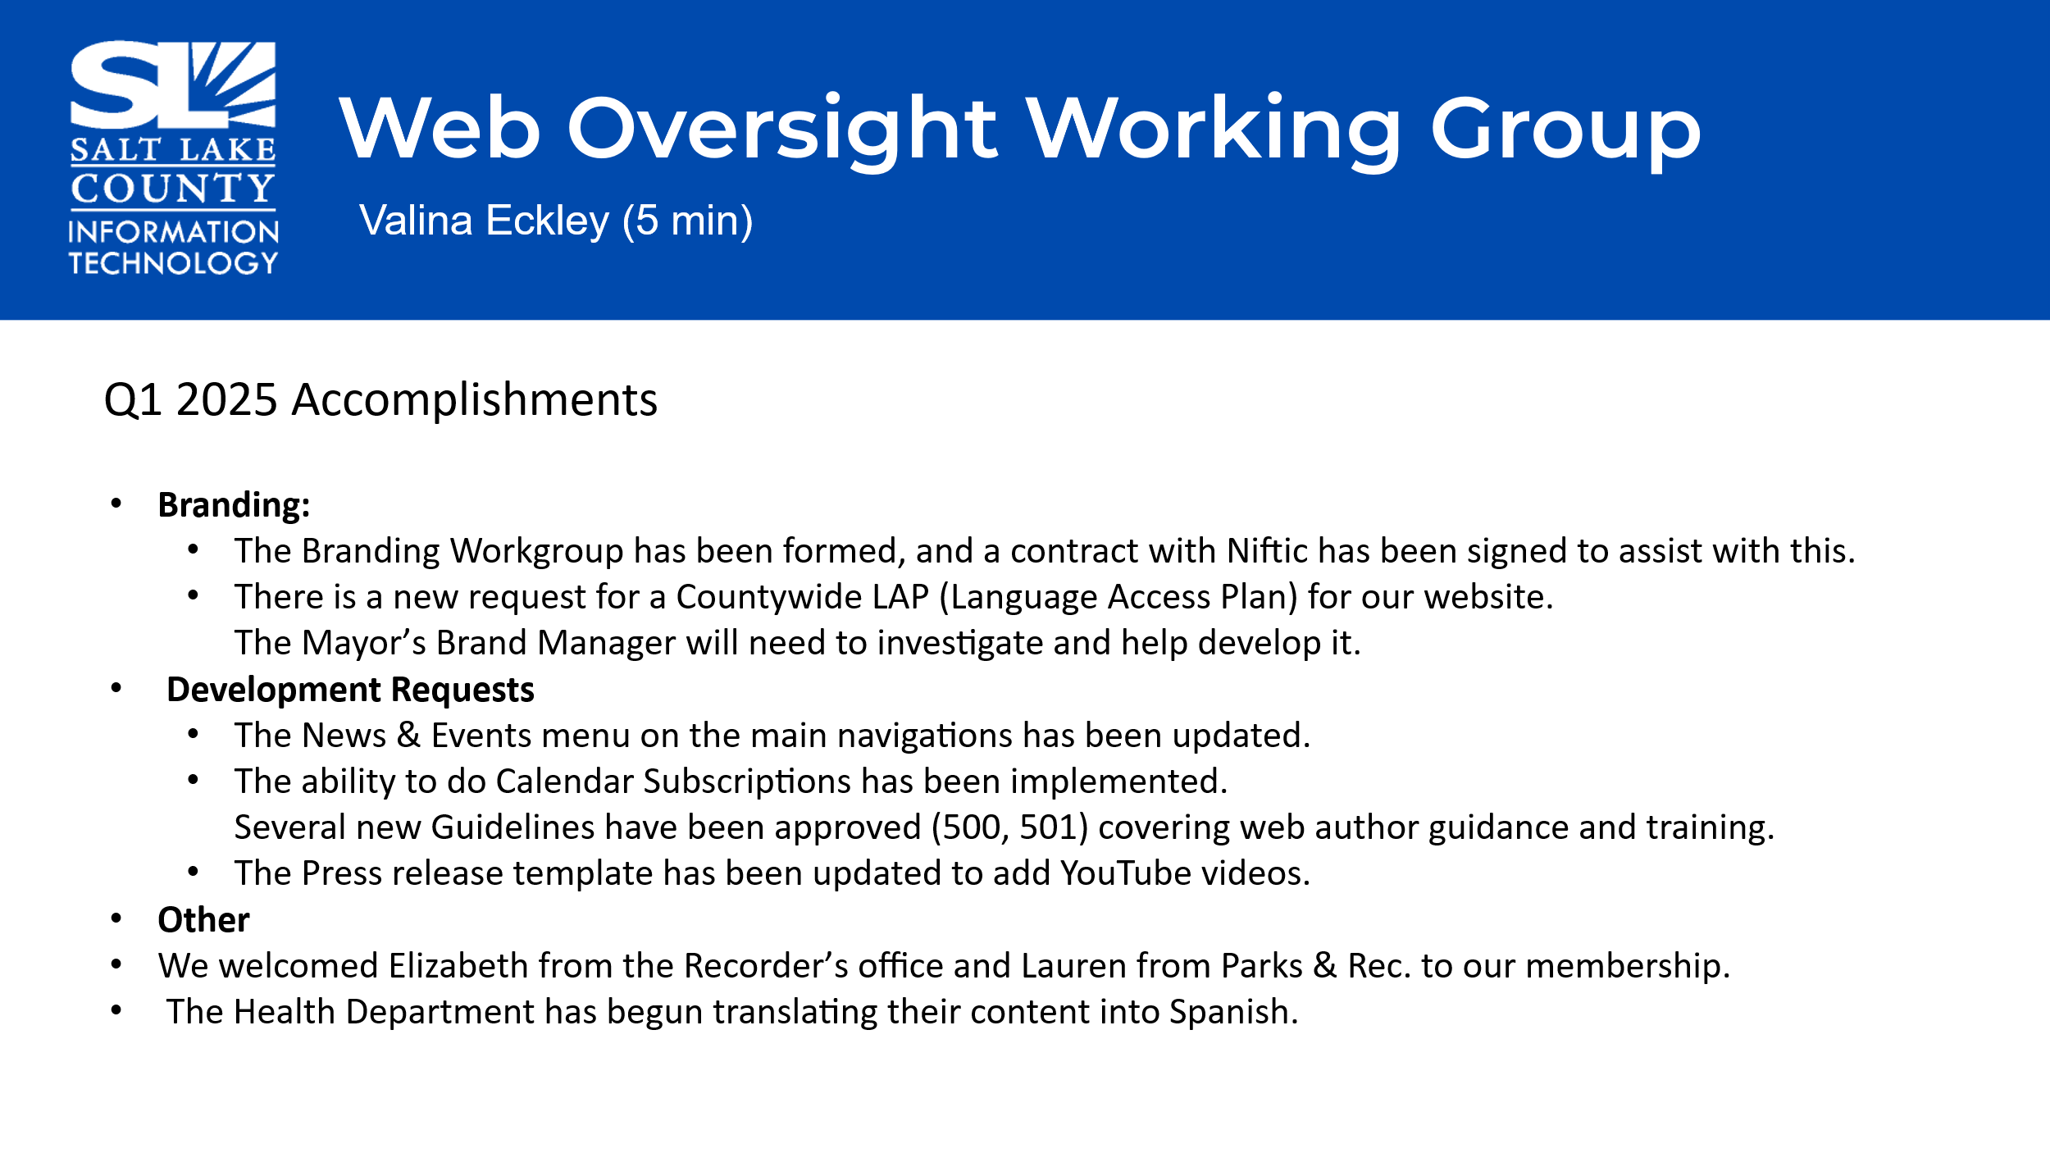  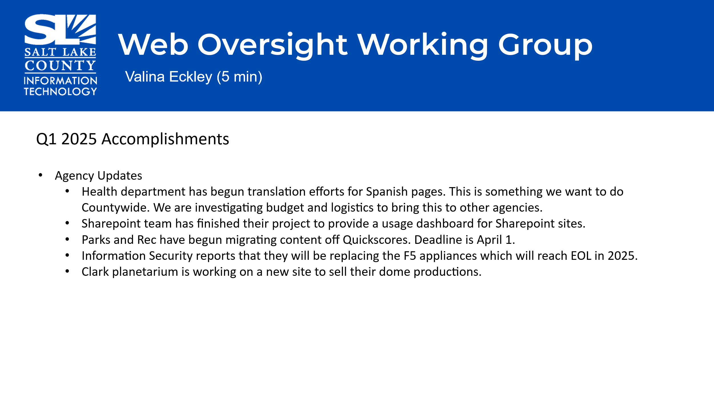
Data Governance Working Group (DGWG)  (Javaid Lal)  Privacy Program Update  What is Utah Government Data Privacy Act GDPA?  A state law is designed to regulate how government entities use, store, and share personal data.  Highlights: New law governs privacy data. Gov’t wants designated records officer to make sure regulations are adhered to.  Dec. 31, 2025 new deadline to have policies and notification in place for those we collect data from.  HR is working on the training requirements for this privacy officer position. | 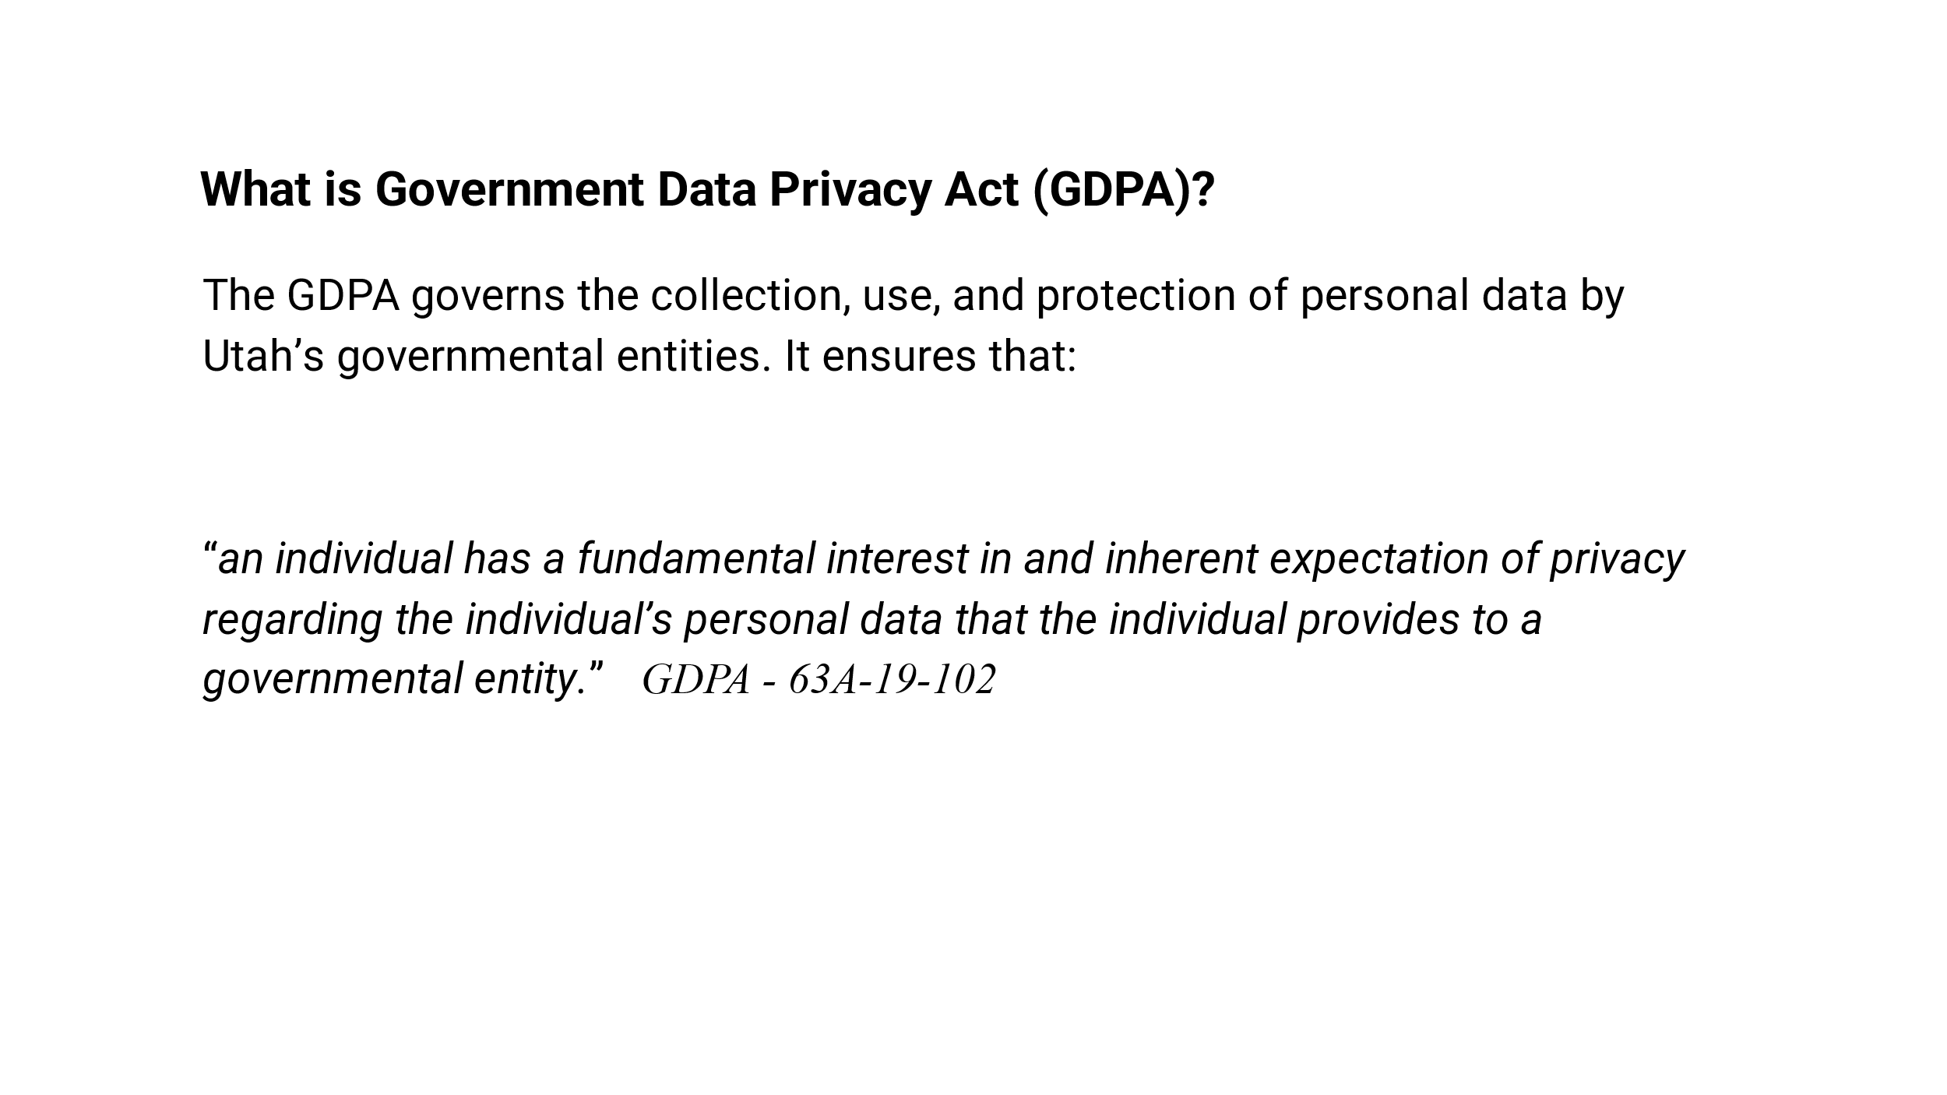  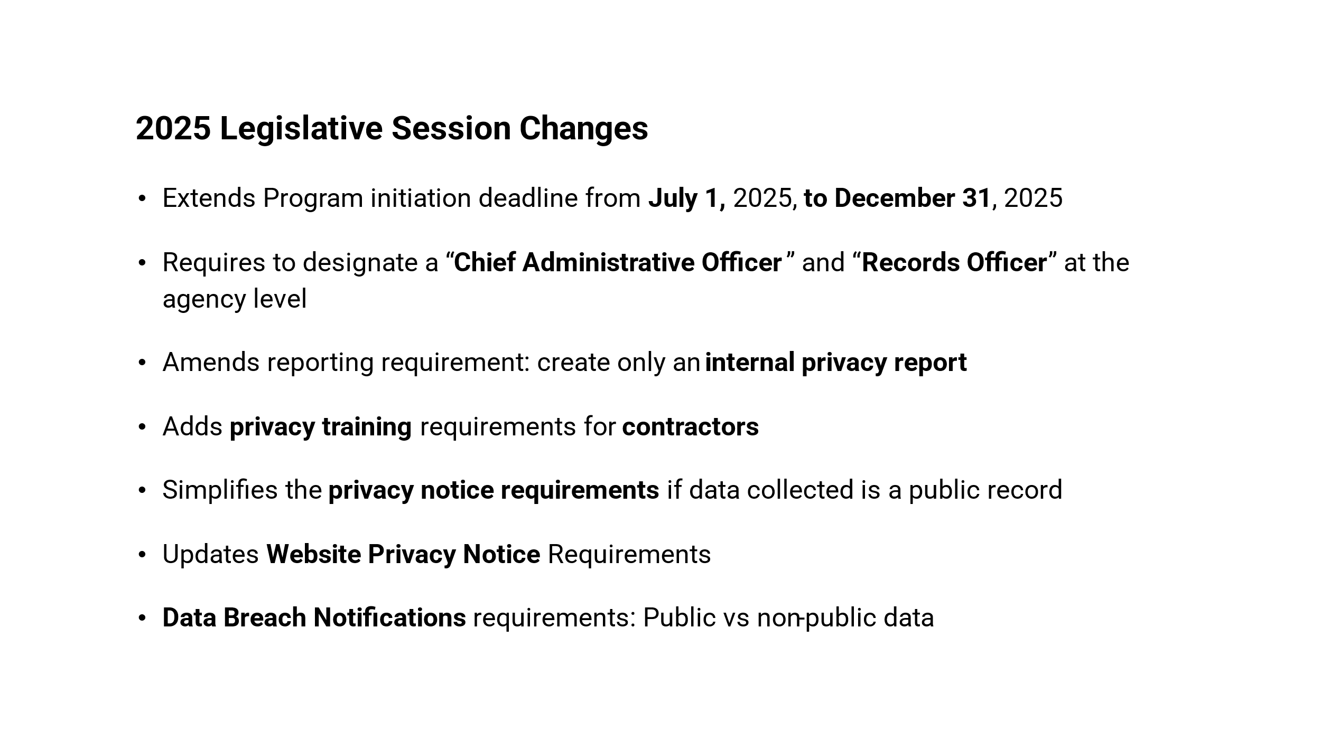  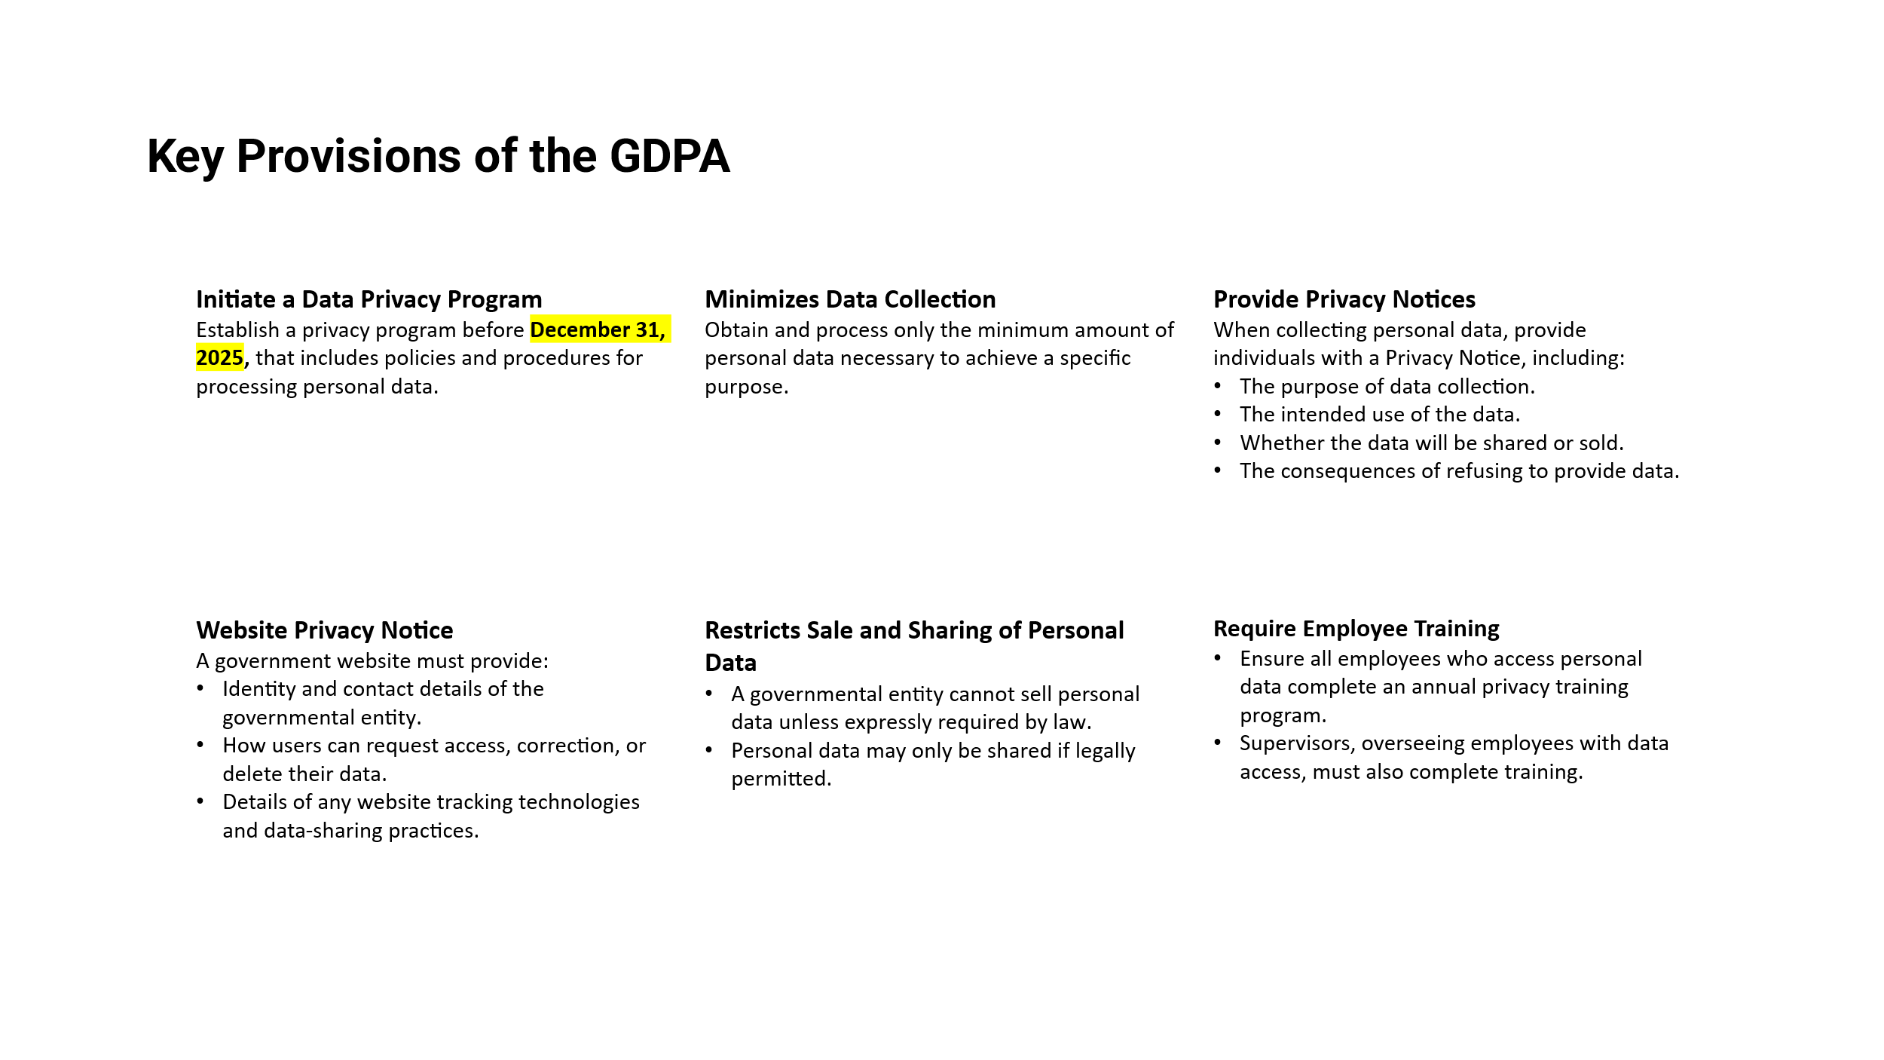
By July 1, 2026, contractors must comply with GDPA. Contractors can meet to get more details.  Will present to Exec. Committee to discuss funding, pay, and how we use this position (Privacy Officer)  Salt Lake County Privacy Framework Timeline Adjusted | 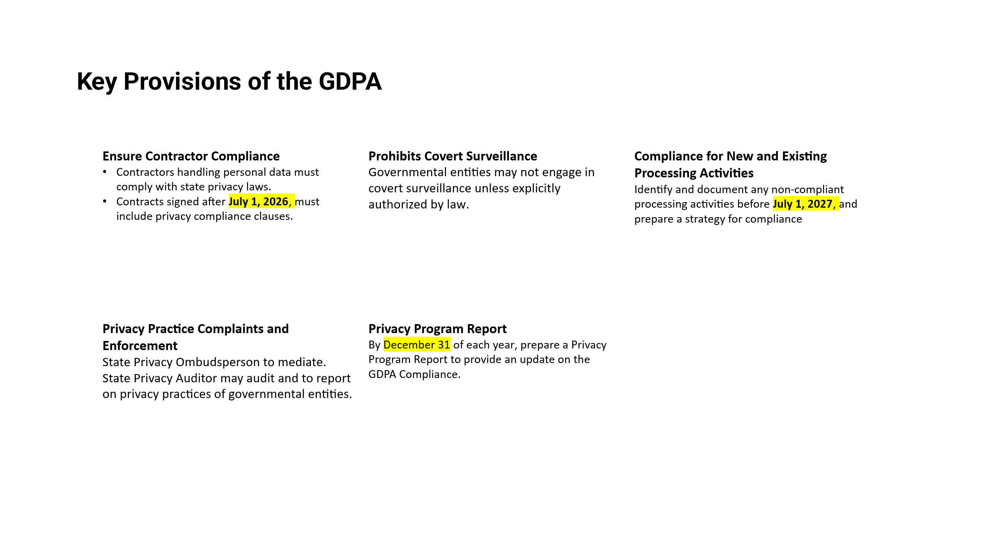  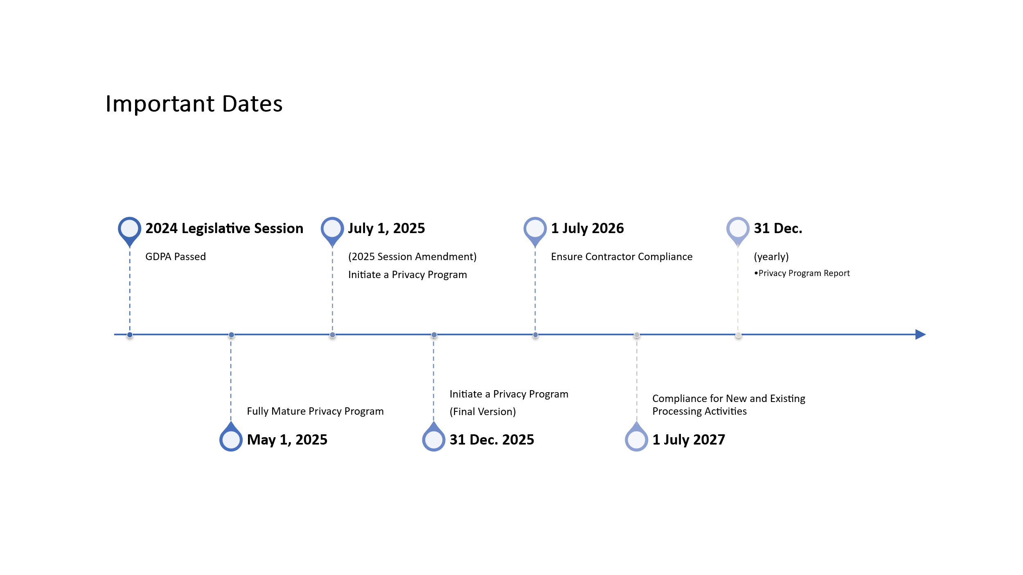  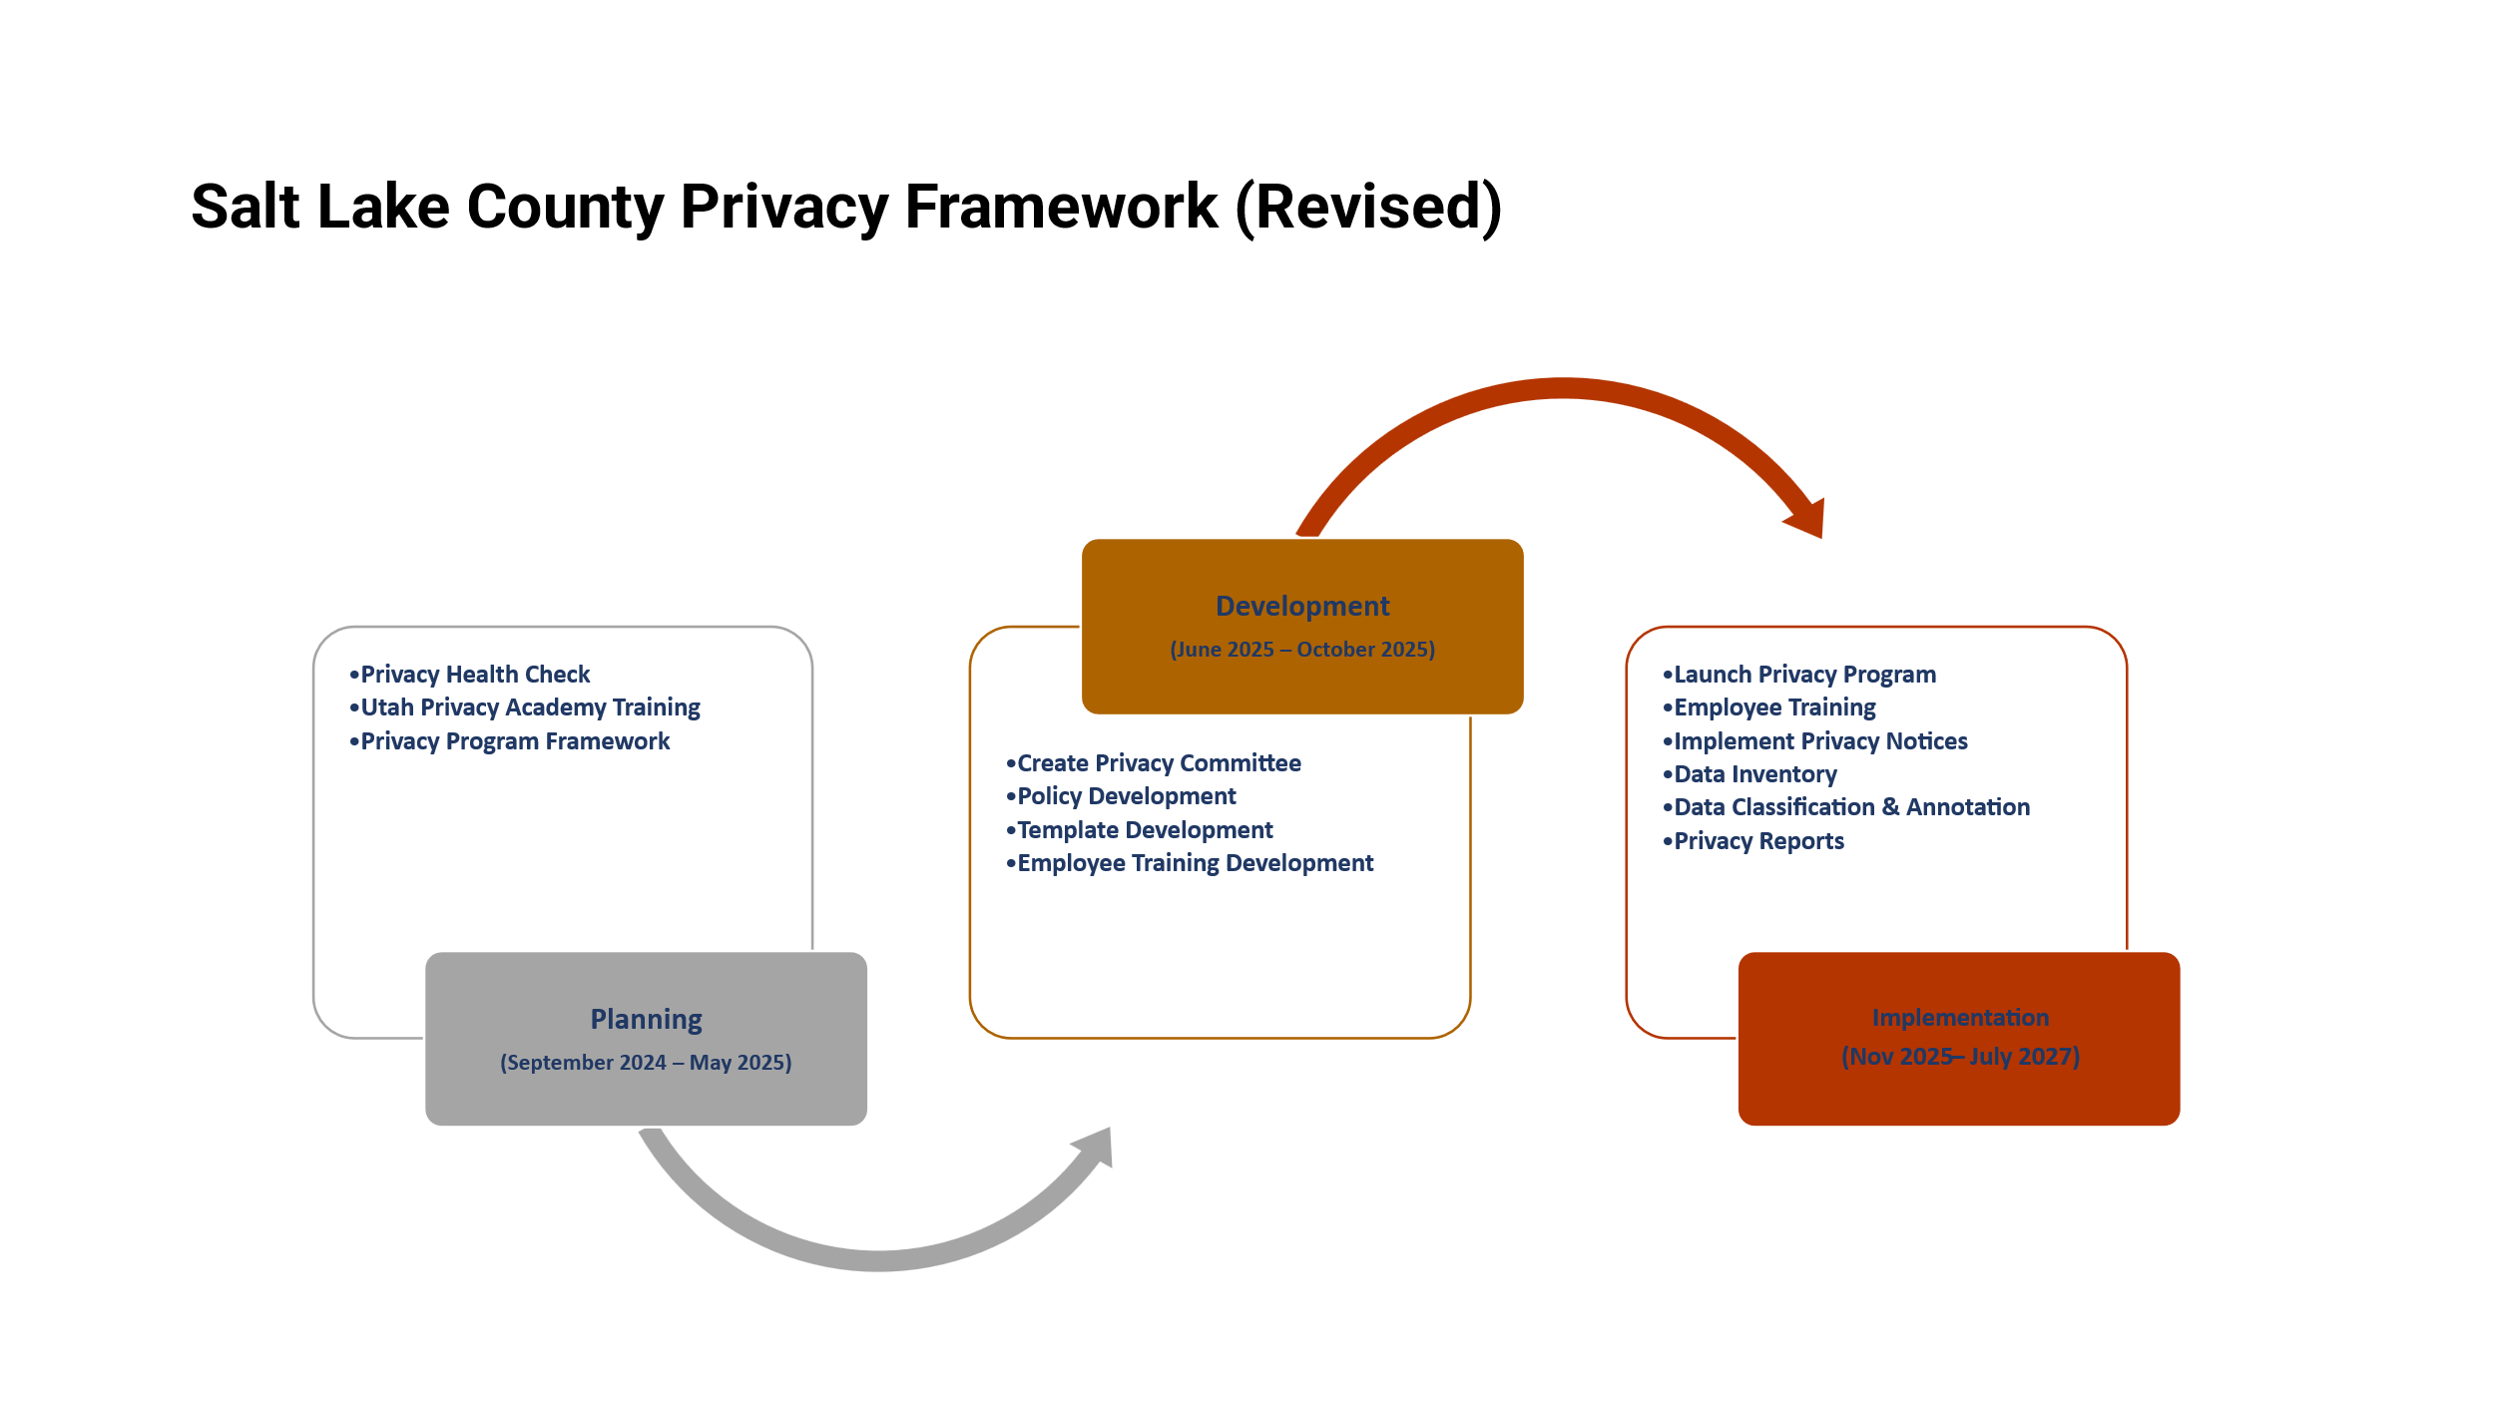
Salt Lake County Privacy Program Survey (Javaid Lal)  Surveys were sent out to Directors and Associate Directors. Please complete them as soon as possible. | 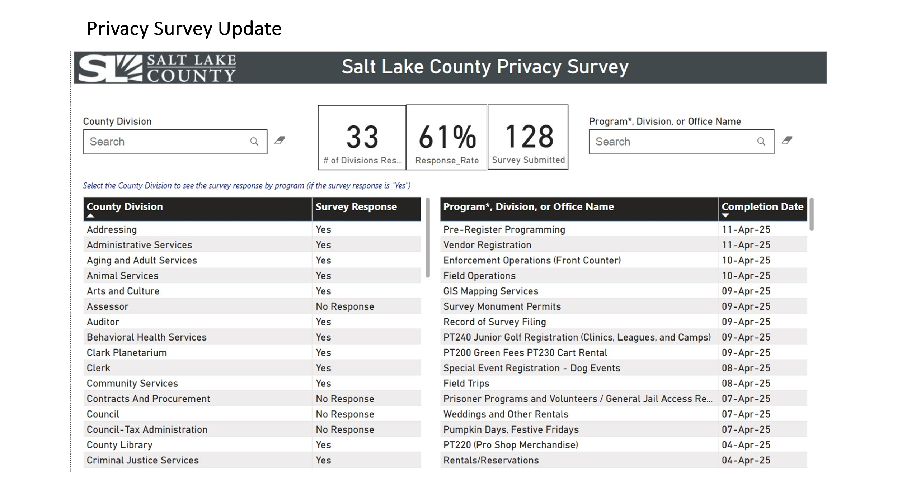  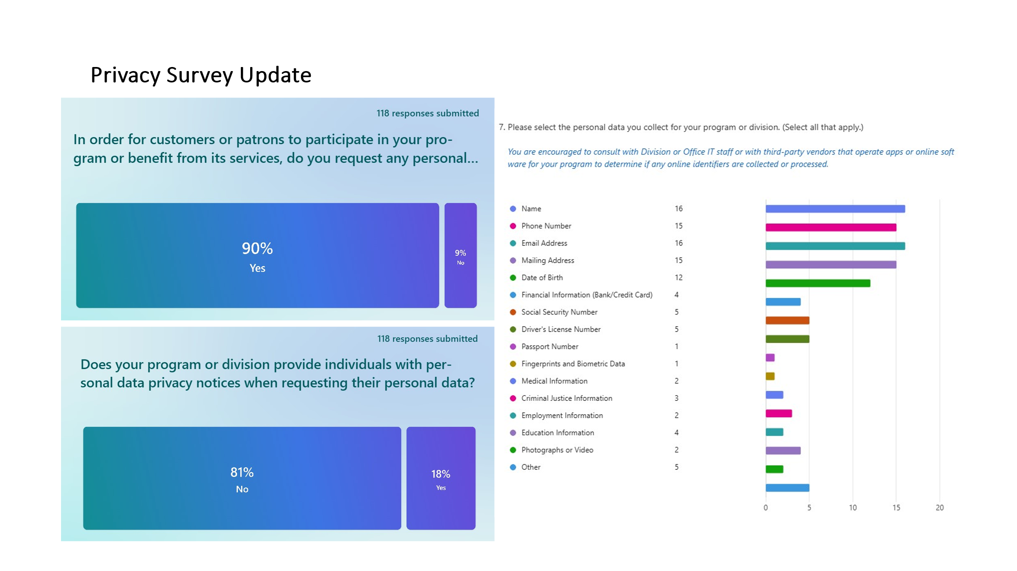
Smart Government Fund Update  (Javaid Lal) | 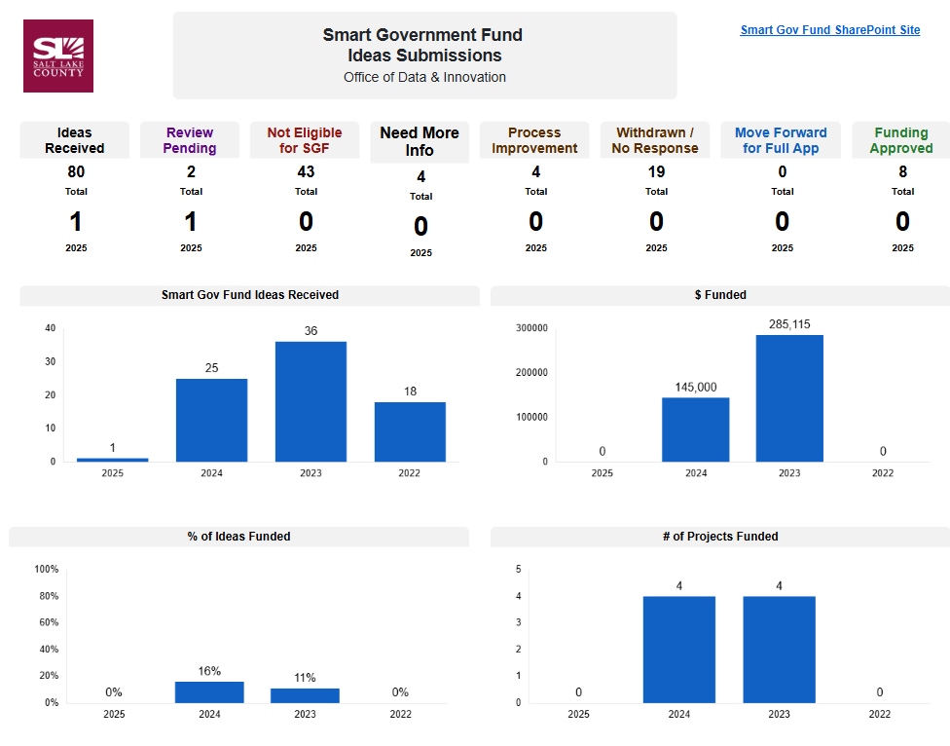  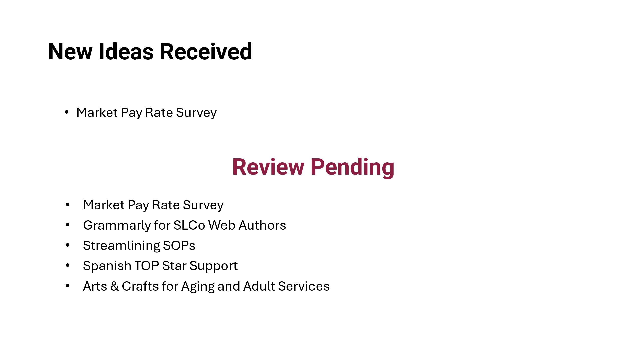  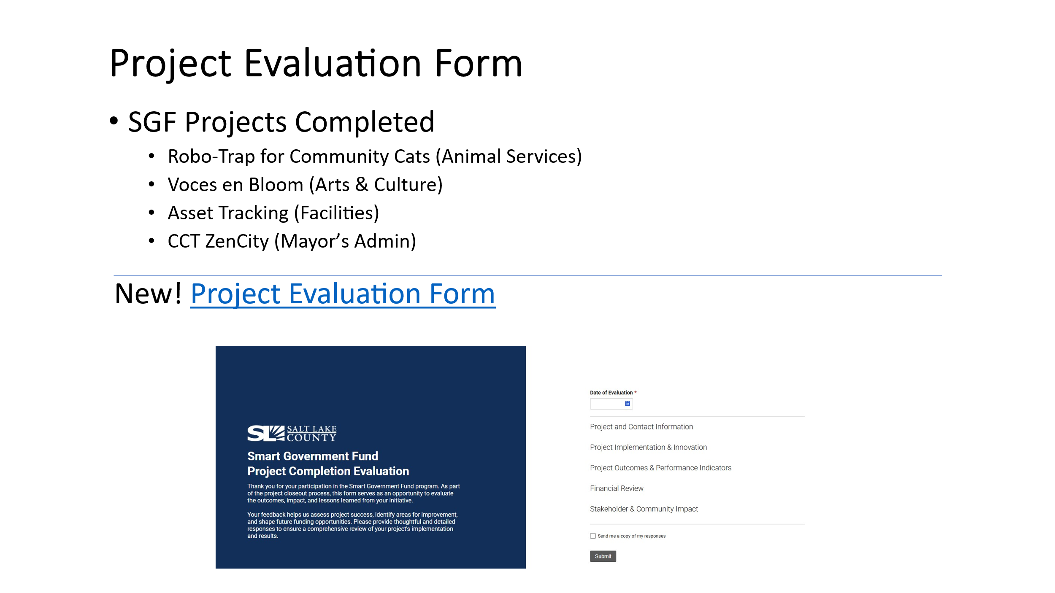
Security Update  (Closed Session) | Motion to enter a closed session to discuss deployment of security personnel, devices, or systems by Brad Park, Megan Hillyard seconds the motion. No discussion.  Aye: Administrative Services, Assessor, Auditor, Community Services, District Attorney, Mayor Administration, Public Works, Recorder, Surveyor, Treasurer  Nay: None  Roll Call: Absent Clerk, Human Services, Sheriff  Motion passed unanimously.  Motion to exit the closed session by Robert Sampson and Brad Park, seconds.  Motion passed unanimously.
Other Business?  (TAB Members)  None | 
Communication Items  (Chair & CIO)  None | 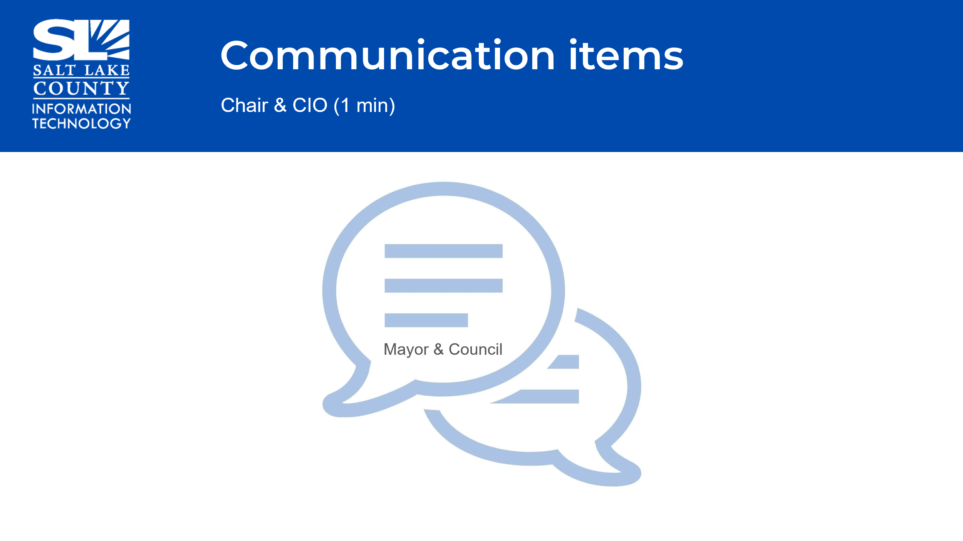
Upcoming Meeting Schedule for 2025  (Wendy Ormsby)  Webex Meeting Invites for TAB 2025 have been sent out.  *Two sessions in August are Combined Sessions with GIS Steering. These sessions focus on budget for the upcoming year. | 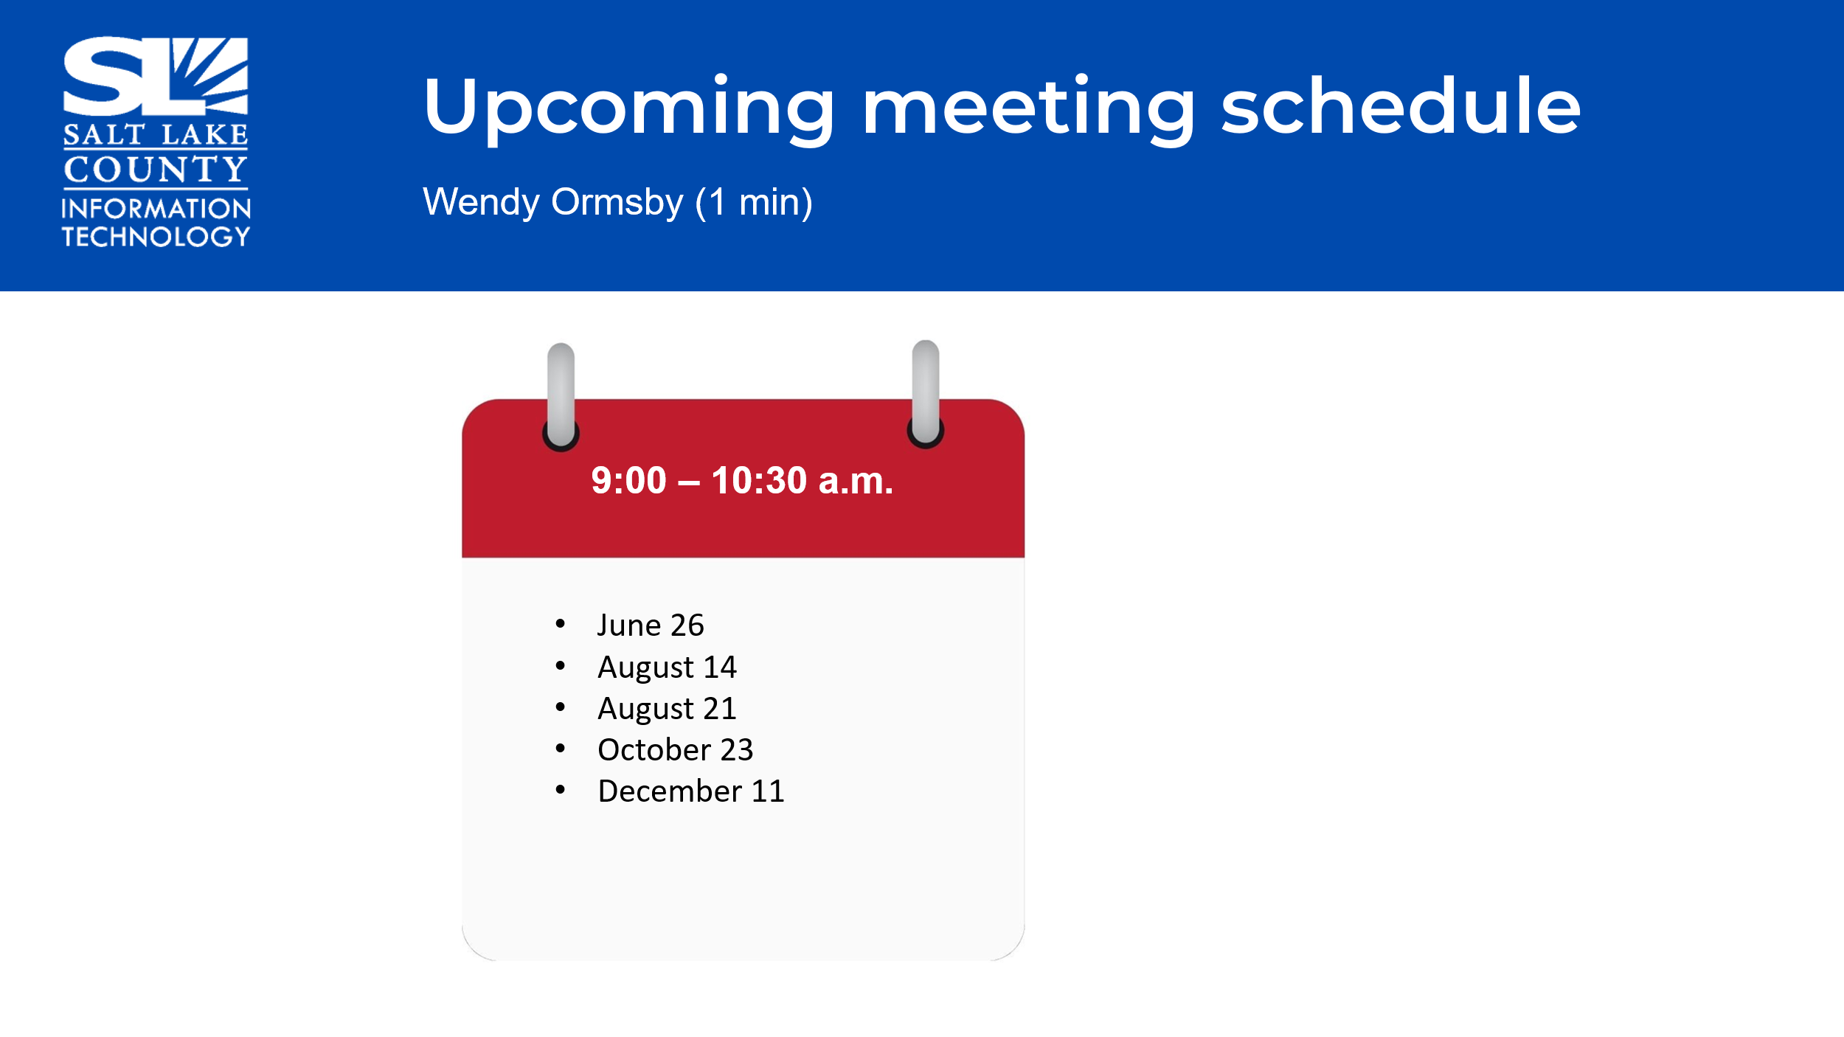
Review Action Items  (Wendy Ormsby)  There are two action items from this meeting  OPMA training completion for absent members  Develop AI Educational Materials | 
Next TAB meeting:  June 26, 2025. | 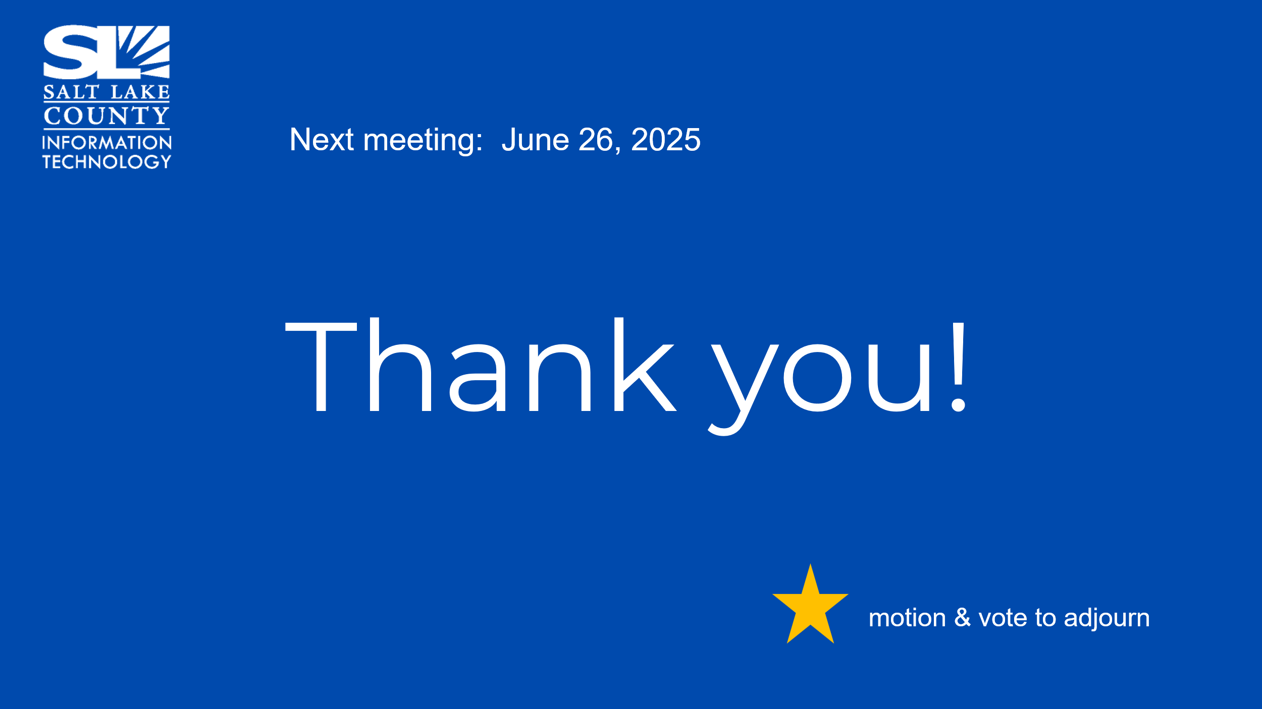
End of Session | Motion to adjourn the meeting by Robert Sampson. No objections. Meeting adjourned. So moved.
Submitted by Wendy Ormsby | The following was noted during this session: a Salt Lake County resident attended the meeting (Steve Van Maren) and there were no communication items in the chat for this session.

