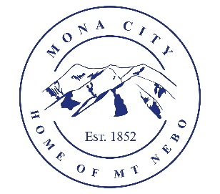
Mona City
435-623-4913
www.monacity.gov
20 West Center Street Mona, Utah

Meet the Candidate Night Agenda
Mona City 2025 Elections

Tuesday, July 15, 2025
Mona City Council Chambers
7:00 p.m.

- Open and Welcome

- Pledge

- Candidate Introduction – 3 minutes per candidate
  - Mayor Candidates
  - Councilmember Candidates

- Candidate Questioning – 3 minutes per candidate

- Adjournment

CERTIFICATE OF POSTING
This agenda is hereby properly advertised this 26th day of June, 2025, through posting of copies of this agenda in the following places: the Mona City Office, at the United States Post Office Mona City Branch, on the Mona City Website at monautah.gov, and on the Utah Public Notice Website at www.utah.gov/pmn/index.html.

______________________________________
Alicia Hills, Mona City Recorder

Upon Request, in compliance with the Americans with Disabilities Act, reasonable accommodations for individuals with disabilities will be provided. For assistance, please call 435-623-4913.

