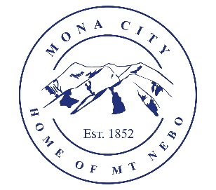
Mona City
435-623-4913
www.monacity.org
20 West Center Street Mona, Utah

Mona City Council Meeting Cancelled
Tuesday, July 22, 2025

Notice is hereby given that the Mona City Council has cancelled the City Council Meeting on July 22, 2025, due to conflicts with the Mona City Celebration and the Meet the Candidate Meeting held on July 15, 2025.

CERTIFICATE OF POSTING

This agenda is hereby properly advertised on this 26th day of June 2025, by posting copies of this agenda at the Mona City Office, at the United States Post Office located in Mona City, on the Mona City website at monautah.gov, and on the Utah Public Notice Website at www.utah.gov/pmn/index.html.

_______________________________________
Alicia Hills
Mona City Recorder

Upon Request, in compliance with the Americans with Disabilities Act, reasonable accommodations for individuals with disabilities will be provided. For assistance, please call 435-623-4913.

