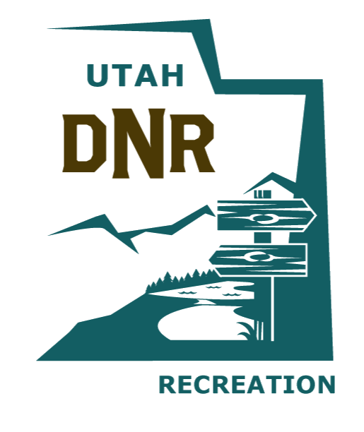

OFF-HIGHWAY VEHICLE ADVISORY COUNCIL
DIVISION OF OUTDOOR RECREATION
DEPARTMENT OF NATURAL RESOURCES
Audio File of the Meeting Held on April 25, 2025, at 10:30 a.m.

HOST:

Department of Natural Resources – Soldier Hollow
1594 W North Temple St, Salt Lake City, UT 84116

AUDIO FILE:

Off-Highway Vehicle Advisory Council 05/23/2025

