
151 SOUTH UNIVERSITY AVENUE
PROVO, UTAH 84601

MINUTES
January 23, 2023

Members Present:
Dr. Jordan Singleton, Chair | excused | Ryan Schooley | X
Carl Hanson, Vice-chair | X | Dr. Michael Kennedy | X phone
Dr. Mark Donaldson | X phone | Julie Fullmer | excused
Amelia Powers Gardner | X phone
Dr. Jeffrey Ogden | X

Others present:
Eric Edwards, MPA, MCHES | UCHD Executive Director
Julie Dey | UCHD Secretary  Number of people in attendance 14
- Welcome by Carl Hanson, Board of Health Vice Chair

- Approval of the minutes from November 28, 2022

MOTION: Amelia Powers Gardner made a motion to approve the minutes from November 28, 2022, which was seconded by Ryan Schooley and passed unanimously.

- Elect Board of Health Chair and Vice Chair for 2023
MOTION: Amelia Powers Gardner made the motion to carry over from 2022 the election of Board of Health Chair, Dr. Jordan Singleton, and Board of Health Vice Chair, Carl Hanson, to continue for 2023 which was seconded by Ryan Schooley and passed unanimously.
- Google Business Profiles
During our January 2020 meeting, the Health Department was asked by the board to increase the promotion of our programs and services through electronic means. Aislynn Tolman-Hill, Public Information Officer, UCHD explained how Google Business Profiles work. She showed the board the various ways UCHD has been using Google Business Profiles for programs such as Foster Grandparents, Mosquito Abatement, WIC, Vital Records, etc.
“In summary, UCHD has been using Google Business Profiles since 2020. Currently UCHD has 14 profiles being managed by the Communications team. There is a significant amount of behind the scenes work by the communications team, much of it after hours; but it is considered ‘good and needed’ customer service. UCHD has not used the free advertising that comes with the platform, yet that is something that is being looked into. Aislynn and the Communications team pull analytics from Google each quarter and provide the data to Eric Edwards and Tyler Plewe.”
The slides from the presentation are included in the minutes.
- UCHD Quality Improvement Project – Employee Onboarding and Reference Portal
Emma Sheranian, Quality Improvement Specialist, UCHD presented the ‘Employee SharePoint’ program she is developing which will be used for employee onboarding at the health department. The SharePoint program will be used for new and existing UCHD staff members. The program will be a resource for important and relevant information for health department staff members. This new system modernizes the antiquated employee orientation system the health department has been using for some years.
Some key elements of the ‘Employee SharePoint’ are employee directory; onboarding checklist; UCHD policies and procedures; UCHD mission, vision and values; leadership; division information; how to’s; and FAQs.
- Fee Schedule Update Based on Contractual Change
Jason Garrett, Environmental Health Division Director, UCHD explained to the board that swimming pool sample testing fees have been increased by the health department’s lab/vendor as well as the increased staffing costs for pool sampling. The price increase will raise the two following lines on UCHD’s fee schedule:
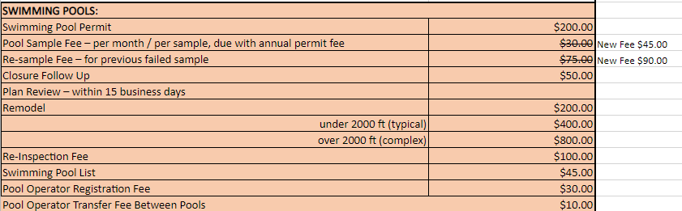

MOTION: Dr. Jeffery Ogden made a motion to approve the increase to UCHD’s fee schedule for 1) Pool Sampling Fees, and 2) Re-sample Fee for previous failed pool samples. The motion was seconded by Ryan Schooley and passed unanimously.

- Public Health Notification System Update

A follow-up discussion resulting from our last board of health meeting was held concerning this agenda item. In November, all four physicians on the board of health agreed that they would not have any concern in having their contact information available to the local health department for this critical need.

Dr. Kennedy provided the contact information for the director of DOPL. He recommended we reach out to DOPL and request access to all physician contact information for Utah County. In December 2022, Eric Edwards was able to successfully contact the DOPL director to inquire about the intent and need. DOPL was very cooperative and approved our request.

They are currently working with their database system to make the physician contact information available for all 13 local health departments. It will only be used for important physician notification items and must be approved by each health officer in respective LHD jurisdictions. Dr. Kennedy was thanked for his involvement in making this possible.

- Approve and set a date, time, and location for closed meeting to discuss the character, professional competence, or physical or mental health of an individual or individuals for today’s date, at this location, following the completion of the regular agenda.

MOTION: Dr. Jeffery Ogden made a motion to approve and set a date, time and location for closed meeting to discuss the character, professional competence, or physical or mental health of an individual or individuals for today’s date, at this location, following the completion of the regular agenda. The motion was seconded by Ryan School and passed unanimously.

- Employee Changes

Employee changes will be presented at the Board of Health meeting in March 2023.

- Other Items

Utah Association of Local Boards of Health (UALBOH) will be sending invitations to our Board of Health members for the 2023 Annual UALBOH Symposium at the Homestead Resort in Midway. Dates for the symposium are April 26 – April 27, 2023. Expenses are covered by UALBOH for board members who would like to attend.

MOTION: Dr. Jeffery Ogden made a motion to move to closed meeting to discuss the character, professional competence, or physical or mental health of an individual or individuals. The motion was seconded by Ryan School and passed unanimously.

MOTION: Dr. Jeffery Ogden made a motion to move to open meeting. The motion was seconded by Ryan School and passed unanimously.

MOTION: Dr. Jeffery Ogden made a motion to nominate three candidates for board of health membership: Sonia Pineda, Francine Jensen, and Keith Rittel. The motion was seconded by Ryan School and passed unanimously.

Zachary Zundel, Utah County Attorney, will take the three candidates names and curriculum vitae to the Utah County Commissioners for final approval.

Amelia Powers Gardner will continue as the Utah County Commissioner assigned to the Health Department and the Board of Health.
MOTION: Dr. Jeffrey Odgen made the motion to adjourn the meeting which was seconded by Ryan Schooley and passed unanimously.

___________________________________ ___________________________________
Eric Edwards, MPA, MCHES Dr. Jordan Singleton
Executive Director / Local Health Officer Chair
Utah County Health Department Utah County Board of Health

