PUBLIC NOTICE IS HEARBY GIVEN THAT THE
UTAH COUNTY CRIMINAL JUSTICE COORDINATING COUNCIL
WILL HOLD A PUBLIC MEETING AT
51 SOUTH UNIVERSITY AVE., PROVO, UTAH 84601
IN THE HISTORIC COURTHOUSE, 3rd FLOOR COMMISSION CONFERENCE ROOM
June 13, 2025 – 1:00 p.m.

~MEETING MINUTES~
In attendance: Christiana Wagstaff, Monte Memmott, Irv Hale, Jeff Gray, Ben Van Noy, Judge Denise Porter, Judge Reed Parkin, Sheriff Mike Smith, Skyler Beltran, Josh Esplin, Sgt. Peter Anderson, Tracie Miller, Jared Nelson, Andrew Stewart
(Meeting called to order: 1:00 pm)

- Welcome & introductions
-Jeff Gray

Had each member introduce themselves and their job responsibilities.

- Approve previous meeting minutes
Meeting minutes were not approved.

- Pretrial Services discussion with Weber County Jail
Sgt. Peter Anderson and Tracie Miller from the Weber County Sheriff’s Office spoke about Weber County’s Pretrial Release program, followed by a question-and-answer session from the members of the Council to Sgt. Anderson and Tracie Miller.

- Report from Pre-Trial Services Subcommittee
- Discussion on finding the right space to use to run pre-trial services.
- Lt. Nelson said there’s no space to run another program from the jail and that the HJB is the best option due to holding cells and accessible transportation. Waiting on public works for a time table.

- “If the justice courts want to participate, we may need cities to help fund the program”.
-Jeff Gray

- Ben Van Noy provided a presentation on pre-trial services

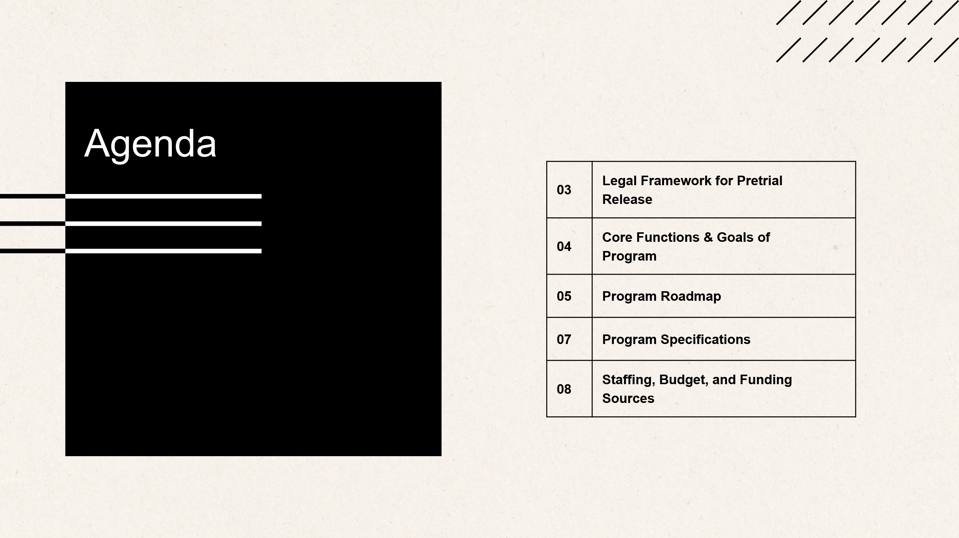
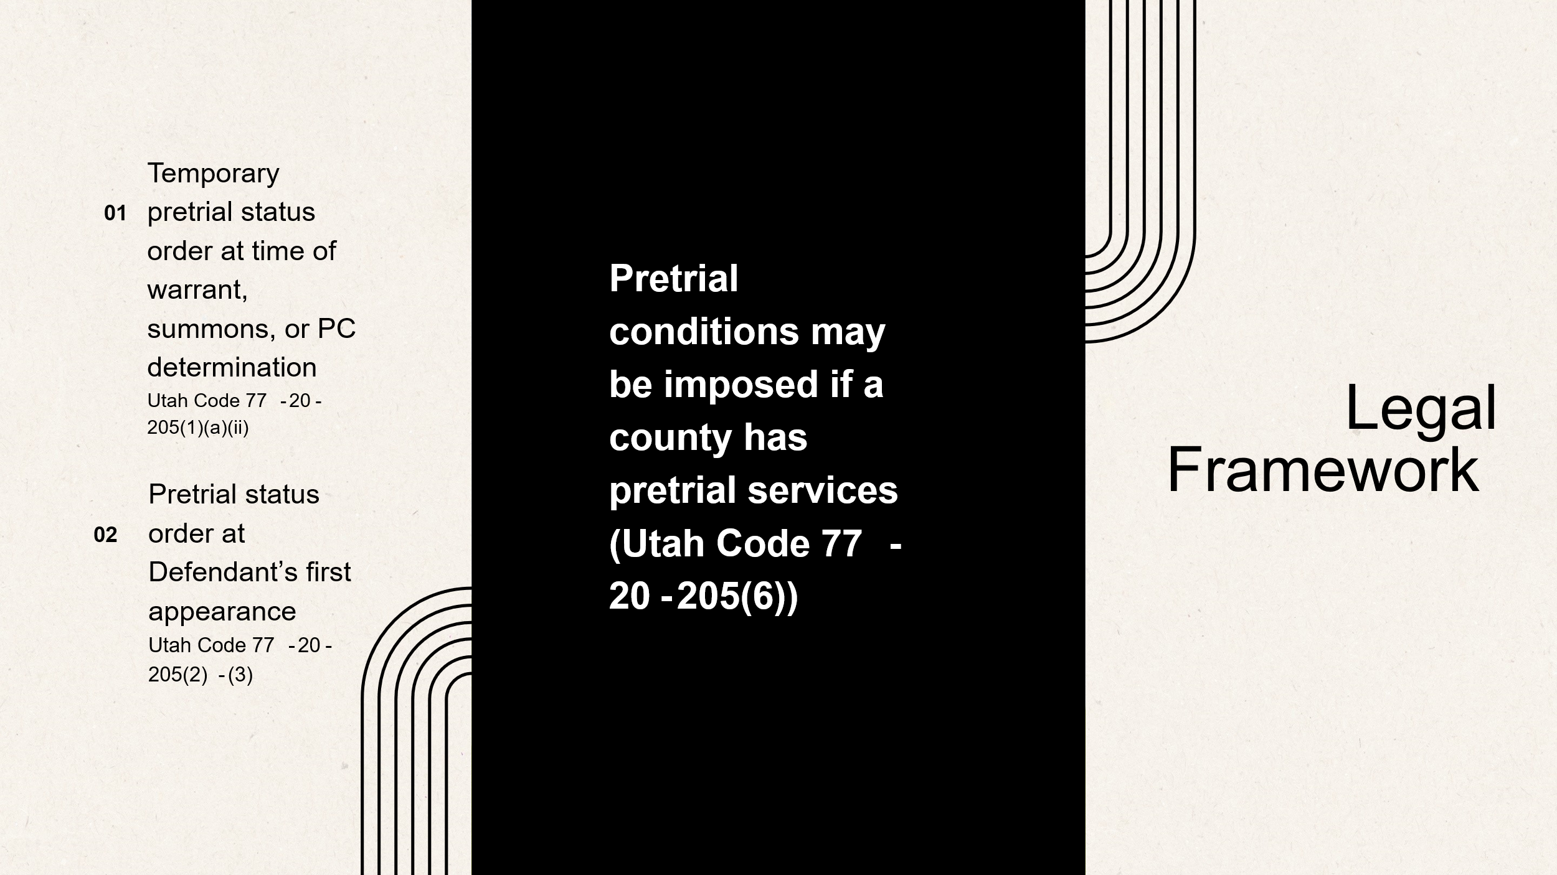
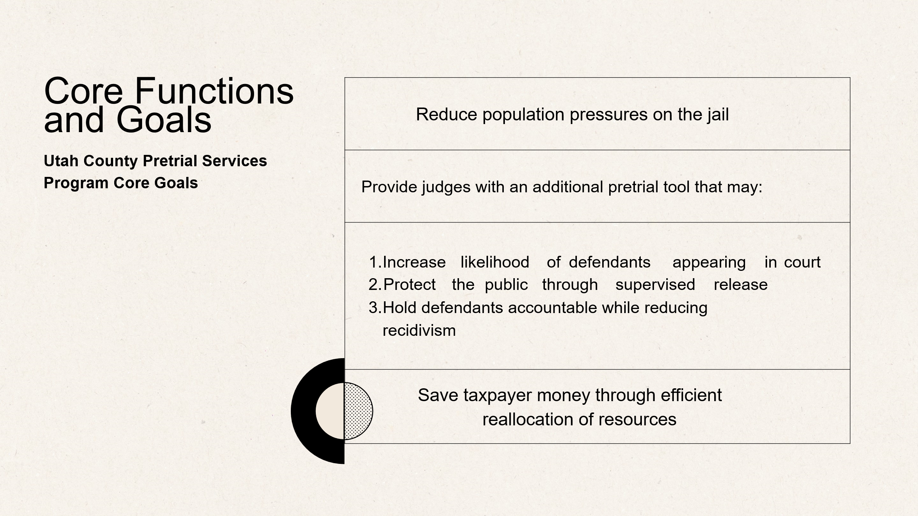
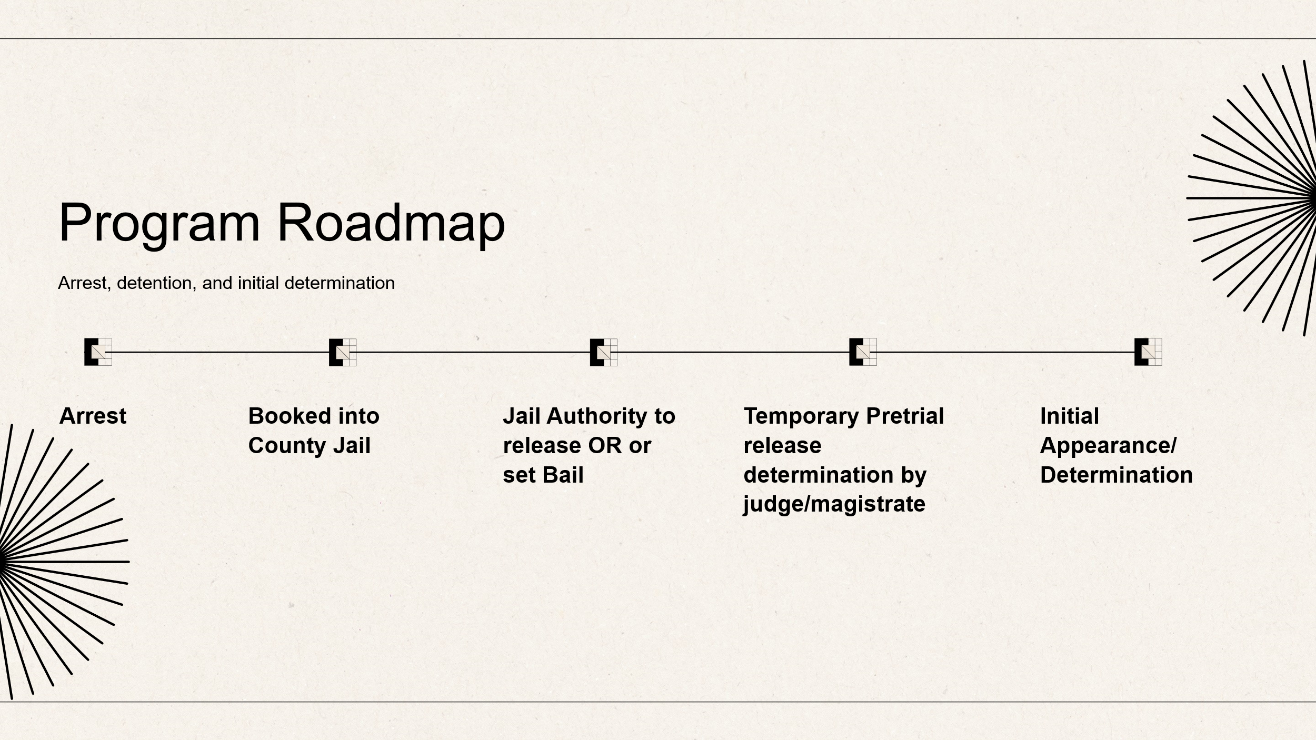
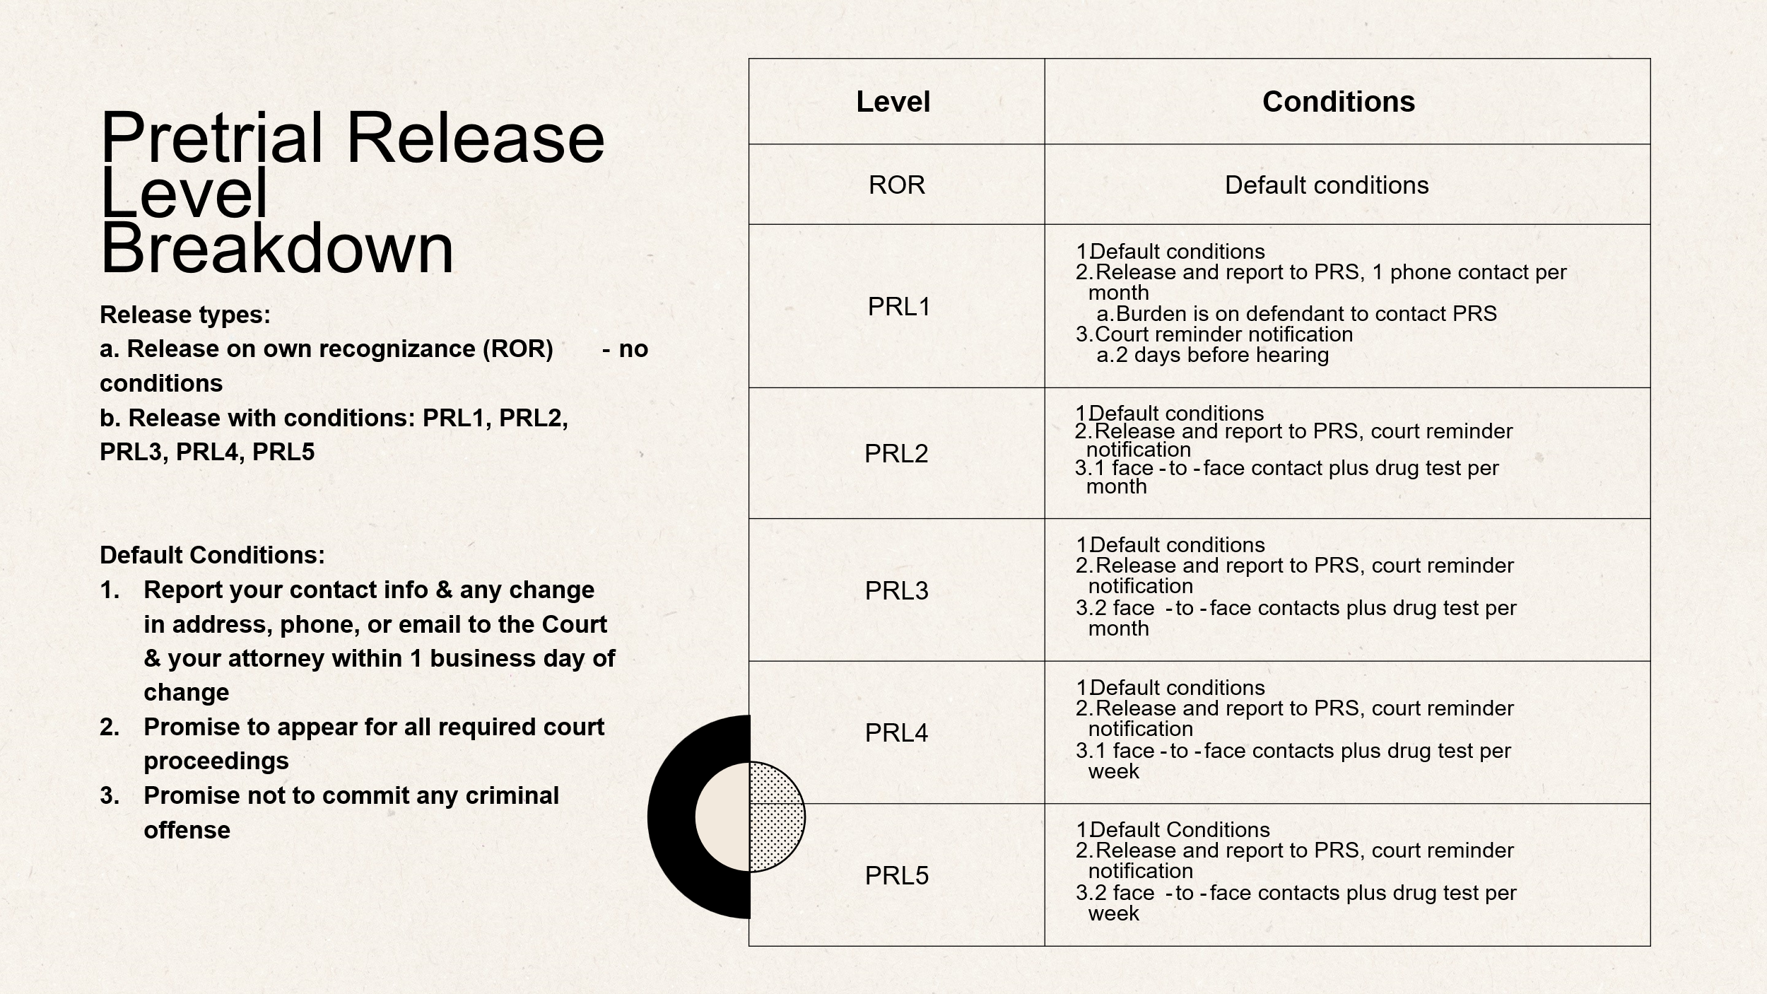
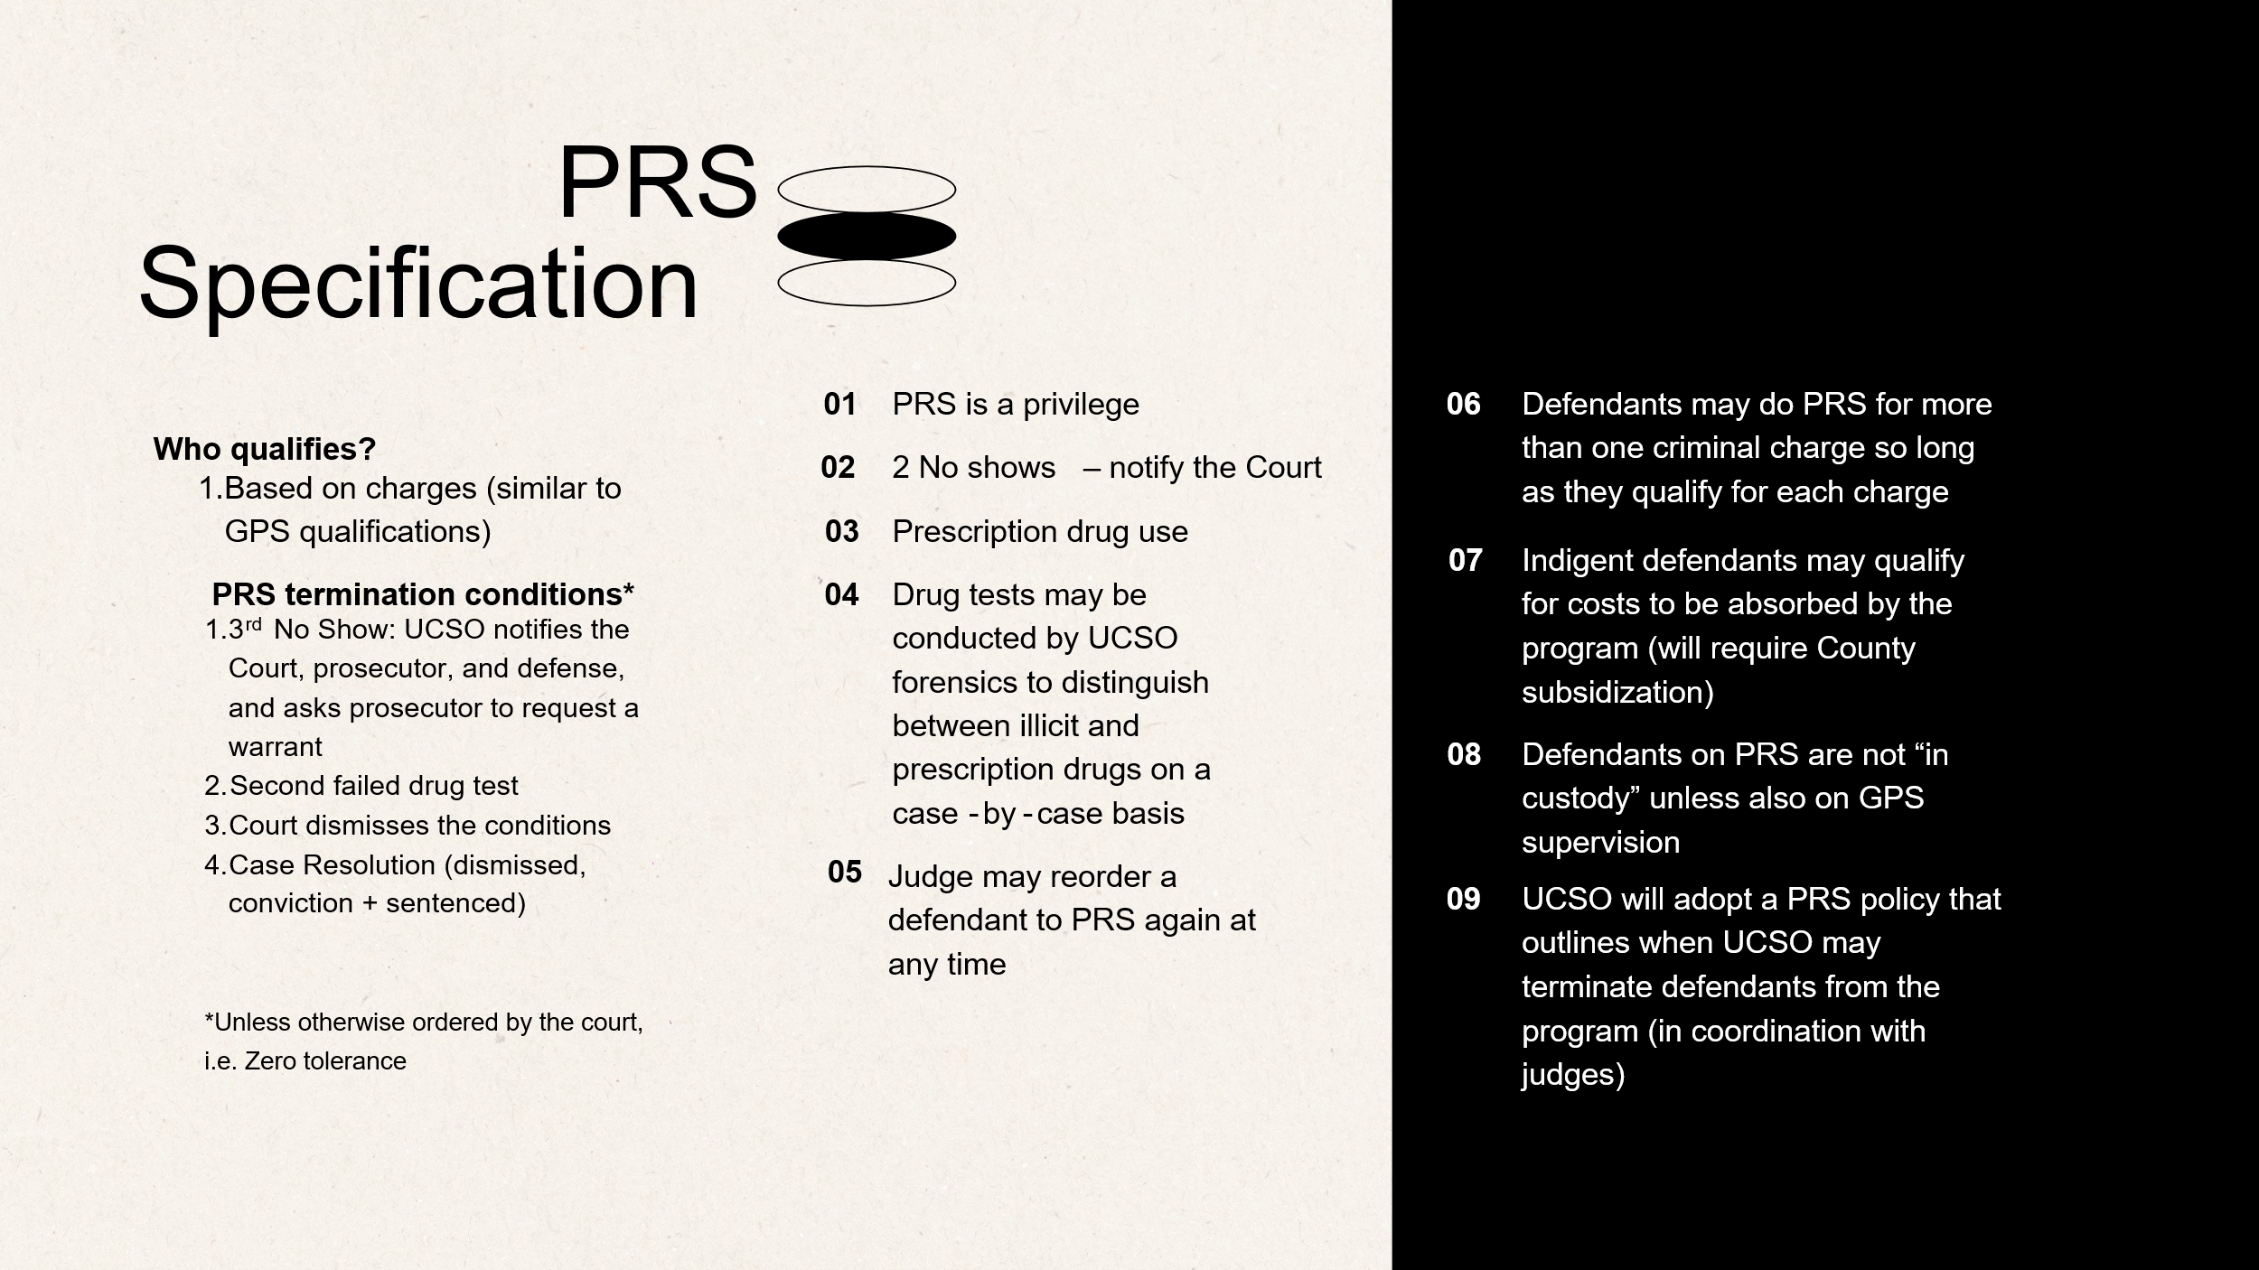



- Discuss goals and next steps

- Next Meeting Date & Adjourn
Motion to adjourn: Judge Parkin
Seconded: Irv Hale
Approved by all
Next meeting is scheduled for August 1st at 12 p.m.

